Global Studies Unit Overview
Week 1
Mātauranga Māori and Science

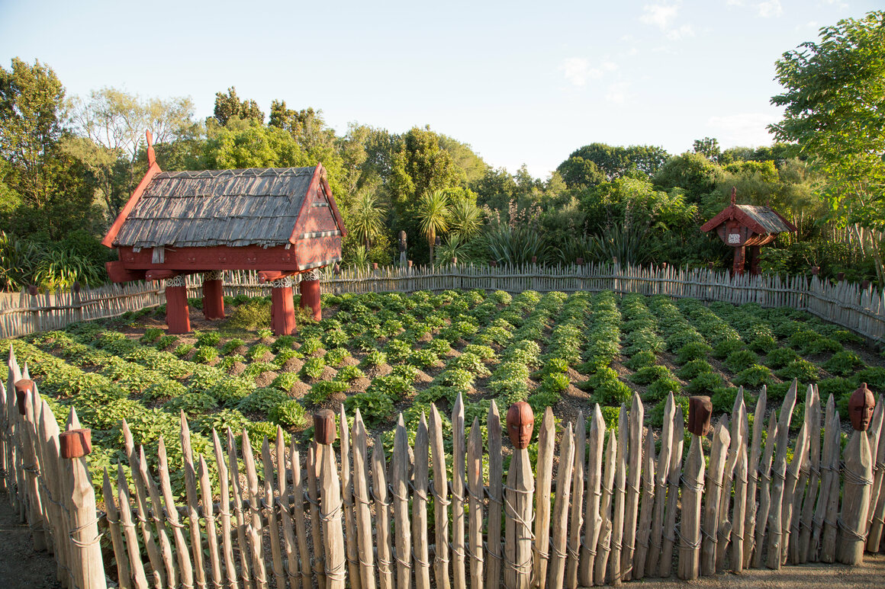
Above: Traditional Māori garden.

This term we will explore ‘Mātauranga Māori’ which is a modern term for the combined knowledge of Polynesian ancestors and the experiences of Māori living in the environment of Aotearoa New Zealand. The term takes many forms, such as language (te reo), education (mātauranga), traditional environmental knowledge (taonga tuku iho, mātauranga o te taiao), traditional knowledge of cultural practices such as healing and medicines (rongoā), fishing (hī ika) and cultivation (mahinga kai). Students will also become familiar with the new Matariki public holiday and the significance of this event to Māori society.

Week 1, Lesson 1
Mātauranga Māori

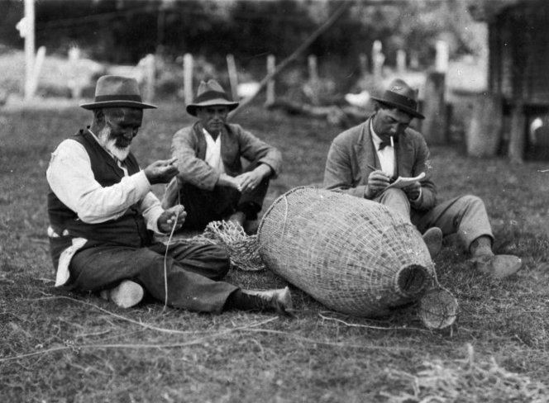

Success criteria:
At the end of this week, students will have a thorough understanding of Mātauranga Māori and how it complements science. They will be able to describe the difference between the two as they are not the same and explain why Mātauranga Māori is a substantial body of knowledge that is worthy of respect.

Task 1: In your Red Book, go about one-third of the way down the page and draw a line across the page. In the top section write the title of this unit – ‘Mātauranga Māori and Science.’ Underneath the line, write ‘Lesson 1: An Introduction to Mātauranga Māori.’

Task 2: In your Red Books write down the following definition:

Mātauranga Māori refers to the combined knowledge of Polynesian ancestors and the experiences of Māori living in the environment of Aotearoa New Zealand. It includes language, education, environmental knowledge, and cultural practices such as healing and medicines, fishing, and growing things.
Task: As a class we will listen to the interview with famous scientist Richard Dawkins on whether Mātauranga Māori is science or not.
We will listen from the 1:40 mark to the 3:40 mark –
https://www.youtube.com/watch?v=g6kNreMIYQE

Class discussion:
Is Māori knowledge and traditions part of the scientific process? Should we consider it science? Why? Why not?

Answer this question in your books:
What does Richard Dawkins say about Mātauranga Māori and science?

Task: We will watch the video clip: “Endangered Māori construction techniques successfully hold up in seismic testing,” at: https://www.youtube.com/watch?v=WTQg6DuzFGE (3:25 sec.).

Next, we will read as a class, the article: “Ancient Māori building techniques proven to withstand major earthquakes,” New Zealand Herald, April 25, 2023.

Ancient Māori building techniques proven

to withstand major earthquakes

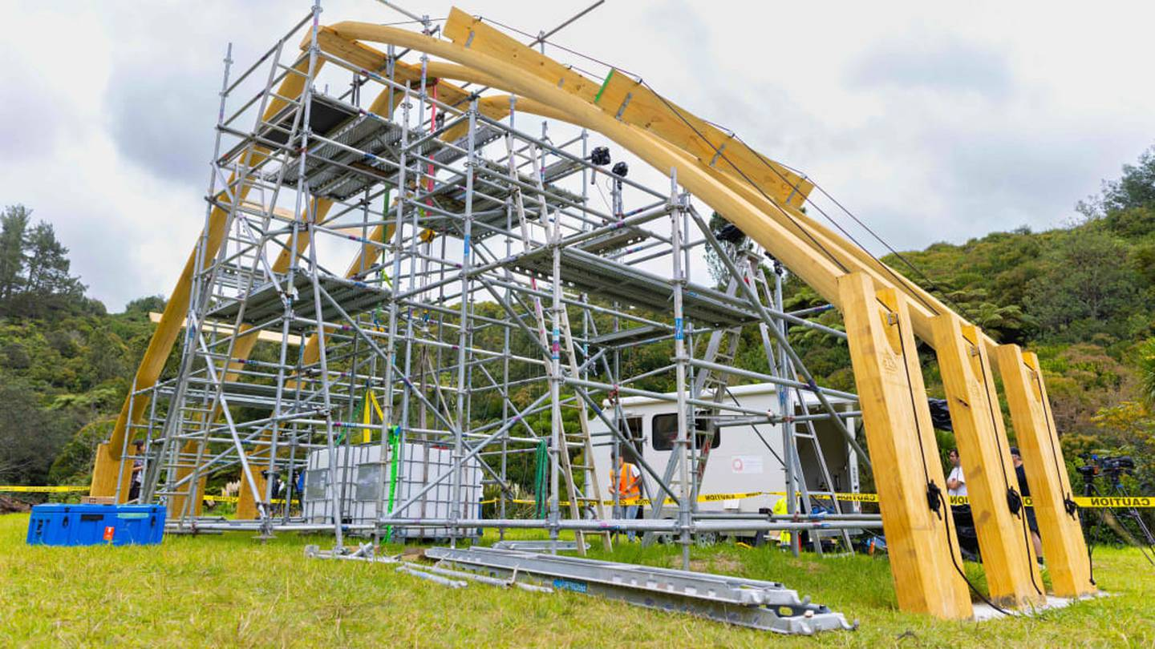
Above: The shell for the new whare, pictured before the testing.

Endangered Māori construction techniques that have been proven to withstand major earthquakes will be used to rebuild a Bay of Plenty wharenui. Architect Anthony Hoete and his team from Auckland University showed this by using endangered construction knowledge called mīmiro to create a full-scale timber structure, and successfully tested it against earthquake requirements for modern buildings.
Mīmiro involves the use of interlocking structure supports, with rope used to lash the supports together before tightening them to strengthen the building.

Professor Anthony Hoete explains the testing.

Hoete said the team was working to revive the ancient method after it was lost when Europeans arrived in Aotearoa.
“So, you can imagine when the Europeans arrived, screws and nails turned up and all kind of manner of things, and of course, [for] Māori, who were effectively using carvings to notch in to make these joints, timbers could be interlocked without fixing.
“And of course, that practice has become increasingly endangered — interlocking timber structures are then pulled back down to the ground with post-tensioning. That’s with harakeke or muka flax, but today, we’re using other materials more commonly available.”
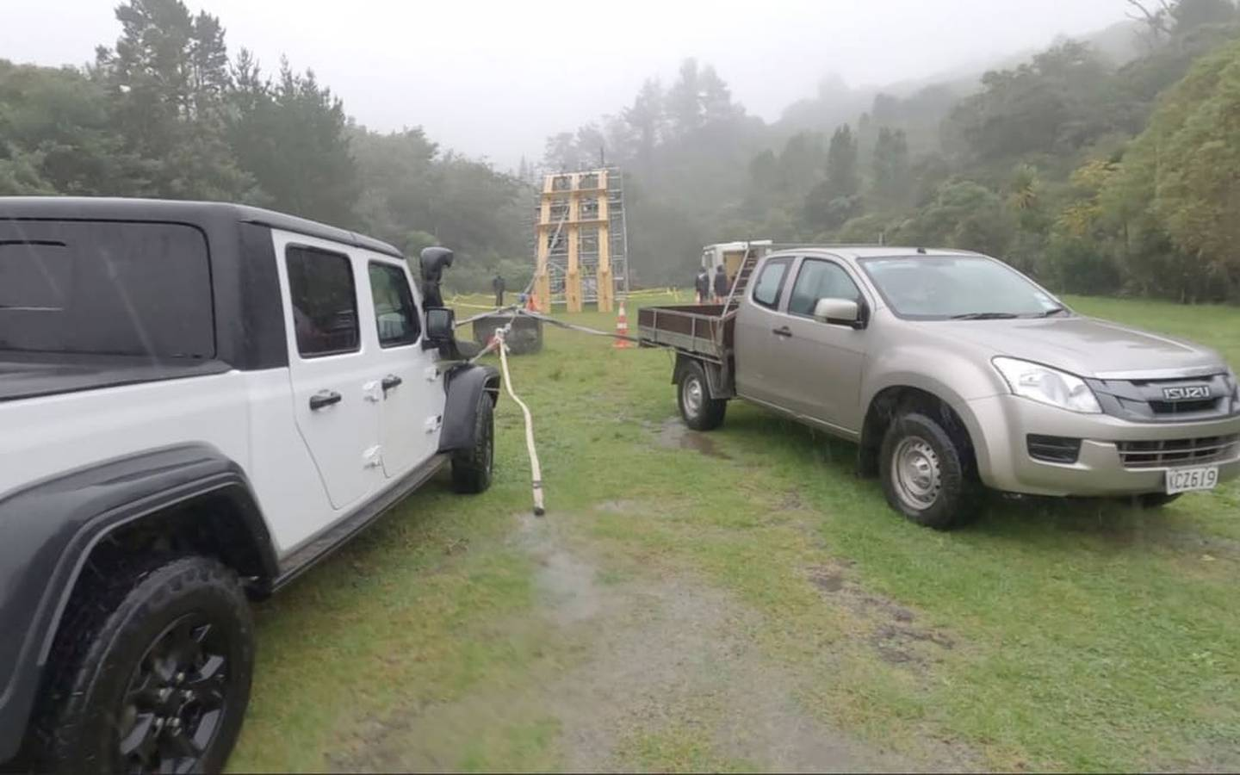Trucks were used to create the effect of an earthquake on the structure.

The team has been working closely with Ngāti Ira o Waioweka, who built the original Tānewhirinaki wharenui near Opōtiki after the 1860 New Zealand Wars.
More than 70 years later, in 1931, it was destroyed by a 7.8-magnitude earthquake in Hawke’s Bay.
Restoration project leader Riki Kurei (Ngāti Ira) said he has been working on restoration since 2010 and was thrilled with how far the project had come.
Senior Māori research adviser Toka Tū Ake Hema Wihongi said this was the type of important knowledge and research the organisation wanted to contribute towards.
“Toka Tū Ake is interested in investing in mātauranga Māori. We have $19 million we use every year for all sorts of research to protect communities against natural hazards.
“This project is important because it was one of the marae that was destroyed during the Napier earthquake, and it also aligns with Toka Tu Ake’s objectives: supporting Māori and building their community resilience,” Wihongi said.

Answer these questions in your Red Books:

1. What is Mīmiro?

2. Instead of using metal nails and screws, how did this new building method bind a structure together?

3. Why was the Māori building method better than screws and nails?

4. What is a wharenui?

5. Challenging question – How can this technique be said to use scientific principles? (we will discuss the answer as a class).

Extension exercise (optional): Watch the video on how one Auckland University student uses Māori traditional knowledge alongside Western Science.

“Fusing Mātauranga Māori and Geothermal Science.” https://www.youtube.com/watch?v=2arZpDDrME4 (4:54 sec.)

Under the heading ‘Maori Traditional Knowledge’ – list all of the different ways you can think of where Maori traditional knowledge is being used to help scientists better understand the world. One example would be making medicines made from plants. How was the Auckland University student from the video, using Maori traditional knowledge to help study and understand geothermal formations in New Zealand?

Look up the definitions online:

1. Traditional
2. Cultivation
3. Polynesia

Homework: Make sure your Red Books are set up and are up-to-date.

Week 1 Lesson 2

How Did Mātauranga Māori Develop?

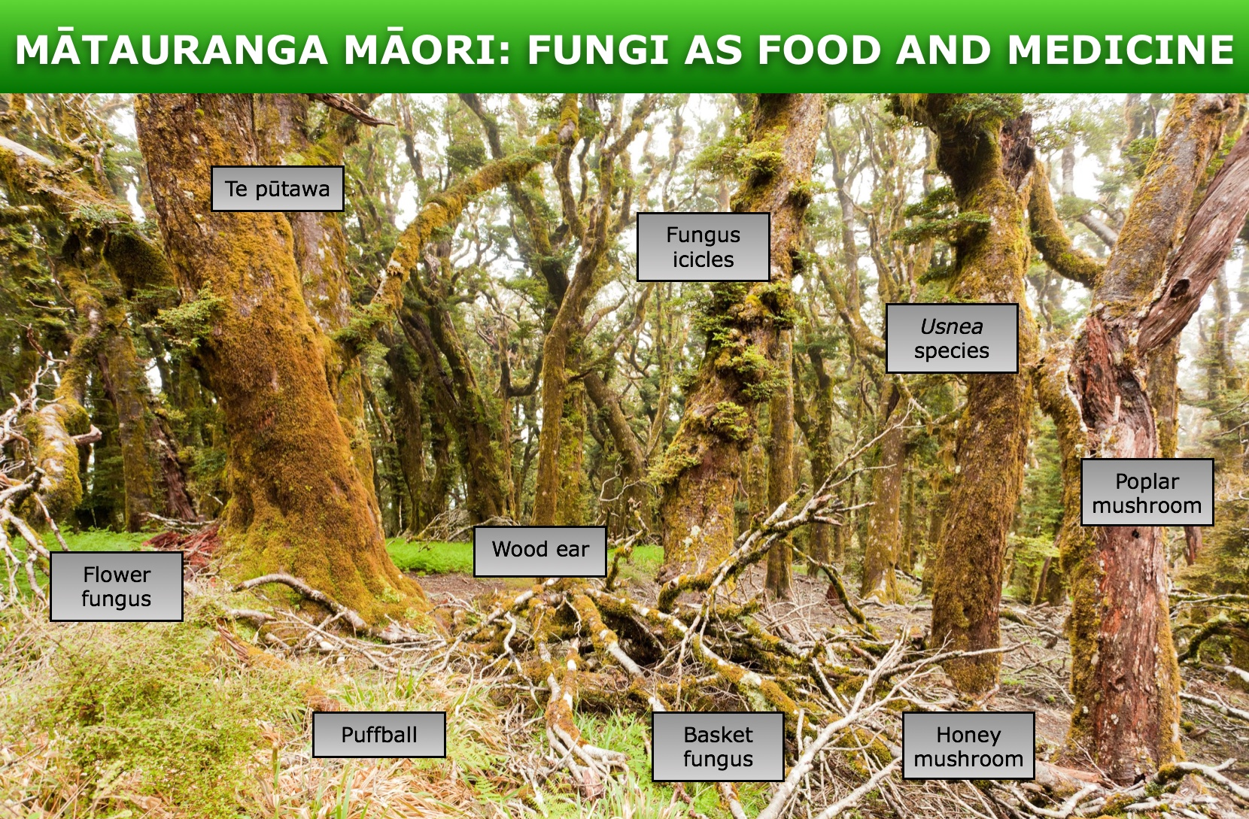

Task 1: The New Zealand Government has a website dedicated to Māori knowledge and science. Click into the link below and read the section titled, ‘How did Mātauranga Māori develop?’
https://www.sciencelearn.org.nz/resources/2545-matauranga-maori-and-science#:~:text=The%20term%20takes%20many%20forms,and%20cultivation%20(mahinga%20kai)

Task 2: In your Red books write the date, Lesson and heading, ‘How did Mātauranga Māori develop?’
Answer the following questions:

1. How was early Māori knowledge passed on?
2. How were Māori able to remember vast amounts of information?
3. What is the meaning of the Māori word – Whakapapa?
4. Go online and look up the difference between ‘hapu’ and ‘iwi’ and write it down.
5. List different fungi that have been used by Māori for food and medicine.

Now look at the green square with the different types of fungi. Write down each name, then click on the square and write down next to the fungi what it was used for by Māori. The first answer has already been done. Please write it down.

a. Te pūtawa - Pūtawa was cut into flexible strips and used to surround and protect wounds. A hole larger than the wound was cut into the strip, and the pūtawa was tied in place as a protective pad.

b.
c.
d.
e.
f.
g.
h.
i.

Homework: Make sure your Red Books are set up and are up-to-date.

Week 1 Lesson 3
Current Event Analysis
Auckland’s Volcanic Hazards – What would you do in the event of an Eruption?
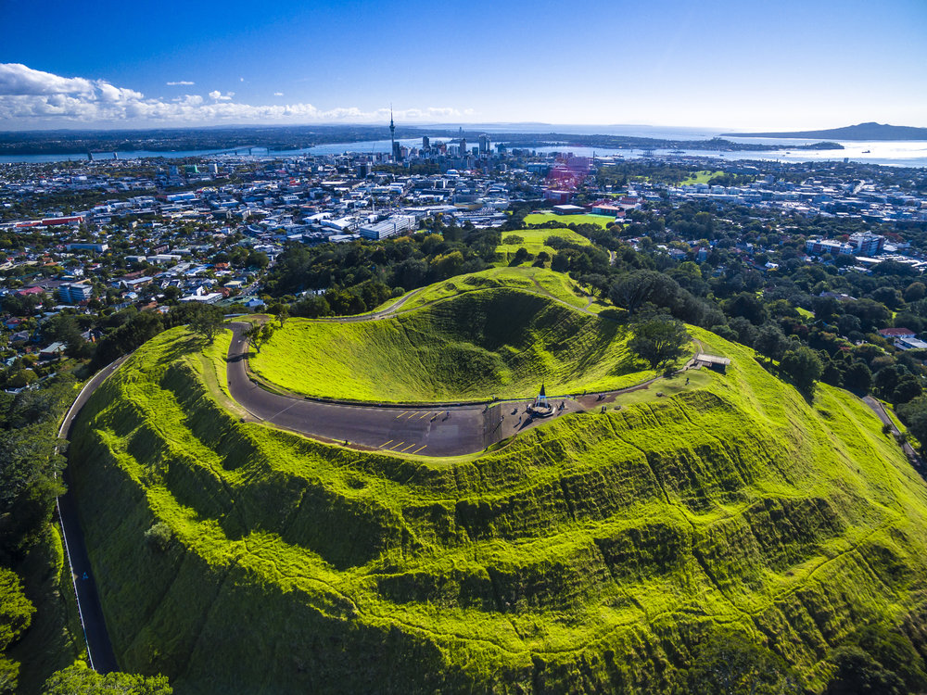

Just 600 years ago there was a major volcanic eruption in Auckland. What would happen if a similar event occurred today? The Emergency Services branch of the New Zealand Government has created a video to explain what actions we can take and how we can prepare for such an event.

Task 1: Watch the video ‘Auckland’s Volcanic Hazards.’ https://www.youtube.com/watch?v=wRVvYsg33yg&t=473s (10:42 sec.)

Based on the video, answer the following questions:

1. How many volcanic cones have been identified in the Auckland volcanic field over the past 200,000 years?

2. Auckland is the only large city in the world that is built directly on a ________ ______.
3. What is the name of the largest volcanic cone in Auckland? How long ago did it erupt?

4. Auckland’s volcanos produce a very fluid form of magma (hot melted rock) called _______.

5. If there is another volcanic eruption in Auckland, how will scientists know days or weeks ahead of time?

6. In the event of an Auckland eruption, what would be the exclusion zone (where people have to be evacuated from?).

7. How hot is volcanic magma?

8. What problems are caused by volcanic ash. List each of these problems.
a.
b.
c
d.
e.
f.
g.

9. How long could a volcanic eruption last in Auckland?

10. What can you do to prepare for a volcanic eruption in Auckland? List each of the things you need to do to be ready – as listed in the clip.

