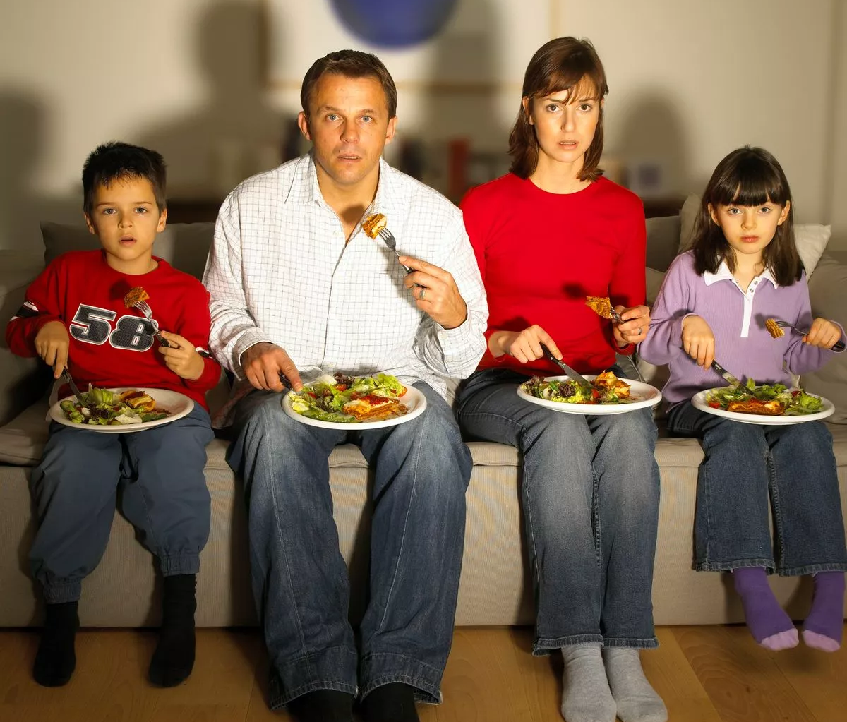

Year 10 Hard Materials Technology
Term 2
“TV Dinner’s”
Planning Journal
Mr Jackson

What is Hard Materials Technology?

In Hard Materials Technology students design and make a range of products (outcomes). The outcome is often constructed using a variety of materials such as wood, metal, plastic and composites.

Students are given or identify a need or opportunity that exists and explore ideas and solutions that can be used to solve the issue.

The Technological process is used to ensure the outcome or product works and is “fit for purpose”. Simply the outcome needs to perform and solve the need or opportunity.

This term our focus will be to design and make an outcome that is both fit for purpose and displays an attribute that has ‘real’ meaning to the stakeholder. Research into materials, ergonomics and safety will also need to be considered.

The journal is a planning tool and is required to be completed by students as they work through the project. This document will aid understanding, act as a record and help with reflection throughout this project.

Completion of this journal is compulsory as it is this aspect of the course that is being assessed and it will influence your achievement grade.

TASK 1. Identifying a Need or Opportunity

Look at the image located on the front page. It's a family watching TV whilst eating dinner. See how they are balancing the plates of food on their knees, how far they are leaning forward?. Imagine if the food and plates were hot and they were wearing shorts?. Imagine if the food had runny sauces or gravy?. Where are their drinks?.
List and describe 5 ways in which you could improve that picture.

(a)

(b)

(c)

(d)

(e)

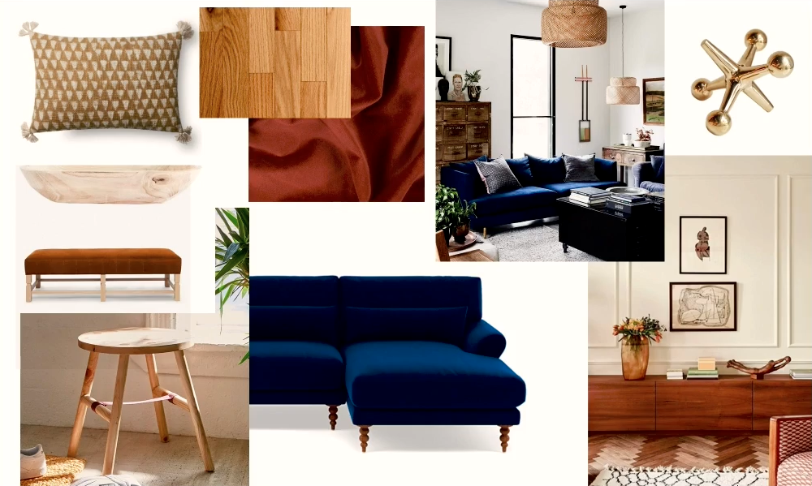
TASK 2. Create a Mood Board.
A Mood Board is a collection of photos, sketches, ideas that help understand the problem and possible solutions.

Using images to communicate possible ideas and solutions that would eradicate or minimize the 5 issues observed and listed above.
Annotate your Mood Board with what you like and dislike?

TASK 3. Creating your Design Brief (5 W's & 1 H)

What am I making?

Why am I making this product?

Who am I making the product for? (me or a stakeholder)

Where will the product be made and who will be using it?

When will this product be used, when will it be started and finished?

TASK 4. Product Specifications.

(a) Write about the specifications (requirements) that your design must have

(b) How is my design going to look? (Physical Attributes) list 4.

1.

2.

3.

4.

(c) Size: Maximum dimensions must be no more than,

Height 80mm.
Length 600mm.
Width 300mm.

Personal / Custom Specifications of the prototype

(d) What Colour should it be and why?

(e) What Shape should it be and why?

(f) What material should my design be made from and the reason?

(g) What tools are required to make my product?

(h) How much time is required to complete this project?

(i) Is my design safe to be used in terms of size, shape, weight?

(j) Is my design “fit for purpose” if so explain why?

(k) Is my design unique?

TASK 5. Conceptual Statement, Design Brief & Attributes
A Conceptual Statement describes what you’re going to make.
This includes what it’s called, what problem it solves, what it looks like, . . ).is . . .
Task (a) Type a ‘Conceptual Statement’ using all the information gathered in TASK 4.

(b) List all of the physical attributes of your design below.
(What the ‘outcome’ will look like or be).

(C) List all of the Functional attributes of your design below.
(What the outcome needs to be able to do or perform).

TASK 6. Your Product's Conceptual Design Ideas.

Sketch TWO conceptual design ideas of your product / outcome.
These may be rough sketches of any ideas that you have considered. Insert the sketches below, use only one scanned page.

TASK 7. Product Development

Now using your best conceptual design idea from Task 6 develop it further to become the final drawing of your teatray (outcome). Develop your freehand sketch to include and display:

Measurements (mm)
Materials
Colours
Finishes
Any special design features you wish to include.

Scan and insert the prototype below.

TASK 8. Stakeholder feedback

It is always important to consider that what you are creating is what the ‘Stakeholder’ is expecting and wanting. This is a very important stage in the technological process. Many designs will fail if stakeholder feedback is not considered or sought.
Questions to ask are:

(a) Who is your stakeholder?

(b) Does it meet the design brief and specifications agreed upon?

(c) Is this what the stakeholder wants, consider their feedback?

(d) Speak to your teacher, they are the ‘experts’ in the room”?

TASK 9. Create a Functional Model (Prototype) of your product.

Please note that Task 9 is your first assessment to be completed.

Using cardboard and paper construct a scale model / mock-up of your final design. The functional model should include handle design, tray design and 2 other features / attributes that personalizes the outcome.
Include dimensions and some annotation.

Attach a plan, end and side view photos here.

TASK 10. Key stages & Construction Steps

Now you have experienced designing and making your own personalized tray, put the stages listed below into the correct chronological order.

Shaping Finishing Concept sketches Design ideas Attributes

Measure Modeling Mark out Stakeholder Finishing Wax

Research Mock up Jointing Cut Need or Opportunity

1 |  | 4 |  | 7 |  | 10 |  | 13
2 |  | 5 |  | 8 |  | 11 |  | 14
3 |  | 6 |  | 9 |  | 12 |  | 15

TASK 11. Use the construction steps to keep a record of your progress in this planning and sequence chart.

CONSTRUCTION STEPS & KEY STAGES | RESOURCES AND MATERIALS.  TOOLS AND EQUIPMENT USED | W1 | W2 | W3 | W4 | W5 | W6 | W7 | W8 | W9 | W10 | W11 | W12 | W13 | W14 | W15
FINISHING OF THE TRAY PROJECT | Varnish / Paint or Wax the finished tray and design in the centre of the tray bed

Use the construction and key stages in Task 10 to fill in the planning and sequence design process chart above.
See the example given in green (delete this and do your own).
Also check out the task description and the resources and equipment required for the task.

Please show your chart to Mr Jackson so he can help you learn the skills and understanding to complete each step /stage.

