Week 1:
Paraphrasing, Plagiarism, Grammarly & Chat GPT & All That…
An Introduction
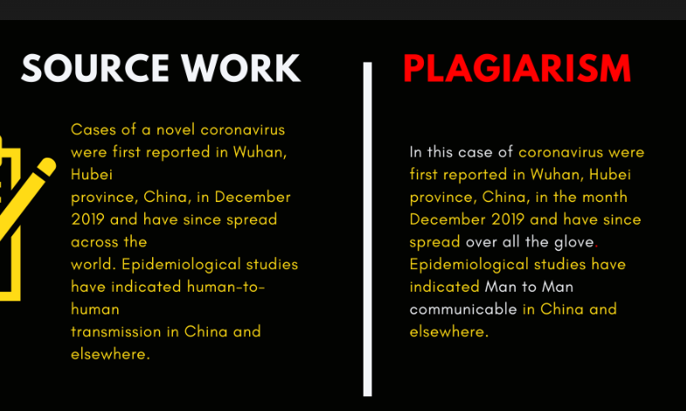
Success Criteria: By the end of the week students will become familiar with the debate over the use of Artificial Intelligence to help them write research papers and assignments – and be able to describe what is acceptable and what is not, for Mr Bartholomew’s Global Studies class.
Class discussion:
What is plagiarism?
Is any degree of plagiarism acceptable?
What is paraphrasing?
Question: Is it OK to use a spellchecker/grammar checker? Of course, but just remember, many if not most of the suggested changes are inappropriate. In other words, it only works well if you know some grammar and spelling.
Plagiarism is when you take someone else’s work or ideas and pass it off as your own. This now includes using text generated by Artificial Intelligence or AI. This is a big deal because if you get caught plagiarizing it can have severe consequences.
We all know that cutting and pasting from a website or an AI-generated text is plagiarizing and considered cheating, but is it acceptable to copy a text, paste it into Grammerly or some other AI-generated tool – and ask it to paraphrase it for you? The answer is NO because it is not your work and you are robbing yourself of the skill of paraphrasing. In the past people have seen plagarizism as simply taking someone else’s ideas or material and claiming it as your own. But what if you write a text on your own (so it’s your work), then paste it into an AI tool and ask it to reword it for you. Is this acceptable? While it may be your own work and ideas, it is NOT acceptable to do this because you did not do the work yourself – a computer program did it for you.
Let’s begin by looking at the different types of plagiarism.
Watch the video on the most common types of plagiarism. This video was created just before the pre-Chat GPT era for university students. Later we will address AI-generated text. As you watch the video, IN YOUR OWN WORDS, write in your Red Books the definitions for each type of plagiarism.
Seburn, Chelsea (2021). “Plagiarism: 6 different types of plagiarism to AVOID.”
https://www.youtube.com/watch?v=N4j6ILb_hBo (8:23 sec.)
Questions: Describe the following types of plagiarism.

1. List different consequences of plagiarism (1:17).
2. Direct plagiarism (3:05 sec.)
3. Find and replace (3:39 sec.)
4. Patchwork plagiarism (4:49 sec.)
5. Accidental plagiarism (5:23 sec.)
6. Self-plagiarism (6:27 sec.)
7. Total plagiarism

________________________________________________________________
Week 1 Lesson 2
Read the article below on the eight types of plagiarism. Then, in your own words, in one or two sentences, define each type. Next, use the type of plagiarism in a sentence, underlining the word. See the example below:
1. Self-Plagarism

1. Self plagiarism: Self-plagarism or auto plagiarism occurs when you use something you have already written for one class, then submit it for another class.

Sentence: When a student uses part of a research paper that they submitted to Science class and then submits it for a different assignment in Global Studies, it is known as self-plagarism.
2. Mosaic plagiarism
3. Accidental plagiarism
4. Verbatim plagiarism
5. Paraphrasing plagiarism
6. Aggregate plagiarism
7. Complete plagiarism
8. Source-based plagiarism

8 Most Common Types of Plagiarism with Examples
by Paige Pfeifer and Hannah Skaggs (September 5, 2023)

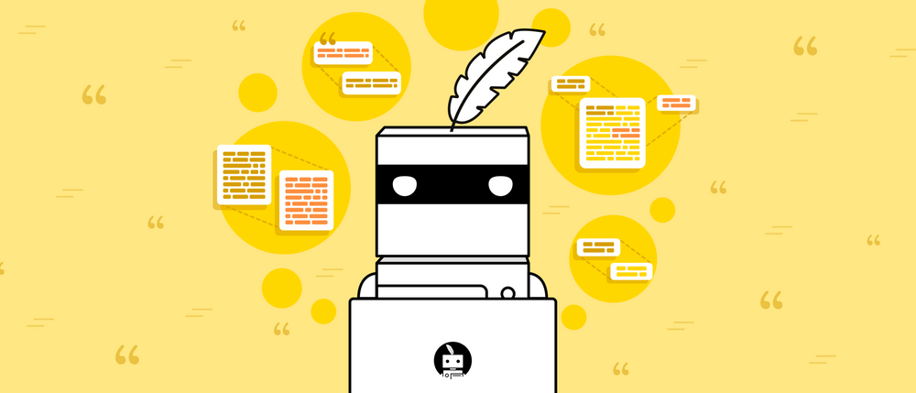

Plagiarism is a very serious academic offense, and it comes in many forms.
The Most common types of plagiarism are self-plagiarism, mosaic plagiarism, accidental plagiarism, verbatim plagiarism, paraphrasing plagiarism, aggregate plagiarism, complete plagiarism, and source-based plagiarism.

Here are the 8 Most Common Types of Plagiarism with Examples

1. Self plagiarism
Self plagiarism, also known as auto plagiarism is a form of plagiarism that occurs when one reuses their own work that was published elsewhere.
For example, a student may copy a portion of an essay they wrote for one class, and use it in an essay for another class. Although it is their own work, it was repurposed without credit to the original essay or class.
Citations are always required, even if it's one's own work.

2. Mosaic plagiarism

Mosaic plagiarism, or patchwork plagiarism is another type of plagiarism, occurs when the writer:

- Copies a quote from another source but doesn't use quotation marks

- Copies the original source's structure but replaces all words/phrases with synonyms

- Entwines their own words with another writer's words without proper citations

The finished product will often look like a new piece of writing; however, portions will have been stolen from other sources without acknowledgment/proper citations (hence the nickname "patchwork plagiarism").

3. Accidental plagiarism

Accidental plagiarism is just that: an accident. This type of plagiarism occurs when the writer unintentionally misses a citation, forgets to use quotation marks, or paraphrases text in a way that's much too similar to the source material.

The consequences of plagiarism are the same whether it's accidental or otherwise. This is why it's important to double-check all of your work or run it through a plagiarism checker. Accidental plagiarism will still cost you.
Check Plagiarism Now

4. Verbatim plagiarism

Verbatim plagiarism or direct plagiarism is another form of plagiarism, that occurs when the writer copies and pastes text from the original source into their essay.

This is what most people think of when they think of plagiarism: an exact transcription of someone else's work without a citation, or even quotation marks (hence the nickname "direct plagiarism").

5. Paraphrasing plagiarism
Paraphrasing plagiarism occurs when a writer paraphrases someone else's work and passes the idea(s) off as their own, meaning they do not properly cite where the paraphrased material originated from.
This is similar to mosaic plagiarism; however, paraphrasing plagiarism often deals with one small section of a larger work, whereas mosaic plagiarism deals with the entire work.
Plagiarism deals with the copying of ideas as well as words━paraphrased material must include a citation for the original source.

6. Aggregate plagiarism
Aggregate plagiarism is another example of plagiarism that occurs when one copies and pastes an entire body of work and includes a citation.
Wait, I thought plagiarism occurs when you don't use a citation!
What makes aggregate plagiarism is the fact that the entire text has been lifted from elsewhere. There is no original work, so though you credit the original source, they are still turning in someone else's work.

7. Complete plagiarism
Similar to both direct and aggregate plagiarism, complete plagiarism occurs when one copies an entire body of work, word-for-word, and does not give credit to the original source. A few examples are as follows:
- A student submits a paper written by someone else. This includes paper-cloning plagiarism, which occurs when a student buys a paper from an essay writing agency or similar business, or from another student.

- An author publishes a book written by another person under their own name without informing the person who wrote it.

8. Source-based plagiarism
Source-based plagiarism is a type of plagiarism, that occurs when a writer cites a source incorrectly, whether intentionally or unintentionally. This can happen when the writer:
  - States a fact that is supported by two or more sources, but only cites one
  - Uses a secondary source but doesn't cite the primary source from which it was referenced

  - Cites a source that is incorrectly listed

  - Doesn't complete a citation

  - Cites a source that doesn't exist
Oftentimes, if intentional, these methods are used in order to pad the bibliography/Works Cited page.
Although source-based plagiarism isn't dealing with stolen text like the other types of plagiarism, it is still considered to be highly unethical and can lead to serious consequences.

Week 1 Lesson 3: Chat GPT and other AI Tools
There are many videos on Youtube claiming that they know ways of getting around AI detectors and that you can literally create an AI-generated research paper and have it appear as your own work, without being detected. Be aware that the AI detection products are not static, the only reason they are in business and making a profit is because they can detect AI text and the level of plagiarism in any given paper. As a result, as people try to get around AI detection, sites like Turn-It-In and others are working continuously to counter each new method. Turn-It-In and other similar programs work like virus patches – they are updating to counter new attempts to get around it. The people who work at these are not studip – and they would be continuously checking the latest Youtube video claims of getting around Turn-It-In and updating their program to address them.
Task: Watch the following video:
https://www.youtube.com/watch?v=IsNln_7U__A
At the end of this unit, we are going to do this year’s Global Studies NCEA Assessment. While most students will choose not to do the NCEA version of the assessment (based on past classes – only 2 to 5 students per class usually attempt the NCEA assessment), either way the assessment will be the similar, it is just that the one graded for NCEA will be expecting greater depth and will be assessed to a higher standard. Having said this – the way we are designing the assessment, it will not be possible to use AI text generators and paraphrasers because it will ask for information that is so specific information that Chat GPT will not be able to generate an appropriate text. Now write the following points in your Red Books:
1. It is not acceptable to use Artificial Intelligence to paraphrase any material and pass it off as your own.

2. If you use information verbatim (word for word) from any source, and you do not place it in quotation marks, it is considered plagiarism.

3. Using AI to paraphrase robs you of honing your writing skills because plagiarism does not help you improve your writing. It is considered cheating.

4. The penalties for getting caught plagiarizing are significant.

5. I have now been forewarned in writing, so I cannot claim I did not know about plagiarism.

6. The solution to plagiarism concerns is easy: do your own work.

