Week 6

The Power of Pictures: Visual Evidence of Discrimination

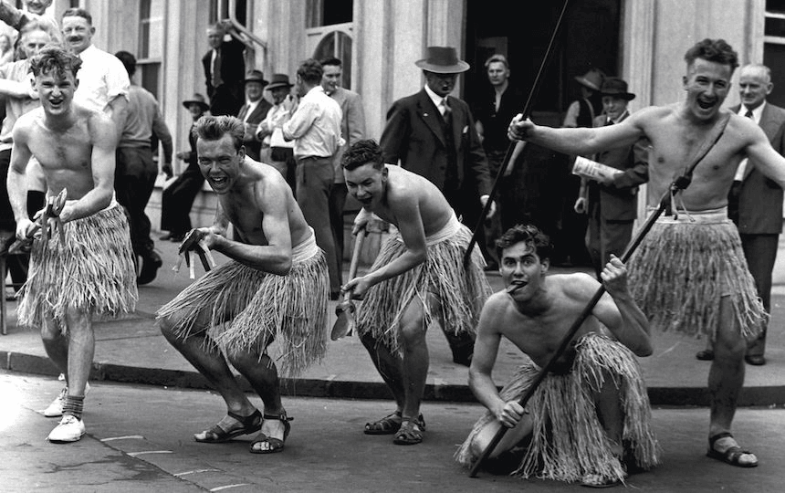

Success Criteria
Students will become familiar with iconic images from the era of Maaori racial segregation and how to analyse them based on the social, cultural and historical context of the period they were taken.

Lesson: Images of the KKK in New Zealand.

Task 1: Read chapter 4 and pay particular attention to the Auckland University students who were riding through the city on horses and dressed as Klu Klux Klan members. Research the history of the Klu Klux Klan. What are the goals of the organisation?

Write a one-page summary in your own words. Do not copy or cut and paste from websites or books. The Auckland University students riding through the city dressed as Klansmen, were promoting a play. What does it tell us about the state of racism in New Zealand in 1923, that their actions were viewed as acceptable? What would be the reaction if a group of students did something similar today?

Lesson 2: Images of the KKK in New Zealand.

1. What scientific discoveries have occurred since 1923 that discredit the belief in white supremacy? (refer to p. 11 of Chapter 1).

2. Examine the photos of Auckland University Engineering students making fun of Maaori culture and performing mock hakas. These events were not officially stopped by the University of Auckland until 1980.

a. What do these images tell us about respect for Māori culture between 1955 and 1980?

b. Imagine you have Maaori ancestors. How would seeing non-Maaori mocking your culture make you feel? In what ways are they showing disrespect to Maaori?

3. Look up information on ‘the Haka Party Incident.’ Write a summary of the incident.

Lesson 3: Analysing the Past through Images

1. Picture Analysis. Analyse each of the 5 images in Chapter 4. Create 3 columns with the headings, ‘People,’ ‘Objects,’ and ‘Activities.’

Under ‘People,’ who are being depicted in the image? Who took the photo and why? How did most people view the image at the time it was taken? How can you draw such a conclusion? Some of these images have not aged well – why? Specifically, why would they be upsetting to many Maaori today?

Under the ‘Objects’ column, what objects can you identify and what does it tell you? For instance, the fake spears and grass skirts (which are NOT part of Maaori culture). How are these objects used to create a stereotype of Maaori – and what is that stereotype?

Under the ‘Activities’ column, what activities are people engaging in and what does their behaviour tell us about the attitudes of the time?

