Week 8:

Of Rats and Men –
What Science says about the First Settlers to New Zealand

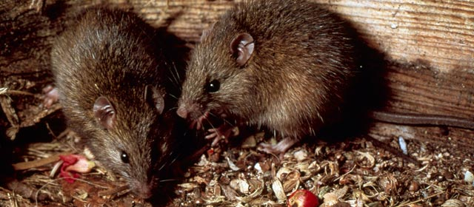
The kiore or Polynesian rat

Success Criteria
Students will use critical thinking and mainstream science to counter claims that Maaori were not the first to settle New Zealand and they will be able to recount key evidence that supports this position.

Class Discussion: How many students have heard stories that Maaori were not the first people to settle what is now New Zealand? How many think it may be true? What is the evidence?

As a class we will watch the following video: “Forbidden History of New Zealand & The Pacific Ancient Egyptian Navigators.”
https://www.youtube.com/watch?v=pDAn-poFubM

*Warning – this video contains information that is not supported by the scientific evidence, yet it continues to be allowed on Youtube and has nearly 40,000 views. Do not believe everything you see online or read in a book.

Lesson 1: Who Settled Here First?

Read pages 69-to the top of p. 71. You can do this in pairs or small groups, taking turns reading. Discuss the answers and write them down. What is the evidence that Maaori migrated to New Zealand around 1250? Present your evidence in the form of dot-points under each of the following headings:
1. Kiore Bones
2. Pollen
3. Volcanic Ash
4. Human remains

Create at least 5 dot-points per section or a full paragraph.

Lesson 2:
The Mystery of how Rats reached New Zealand 2,000 years ago?
In Skeletons in the Cupboard, it is claimed that there are two key pieces of evidence supporting the notion that Celtic people were the first to settle in New Zealand. The first revolves around the fact that some Maaori have red or blonde hair. The second piece of evidence has to do with when Maaori first arrived, they spoke of seeing a race of fair-skinned human-like people who were already here.

Write a summary of the evidence against the notion that red or blonde-haired Maaori are evidence of Celtic involvement. Ditto for the race of fairy people. (pp. 71-72).

Lesson 3: The Maaori Privilege’ Debate and Catch-up.

1. What is ‘internalised racism’ and how can it negatively impact people?

2. The term ‘Māori Privilege’ could be viewed as negative, suggesting that they are undeserving of special benefits. Look up the meaning of the word ‘privilege’ and explain why it could be seen as negative. Can you come up with a more neutral term? How is your term an improvement over the status quo (what we have at present)?

3. Write a newspaper editorial making the case that Māori should be afforded special treatment to help overcome historical injustices. In paragraph #1 introduce the topic, explain why it is significant, and list the key points you are going to discuss. In paragraph #2 describe key injustices that Māori have faced and how it made it difficult for them to advance. Paragraph #3 should contain a summary/conclusion along with your personal opinion.

