Week 8:
Kiwis Make their Contribution
to Humanity
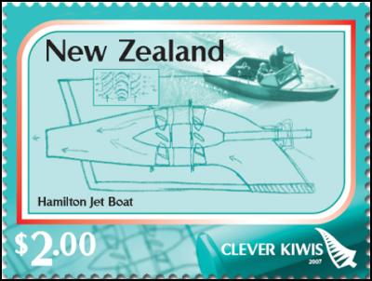
Success Criteria: By the end of the week students will become familiar with six different ways that New Zealanders have contributed to humanity through invention, and they will able to recount the key features of the two Māori inventions.
Lessons 1 to 3
The teacher will hand out the Readings.
Students will take out their Red Books and answer the questions for each of the different readings on inventions. Students will be writing each question out, followed by the answers.
You may work in pairs, but each student must complete the assignment in their own books.
1. Refrigerated Shipping
2. The Buzzy Bee
3. Childproof Lids
4. The Hamburger Holder and Sector Navigation Lights
5. The Kopa
6. Flax Weaving

