Week 5

A Widespread Problem:

Maaori Discrimination Across New Zealand
during the Segregation Era & Beyond

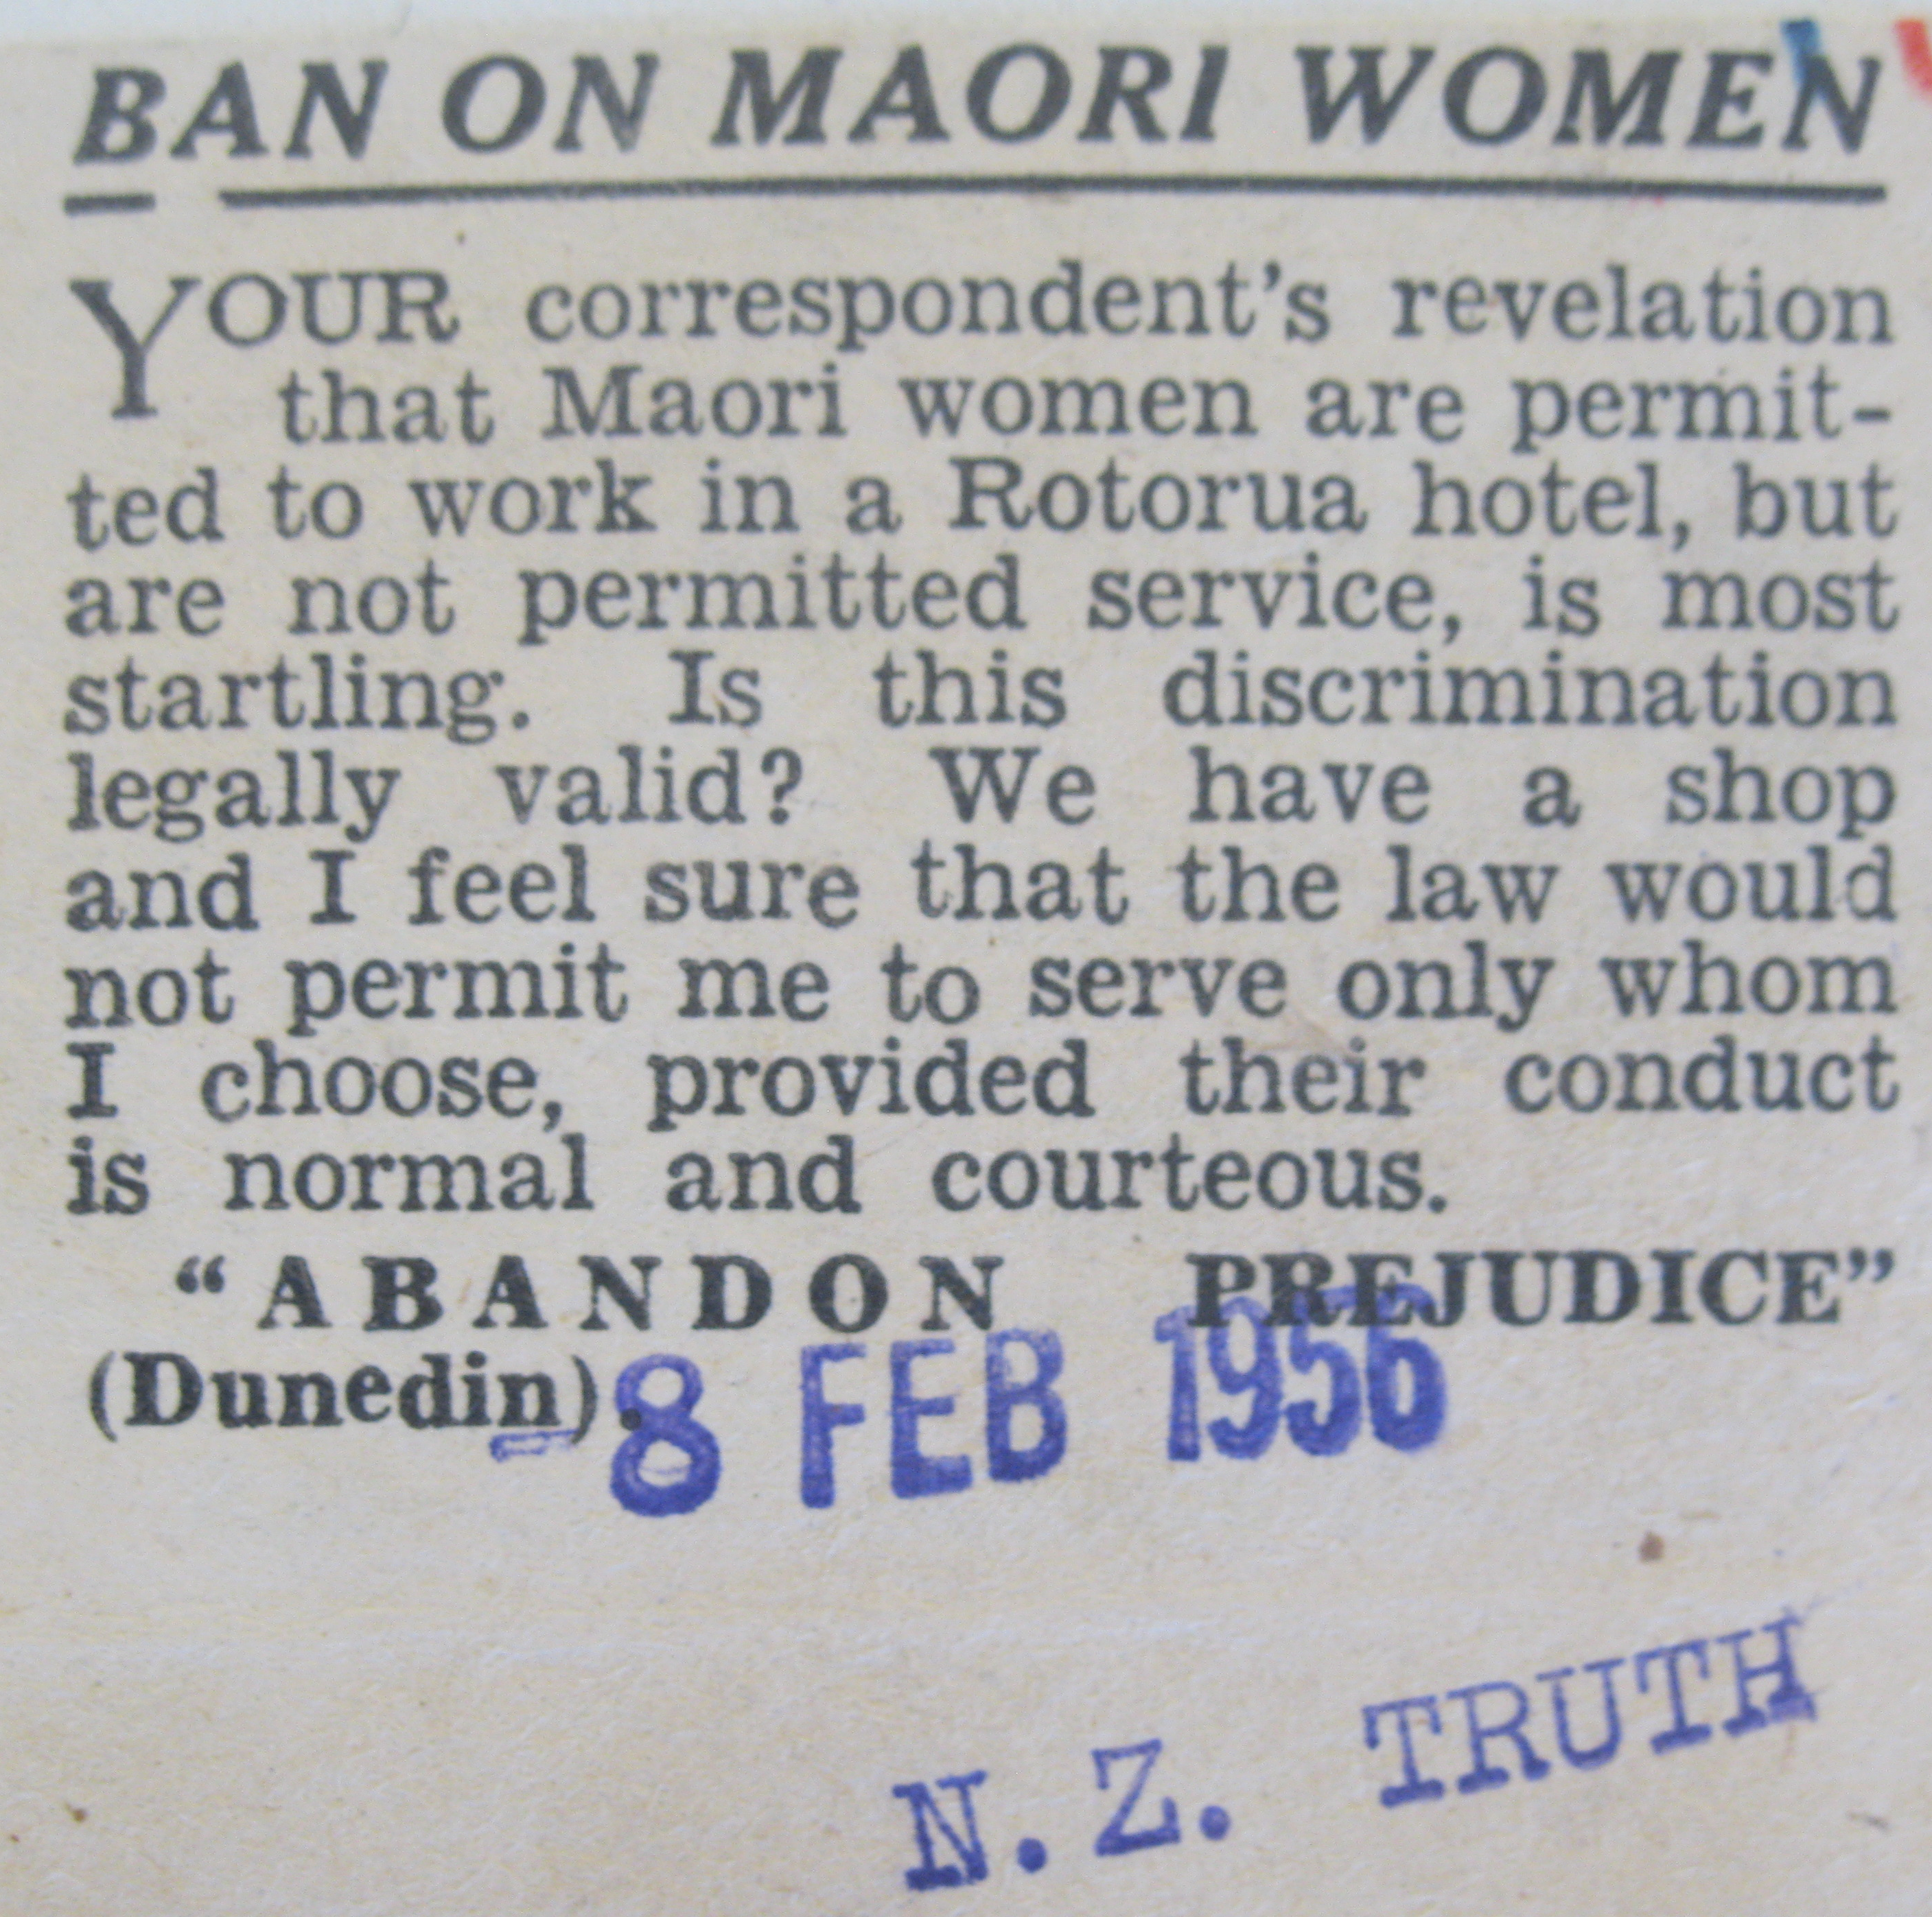

Success Criteria
Students will become familiar with the extent of Maaori racism across New Zealand during the 20th century including cases involving employment, housing, rental accommodation, hospitals, and in general.

Task 1:

In September 1952, an Auckland woman wrote a letter to Ernest Corbett, the Minister of Maori Affairs complaining about Maaori people. Read the letter below. What myths and stereotypes about Maaori were being perpetuated? Break up into groups, read the letter aloud, and discuss.

Sir,

I wish to give my opinion regarding the Maori race in New Zealand. First I wish to say - whilst people in authority in New Zealand boast of equality (sic) Maori and Pakeha - the Maori is absorbing the Pakeha through inter-marriage to an alarming degree. This country will soon be populated by castes and one dar (sic) not think what that will mean. The colour bar should be put into operation at once to save the white race. With all the pensions and benefits under the Social Security Act first means the pakeha is paying for the Maori to procreate as fast as rabbits. Whether one likes it or not one has to associate with Maoris in all walks of life in New Zealand. I have just travelled right through Northland and I return nauseated and fearful for the future. Cheeky arrogant insolent Maoris everywhere - all dressed up in the latest clothes - and definitely predominating in numbers over the pakeha. Very often and most times I was the only white woman in the bus. Distasteful Maori odour and children with dirty noses rubbing them backwards and forwards on the backs of the seats is what the traveller has to put up with. I spoke to one bus driver about it and he just said that their money was as good as mine. One may say that in N.Z. the white people practically have to sleep, that is in beds in hotels that Maoris have just come out of, eat in restaurants at the same tables and in every other walk of life associate with them. There is going to be a penalty for race perversion, and it is almost at the door in inter-marriage and extremely arrogant insolent Maoris and Northland is teeming with them. As I passed by the Kaitaia Hotel on Saturday there were a great many drunk. Maori women scarecely (sic) able to stand up coming out of the hotel. A great amount of easy money from the Social Security fund goes in hard drinking. I think New Zealand should take heed and follow the legislation of Governments of larger countries where they have the colour bar. Why should a small country like N.Z. say that they can get away with no colour bar when much larger countries say that they cannot. The perversion of the white race is a sin and God made all nations to remain as they are. Pandering to Maoris by pakeha has made them an arrogant, too sure of themselves, and pushing, cheeky race – demanding almost that the pakeha feed, clothe and carry them all the way. To go to Northland makes one realise what a push back the Maori needs. ….

Task 2: ‘We Don’t Hire Maaori Here’ – Discrimination in Employment

Read from pages 34 to the top of page 38 in Chapter 3 of We Don’t Serve Maori Here. Answer questions 1 to 3. Be sure to write the heading – ‘Week 4 Lesson 1: ‘We Don’t Hire Maaori Here’and write out the full question and answer in your Red Book.

1. Do you agree with the statement by Nelson Mandela at the beginning of the chapter? Explain your position.

2. What stereotypes (over simplified images or ideas) are present in the reports of Maaori discrimination in employment?

3. Write a summary of the case of BNZ Bank versus Donald Hiki and image it’s the year 1955. Present a case to a judge arguing that Mr Hiki should work in the Huntly branch of the Bank. How would you argue this case? You may also do this in the form of key dot-points.

4. Read the article on the Muslim woman who was denied a job opportunity because of her headscarf at:
https://www.nzherald.co.nz/nz/no-scarf-job-seeker-told-but-jeweller-says-it-was-an-error/NBDG7AR76KP3CHWM4DWE64QDSU/
What stereotypes of Muslims are being perpetuated by wanting the woman to remove her scarf?

Lesson 2: Not Wanted Here – Discrimination in Housing
Read from the bottom of p. 40 to the top of p. 44.

5. What strategies did some hotel and motel owners use to stop Maaori from using their establishments? (pp. 44-46)

6. Describe the negative attitudes that some teachers had for Maaori (pp. 49-50).

7. How were authorities able to determine that Maaori and Pasifika people were being discriminated against when they applied to rent or buy a home? (bottom of p. 42 to the top of p. 44)

8. Judith Macdonald asserts that Maaori accommodation is a self-fulfilling prophesy. Explain (see the second paragraph on p. 43).

9. Read the article below which highlights a recent instance of Maaori discrimination in housing. https://www.rnz.co.nz/news/te-manu-korihi/421864/landlord-racism-wahine-maori-exposes-prejudice-with-name-change

10. Summarise what happened either in a paragraph or using key dot-points. What basic human rights are being violated? What stereotypes of Maaori are being perpetuated in this case?

Lesson 3: Miscellaneous Examples of Discrimination

Conduct an analysis on the section headed, ‘Miscellaneous Examples of Discrimination.’ Split the page in half by drawing a line down the middle. On the left side write the column heading: ‘Discrimination Incident Type,’ and on the right side write ‘Maaori Stereotype.’

Discrimination Incident Type Maaori Stereotype

