When writing a response to text:

What is a personal response to a text?
A personal response is an essay in which the reader describes and analyses your own thoughts and feelings about a reading.
It teaches the reader to think about what they are reading and then respond on why they feel that way.

It is an essay where you write about a particular aspect of a text that you have studied and show your knowledge and understanding of this aspect and why it is important or interesting. Personal responses happen as you read/view your text - you identify parts of texts that you found interesting or enjoyable and, most importantly, explain what they helped you understand about yourself, your peers, family and the world we live in.

What makes a good response to a text essay? Your essay should:
- hav a clear introduction that lets the reader know what text you are writing about and how you are going to address the topic/question in your essay.
- focus on the one aspect that the question/topic is asking you to write about
- make two or three points about this aspect
- contain specific details, quotes or references from the text to support each point
- make clear statements explaining how each point/example links back to the topic and addresses the question

This means your personal response must prove:

‘‘Personal understanding’ = responding to a theme, message or issue that you found interesting or reacted to in the text; showing how it affects us, our society and the world we live in.
‘Supported by evidence’ = including quotes, details and explanations to support your response.
‘Convincing’ = fully explained, developed and well supported.
‘Perceptive’ = deep understanding, insight and/ or originality; able to (quickly) notice and understand things that many other people do not notice, and showing good judgement.
USE TEXAS OR PEDAL TO WRITE WELL-DEVELOPED RESPONSES

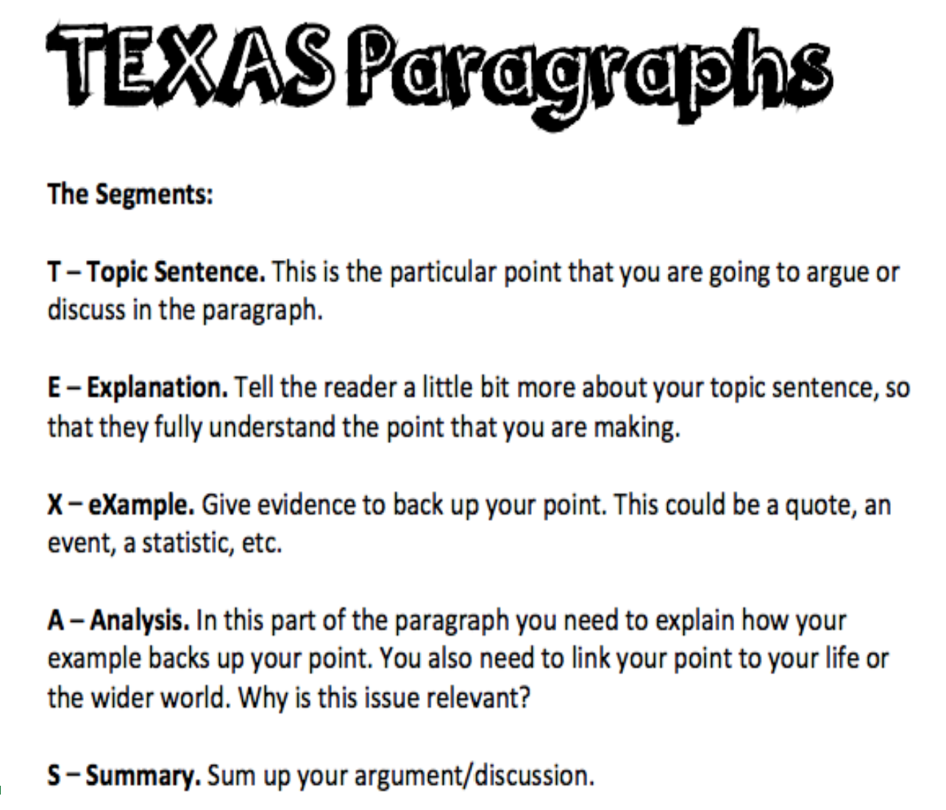
https://slideplayer.com/slide/6175753/ PEDAL explained
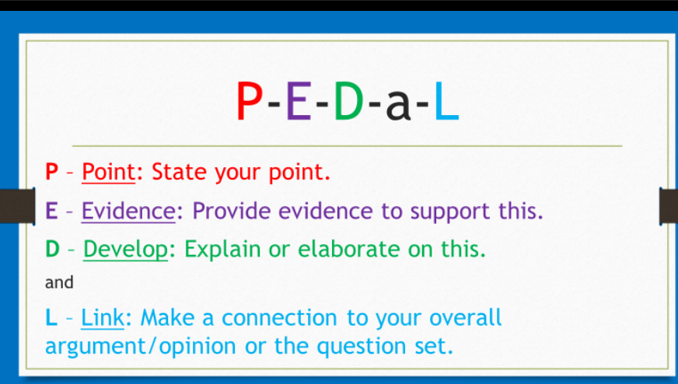

Response to text exemplars:

Student exemplar: response to text (Film ‘The Greatest Showman’)
Describe the beginning of the text. Explain how this beginning helped you to understand at least one idea in the text.
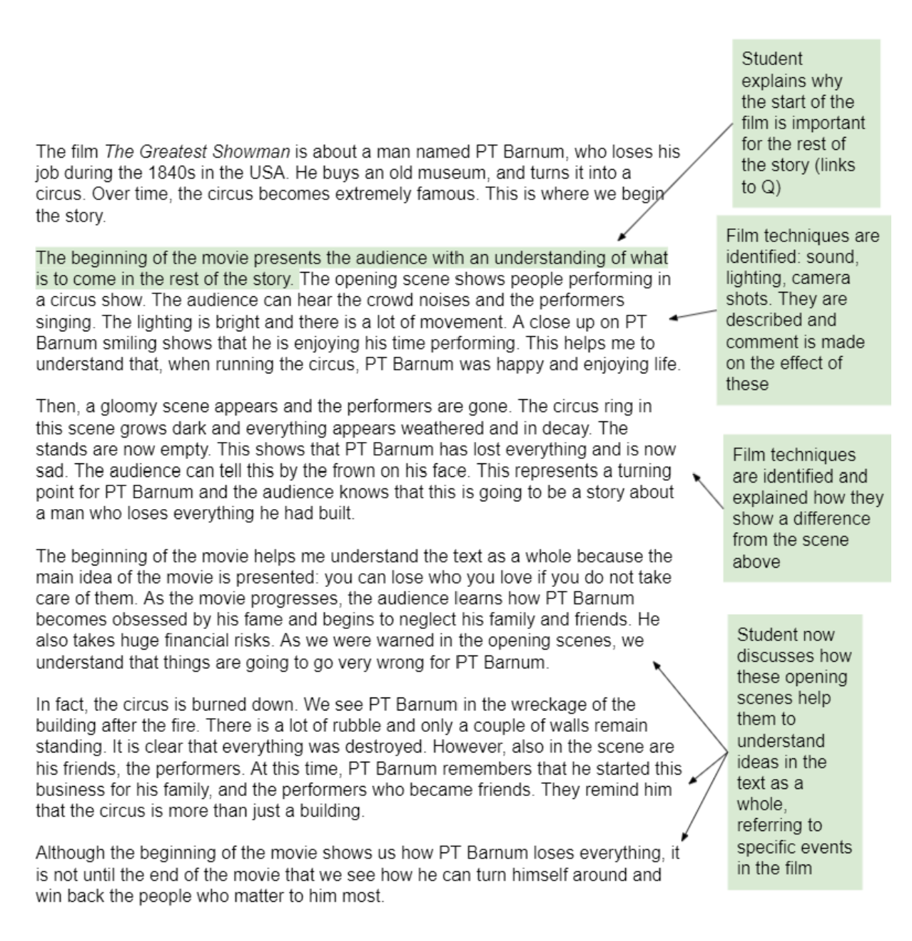

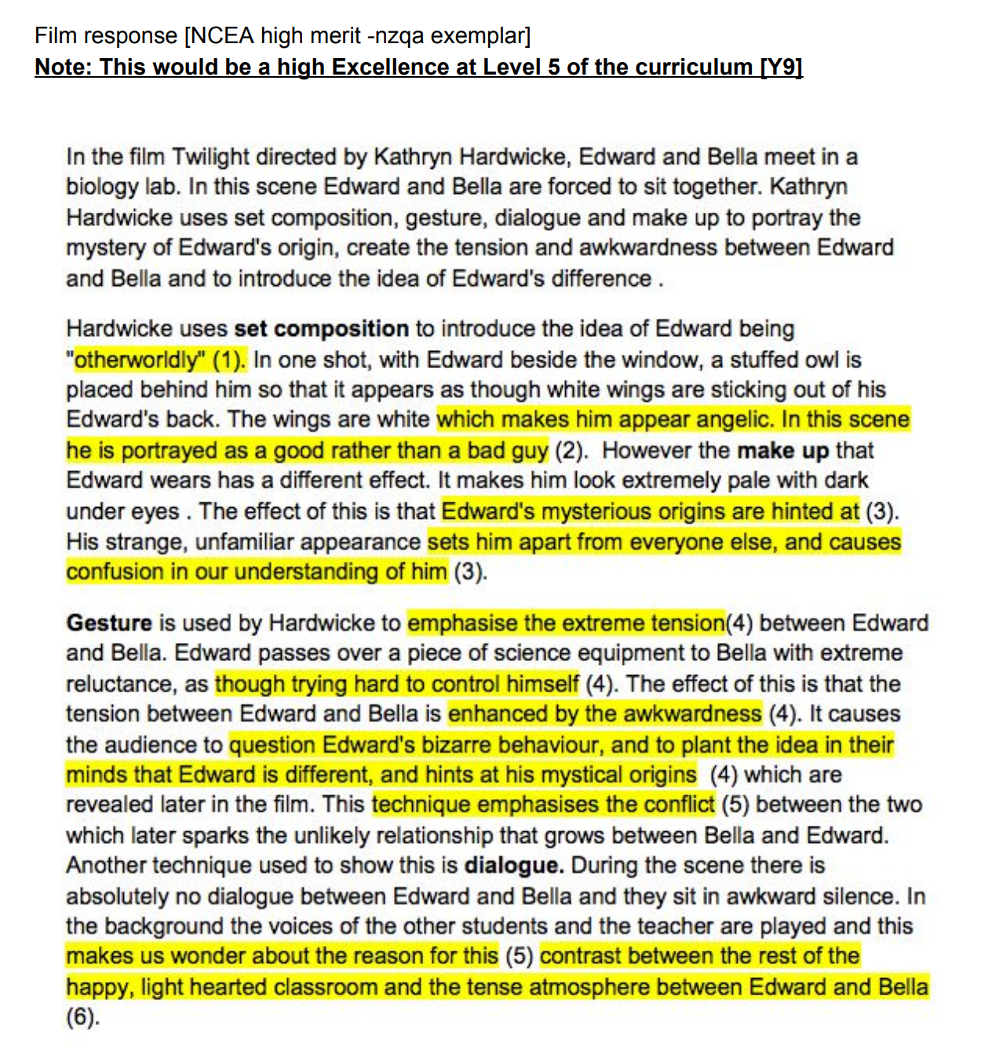
Film response: (NCEA high merit - nzqa exemplar).
Equivalent to BEYOND at L5 of the curriculum

Write a personal response to the character development of a major character and explain the connections you make with this character.

(NCEA exemplar)
Title: Raymond’s Run
Text type: short story
Author: Toni Cade Bambara

Raymond’s Run is a short story about a young girl named Hazel Elizabeth Deborah Parker and her brother Raymond. She is six years old and takes running very seriously. She is proud of being the fastest runner and is very confident about every race she does. As worded in the story "Raymond is not quite right" meaning, he suffers from some sort of disorder. Hazel is very quick off the bat to describe her family, her street and her life. One thing she goes into much detail about is her family and their jobs around the house. Her mum does the housework, her brother runs errands and her father does every bit in between. She does admit in description of her family's jobs that she does not do much other than look after Raymond.

[1]This story is built around strong character development, although this is a short story Hazel grows and develops a lot from beginning to end. In the beginning Hazel talks about girls that pick on her and her brother, “smart mouths”, causing [2]her to form a strong dislike for them. This is relatable in itself as I am very quick to form my own opinions about someone without properly getting to know them, which Hazel does in the beginning. You can see she has very strong opinions especially towards the maypole dance which is done at the fair along with the running race. Her mum really would like her to do the maypole dance and get dressed up, but Hazel has a very strong will against this. She refers to it as a rich girl activity and does not in any way want it to interfere with her running. I think this also relates strongly to me as my mum really wanted me to do ballet when I was younger but I always associated with "girly girls" and I wanted to steer clear of that image. Much like Hazel not wanting it to interfere with her running, when she says “I do not dance on my toes. I run. That is what I am all about”. I did not want it to take over my swimming as that was very important to me.

This story is also more relatable to me on a more personal level as my sister has some struggles of her own and I have been put in situations where I have had to grow up and help out more towards her. When Hazel makes it to her running race she takes Raymond to the stands so he is out of her way to race. When the race is over she notices before anything [3]else that Raymond is running towards her. In this moment she steps out of her own mind and notices that Raymond actually also has a talent for running. She makes links in her mind about how Raymond has always kept up with her, learnt her breathing exercises and is constantly training with her. She then doesn't care about what place she has come but she wants to train Raymond to take the same opportunities she has and run with them. She is jumping up and down not because she has won but because she has new plans not for herself but for Raymond because “I’ve got a roomful of ribbons and medals and awards. But what has Raymond got to call his own?” This makes connections with me as my [4]younger sister has made many milestones, much the same as mine but I was too young and self absorbed to realize how much more of my support would have helped. But as I aged much like Hazel's character development through the story, I take a step out of my own head, making me help out more and more so she can reach the goals she wants to achieve.

[5]I think the way this story is told through Hazel’s eyes, makes for a closer connection to her character. This story is [6]written where it can be linked to many more situations. This story grows with you as you read and makes you form your own opinions to your own aspect in life. Overall I really enjoyed this story as it took me out of my own head and made me think more positively. It was also very interesting to see the similarities Hazel and I both shared at the same age.

Teacher feedback on this response to text:
This student has independently selected and read the short story Raymond’s Run by Toni Cade Bambara as one of the texts required. The student forms a perceptive personal response to the character development of Hazel (1), the narrator in the story. The student reflects, with some insight, on the impact and relevance of the story itself and the way it is has been told.

The student shows convincing understanding of Hazel’s personal likes and dislikes (2). The understanding becomes more meaningful and perceptive after Hazel ‘steps out of her own mind’ (3), causing the student to reflect on her own ‘self absorbed’ nature when she too has learned to ‘take a step out of my own head’ (4). The student recognises that this learning can relate to ‘many situations’ (6).

For a more secure Excellence, the student could, for example, provide examples and further reflect on ‘the way the story is told through Hazel’s eyes it makes for a closer connection to her character’ (5), discuss the significance of the title (Raymond’s Run), and expand on the ‘many situations’ (6).

- What themes/issues consistently make an appearance in Waititi’s NZ focused work? Describe these themes/issues and support your explanation with a minimum of three separate pieces of evidence from the films viewed so far (evidence = quotes, description of scenes, characterisation etc)
PEDAL
P- Taika Waitit’s feature film Boy displays a theme of abandonment and imaginative play.
E- The film is about a boy who awaits the arrival of his father. Boy imagines different fantasies about his father such as he is a master carver, deep sea treasure diver, soldier, captain of the rugby team and holds the record for punching most people with one hand. Boy soon finds out that his father is a far cry from the heroic adventurer he's imagined the man to be.
D- In this film there were also many references made to different cultures. The movie introduces Boy through his love for Micheal Jackson. A long-shot is used when Boy tried doing the moonwalk. The purpose of the long shot was to relate Boy to his surroundings which was his house. Another technique that was used in the film was an over-the-shoulder shot. In that shot there was Boy’s classmate who told Ricky that he had lied claiming his dad is in jail for robbery. That shot was used to frame and to show the emotions of Boy. The emotions on Boy’s face was anger, pain and a feeling of loneliness.
A- This movie draws the importance of imagination and play whilst dealing with difficult issues. “I like to think it is a human story closer to reality in that we see how children cope with these situations, how they make life more bearable” says Taika Waititi. This movie contrasts real life with how children use their imagination to solve their problems.
L- This film displays the struggle between a father and a son, who imagines different fantasies about his father. About a boy who goes through the struggles of abandonment.

P- Two Cars, One Night deals with children left in cars outside a drinking establishment. While they wait for their parents the children create an imagined world between themselves as a way to pass time.
E- The parents of the children leave them outside in the car, so that they could spend their Friday night in a pub/club. The children sit in their cars, see people going in and out of the pub smoking weed and talking. There are two young boys and a girl. What at first seems to be a relationship based rivalry soon develops into a potential friendship.
D- The whole movie is pictured in monochrome, something filmed totally in black and white. Monochrome is usually used for artistic and aesthetic purposes. The monochrome adds a deeper meaning to the film also indicating the film took place some years ago. Another technique that was used was at the start where the time flies by. This creates a feeling that many people can identify with because as a child, a small amount of time can feel like eternity.
A- This film shows the good and the bad effects on children. It shows that joy can be found and friendships can be made even in a short amount of time, in a car park outside a club. This film also addresses the issue of alcoholic parents who don;t pay attention to their kids.
L- Two Cars, One Night is a film that shows a friendship that is developed between two young people.

Describe an important idea in the text.
Text- Hunt for the wilderpeople
Theme- People deserve a second chance.

P-Everyone deserves to have a second chance, the opportunity to grow and to become a better person.
E- Hunt for the Wilderpeople by Taika Waititi is a great example of second chances. In the movie it shows the potential relationship between two characters and how they have been given second chances too, and their potential to become better people.
D-An example of this was shown at the start of the film. Chiaroscuro lighting was used to set a dark vibe of the scene. The lighting highlights all of the bad things Ricky has done and Paula has listed. Despite that Bella is still willing to give Ricky a home and a good relationship. Another example was at the end of the film, where Hector was displayed in warm lighting. The lighting was an aspect of hope for Hector and Ricky to start a new relationship, to give a second chance to each other and to grow.
A- Everyone makes mistakes, but the most important thing is to give them second chances and space to grow. One of the biggest reasons that a second chance is so effective is because it allows them to correct past mistakes and teaches them the importance of a fresh start.
L- Ricky and Hector made mistakes, whether it be graffiting , spitting, lighting up mail boxes or even manslaughter. This movie highlights the importance of second chances that were given to both of them.

TITLE:
Is the title of the novel appropriate? Explain why the book is titled so. If you could rename this book what would you call it and why.

The title ‘Between Us’ Clearly captures the meaning behind the book. The book is titled ‘Between Us’ as it is a story about a young girl and boy and their story of overcoming hardships and obstacles to gain approval of friendship. The title could also be used to describe the friendship that forms between Ana and Jono throughout the course of the book. I believe that the title is a perfect match for the book and that Clare Atkins has encapsulated the true meaning behind the story. This book is about Ana, a teenage asylum seeker who is waiting to gain news about their refugee status. Jono, a teenage boy who is just keeping his head up above the sea of depression that was caused by him losing his Mum and ex-girlfriend to other cities. And Kenny, a Vietnamese-Australian that works as an officer in the detention centre Ana and her family are currently in. The detainees see Kenny as ‘one of the good ones’, but he soon discovers that not only do they seem as that but they also see him as weak. Kenny has to constantly juggle the pressure of being an officer with the pressure of being a single father to Jono who becomes increasingly distant to him. By Clare Atikins naming the book: ‘Between Us’ it helps the reader put themselves in the perspectives of the characters. For instance I were to put myself in the perspective of Ana I could state that there is a lot going on between Kenny, Jono and I, or I could just say there is a lot going on ‘Between Us’.

