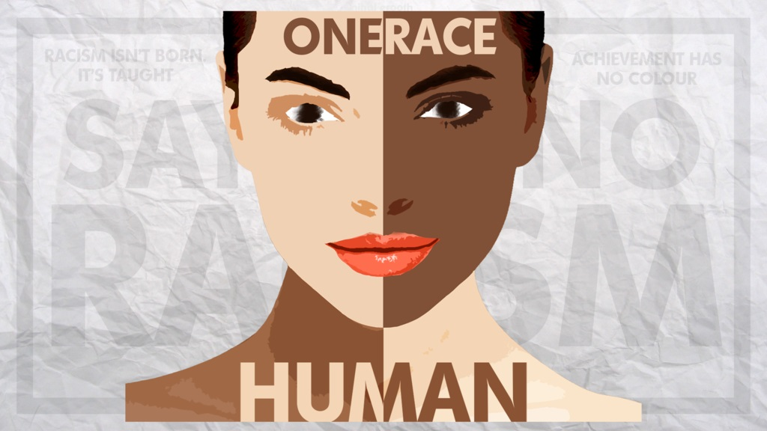

Week 2: Confronting Myths about Racism in New Zealand

Success Criteria
Students will gain an understanding about myths that surround the history of racism in New Zealand. Students will become familiar with key vocabulary on this subject and will be able to recount each the required definitions from Chapter 1.

Activities
1. Class Powerpoint
2. Reading & Writing

Homework
Complete Lessons 1 to 3 by Friday at 3 pm.

Class Discussion:

Without looking in your books – define racism.

Why do people engage in racist behavior?

Can you give me an example of what you believe to have been racist behavior that you have observed?

Have you ever experienced racism while overseas?
What did you observe and why do you believe it constitutes racism?

Which country do you think is more racist – Australia, New Zealand or the United States? Explain your answer?

Lesson 2.1 Understanding the Terminology

Key Definitions

In Chapter 1 of the book, We Don’t Serve Maori Here, write down each of the words in italics in your Red Books. Number them starting with the number 1. At the top of the page, write ‘Definitions for Chapter 1 of We Don’t Serve Maori Here. Be sure to leave at least two spaces between each definition. This will take you the entire period. What you do not finish is homework.

Lessons 2.2 and 2.3

Read Chapter 1 of We Don’t Serve Maori Here. In your Red Books, number and write down the full question and answers to questions 1-3, and 5-13. Just to be clear, I want you to write down the full question, followed by the answers. By the end of today’s class, you should have answered questions 1 to 7. For lesson 3, answer the remaining questions.

1. Why do you think the story of Māori racial segregation has rarely been taught in our public schools until now?
2. “Nazis were made, not born.” What is meant by this statement? See p. 9.

3. How is the notion that there are different races – dangerous?

5. “There is strength in diversity.” Explain.

6. How many different species of humans are there? What about cats and dogs?

7. Give examples of behaviours that are often associated with the following words: racism, racial profiling, scapegoating.

8. How have stereotypes of people of Jewish ethnicity changed over the past 100 years?

9. “Race is a myth, but it is a social reality.” Explain. See pp. 8-12.

10. How can the myth of race negatively impact on student performance?

11. In 1950, which organization issued a statement that race is a myth? Why?

12. Name 5 different ethnic groups, nationalities, and religions.

13. How have stereotypes of people of Jewish ethnicity changed over the past 100 years?

