2024 Student Template Evidence Bank: Growing Greatness Report - Kia Mana Ake - Stage 2

GREAT Learner | Key Focus Areas | Stage 2 Criteria | Quality Evidence - links/screenshots  (likely 2x quality examples with explanation)
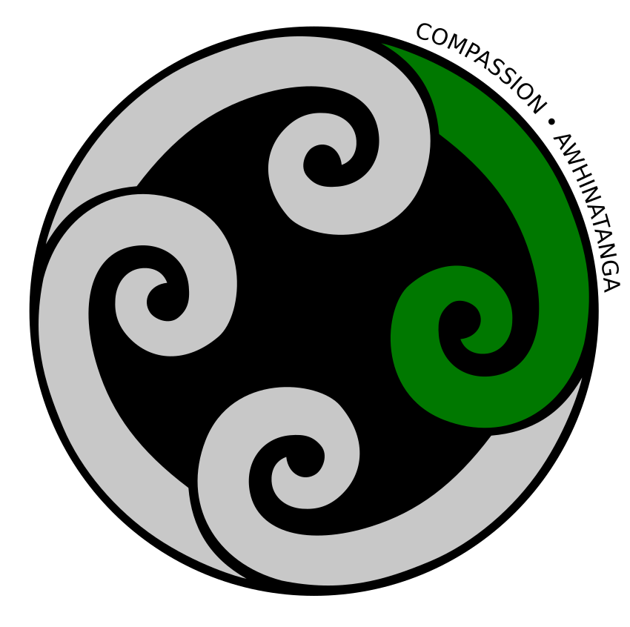  Compassion  Awhinatanga | - Resilient Mindset | I understand that mistakes/ challenges are essential for learning
 | - Positive Partnerships | I regularly share my learning with home and my community
 | - Culturally Connected | I support and participate in Tikanga Māori
  Integrity  Pono | - Active Citizenship | I am a reliable and involved community member
 | - Hauora | I make decisions and take actions that have a positive impact on my Hauora (Wellbeing)
 | - Digital Citizenship | I have a track record of responsible online behaviour therefore keeping myself and others safe
  Learning to Learn  Ako | - Digital Literacy | I use a range of media creation tools
 | - Feedback | I use feedback to take my next learning steps
 | - Brain | I understand how my brain learns and that it can learn in different ways
 | - Thinking & Learning Strategies | I have been guided to use a range of reasoning, evaluation & decision-making strategies
  Life-Long Learner  Wānanga | - GREAT Ako | I can explain my learning using GREAT Ako
 | - Active Learner | I can explain what I am learning and why
 | - The 5Cs | I demonstrate the skills to work collaboratively with others
 | - Active Assessor | I use learning intentions and success criteria (including TAAB) to make learning goals & targets

