Year 10 – Global Studies – Weeks 10 & 11

How Cigarette, Vaping and Alcohol Manufacturers Target Teens & Encourage them to Engage in Ricky Behaviours



Paired Project
Success Criteria
Students will research advertising ploys that manufacturers use to lure teenagers to buy their products and become familiar with key aspects of how they work on a psychological level.

While big corporations commonly claim they do not target teenagers in their advertisements for alcohol, tobacco and vaping, this is clearly not the case. You are to research ways that manufacturers employ experts to make these products attractive to teens.

In 1946, in response to concerns about smoking and lung cancer raised by prominent chest surgeons, the R.J. Reynolds Tobacco Company introduced a print and radio advertising campaign for its Camel cigarette brand, with the slogan ‘More Doctors Smoke Camels.’ Although the company claimed the campaign was based on a survey of 113,597 physicians, the methodology was not described.

Watch the video clip, “More Doctors smoke CAMELS than any other cigarette.” at: https://www.youtube.com/watch?v=5yCaohaECgY

The following ad even appeared in The Journal of the American Medical Association:

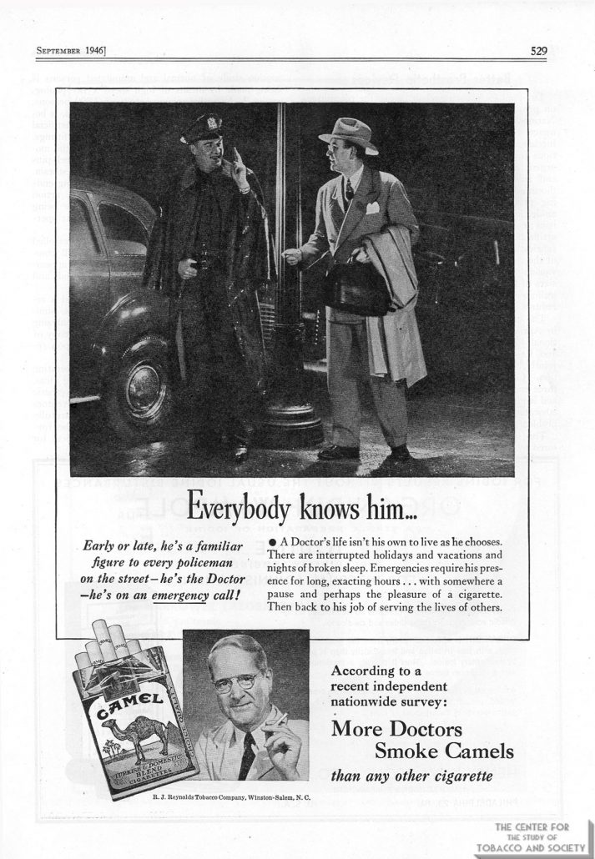

Class Discussion:

What is your reaction to the appearance of such ads given the information that was known at the time about cigarettes causing lung cancer? Should all cigarette ads be banned? What about ads for vaping or alcohol?

Class Project:

Working in pairs, you are going to create a Powerpoint with a maximum of 7 slides that focuses on ONE of the 2 topics above: cigarettes or vaping. You will then create the following slides – each person is to identify which slides they worked on. Both will work on the Introduction slide.

Introduction Slide
Student names, Class and a catchy title. Explain why you chose the title and why it should catch the attention of a teenager.

Student #1
1. Identify and explain an advertising technique that has been used by a big corporation to get teens to buy your chosen product.

2. What evidence is there that your chosen product is harmful and/or addictive to humans?

3. Identify and analyze an advertisement that has been used to market your product to teens.

4. Your Solution.

Week 11– Video Advertisement
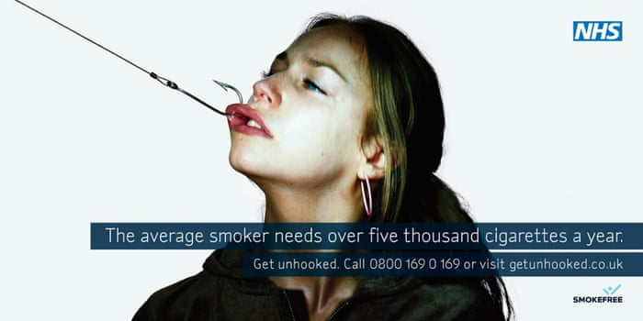
Write and videotape a 1-minute ad that uses some of the same techniques that get people to use your product – but your ad should try to get teens to either stop using it or never start.

Where to find reliable information for each of these products:

Cigarette Smoking:
1. Reading (Excellent - see ‘Methods’ Section)
https://en.wikipedia.org/wiki/Nicotine_marketing

2.https://www.cdc.gov/tobacco/data_statistics/fact_sheets/tobacco_industry/marketing/index.htm

3. https://www.youtube.com/watch?v=hHz_bgj2Rq4

4. https://www.youtube.com/watch?v=6HlSYTQM9xc

5. https://www.youtube.com/watch?v=le_HbIen2b8

6. https://www.youtube.com/watch?v=TbFcJ_L7fE4

1. Vaping
https://www.youtube.com/watch?v=ox-TS2HB62g

2. Reading
https://apcbham.org/2021/06/28/marketing-to-the-youth-of-america-how-e-cigarette-companies-target-young-people/#:~:text=Using%20Emotional%20Appeal%20to%20Attract%20Youth&text=Experts%20have%20found%20that%20all,%2C%20and%2024%25%20used%20success.

3. https://www.youtube.com/watch?v=_iAg2_PQ9o4

(How JUUL Hooked Kids & Ignited A Public Health Crisis)

4. https://www.youtube.com/watch?v=1OPvAsYUrYw

Also search EPIC –
MasterFile,
Australia and New Zealand Reference Centre,
Academic OneFile,
General OneFile,
Health & Wellness

Week 9: Class Presentations



Each group will be presenting their analysis of 2 ads about their chosen product & then they will present their videotaped ‘Solution Ad’ to the class.

