Week 7 Lesson 1:
Current Events – Religions in the News

What is Hinduism?
A Class Discussion

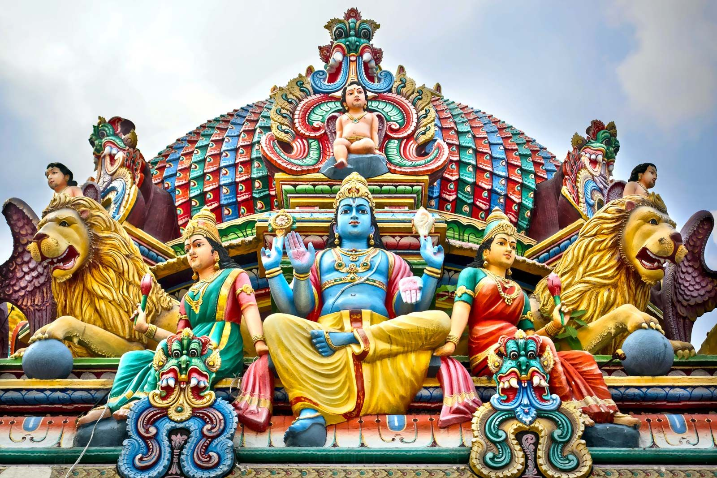Success Criteria: By the end of the lesson students will be able to describe the concept of Hinduism and recount key tenets of this form of religion.
Today’s lesson is focused on Hinduism. As there are hundreds of millions of people who identify as Hindu, today’s lesson will look at basic aspects of Hinduism so we can gain a better understanding of what they believe. As always, it is important to remember that even within Hinduism – as with all the major religions, not every Hindu believes the same thing. In this lesson we will look at the key beliefs held by most people who identify as Hindu.

Class Discussion:
For anyone in the class who does not identify as Hindu – what can you tell me about it? What are some common stereotypes? If any Hindu students wish to add anything – please feel free to do so.

Task: Read the article “What is Hinduism” at: https://www.bbc.co.uk/bitesize/topics/zh86n39/articles/zmpp92p

Task 1: Before you read the article, watch the short video clip at the top of the webpage. Once you have read the article, answer the following questions – please do not copy responses – write in your own words:

Task 2: Questions.

1. Central to Hinduism is the belief in a supreme God called Brahman. Brahman is believed to be everywhere and there is a part of Brahman in everyone. Brahman is believed to take three main forms: Brahma, Vishnu, and Shiva. Describe what these beings listed below, do:
a. Brahma
b. Vishnu,
c. Shiva Brahman

2. List the four Holy texts of Hinduism

3. Explain in a paragraph, how Hindus worship (remember, some Hindus worship differently than others.
Task 3: Take the Quiz – Once you have read the article, take the Quiz near the bottom of the article and see how well you did out of 5 questions.
Task 4: 1. Go to the CIA World Fact Book online by Googling it online. Then go to the section on New Zealand. Next click into the category ‘People & Society” and look under the heading “Religions.”

According to the Fact Book, what percentage of Kiwis identify as Hindu?

Task 5: Watch the clip titled “What Is Diwali and How Is It Celebrated?”

https://www.youtube.com/watch?v=VtMwjW6Gzqs

Write a paragraph summarizing Diwali.

Lesson 2:

Current Events – Religions in the News
What is Buddhism?
A Class Discussion
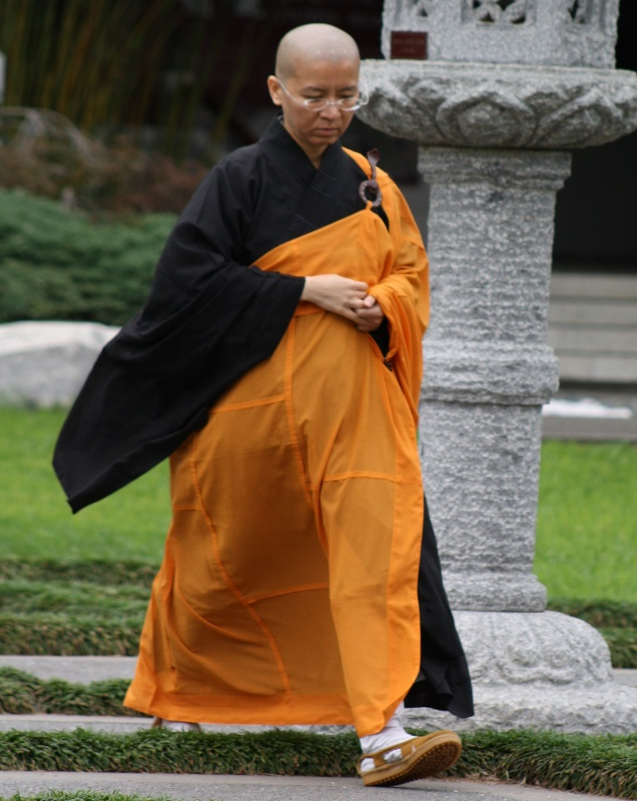

Success Criteria: By the end of the lesson students will be able to describe the concept of Buddhism and recount key tenets of it.

Many students at Mission Heights will know that just down the road there is a Buddhist Temple. Some students at school will belong to families that practice Buddhism. It is important to note that not all Buddhists believe the same thing or worship the same way, however, let’s gain a better understanding of this way of life by examining what many Buddhists believe.

Class Discussion:

What do students know about Buddhism? What are some common stereotypes? If any Buddhist students wish to add anything – please feel free to do so.

Task 1: Watch the video clip titled, “History of The Buddha for Kids” at:

https://www.youtube.com/watch?v=RPxMdHCPTGM

Task 2: Now read the following article below and answer the questions:

What do Buddhists believe?
Adopted from two articles produced by the British Broadcasting Corporation (https://www.bbc.co.uk/bitesize/articles/zmcsmfr) and (https://www.bbc.co.uk/bitesize/topics/zh4mrj6/articles/zdbvjhv)

Buddhism is the name of the religion, and its followers are known as Buddhists.
Buddhists follow the teachings of the Buddha, which means 'enlightened one'. The Buddha was a man called Siddhartha Gautama, who is said to have lived nearly 2,500 years ago in India.
Today there are around 376 million Buddhists living around the world.
Siddhattha Gotama was a prince who lived a life of luxury. When he was 29, Siddhattha went outside his palace and saw people suffering for the first time.
He decided to leave his palace and live among holy men in search of truth. His search took him six years, but he became enlightened while meditating under a fig tree.
Following this, Siddhattha became known as the Buddha, which means the 'awakened' or 'enlightened' one. From then on, he dedicated his life to spreading his teachings.
The Buddha discovered that the answer lay in what have become known as the Four Noble Truths. Buddhists try to achieve enlightenment by understanding these important principles.
Buddhists try to live a good life by following the Buddha's teachings, helping them to avoid suffering and bad feelings. They believe nothing in life is perfect and the way to avoid suffering is to follow a set of important guidelines known as the Noble Eightfold Path.

Buddhism in pictures
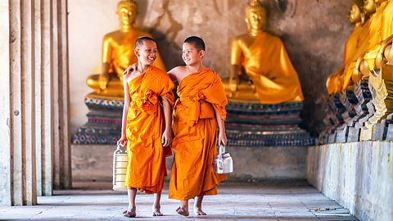
Buddhist monks
Young boys are able to leave home and join Buddhist monasteries as a samanera (novice monk). They can become monks at the age of 20. Young Buddhist girls can train to become nuns.
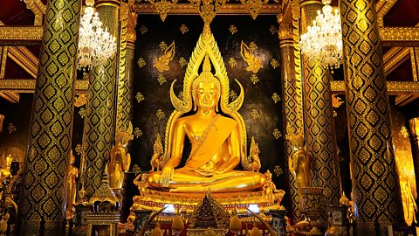
Statues of the Buddha
Wat Phra Si Rattana Mahathat is a Buddhist temple in Thailand. It is famous for its gold sculpture of the Buddha. The pose of the statue celebrates the moment that the Buddha achieved enlightenment.
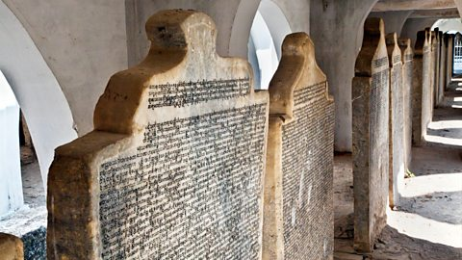
The Tripitaka
Kuthodaw Pagoda is a Buddhist stupa in Myanmar. It houses over 700 slabs inscribed with the Tripitaka. Each slab is 1.5 m tall and together they form what some people think may be the world’s largest book!
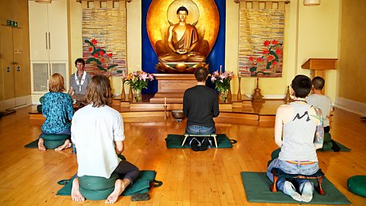
Meditation
This photograph shows people meditating at the London Buddhist Centre. Buddhists believe that meditation is crucial to understanding the cause of suffering. It is a way to clear the mind of worries and fears.
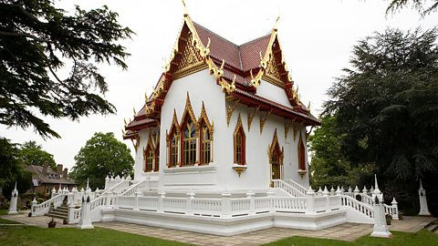
A Buddhist temple
Wat Buddhapadipa is in Wimbledon, London. It opened in 1976 and was the first Thai Buddhist Temple to be built in the UK. It is home to both monks and nuns.

What is the Buddhist holy book?
The Buddhist scriptures are known as the Tipitaka which means 'three baskets'. This is because the original writings were made on palm leaves and stored in baskets.
The Tipitaka contains the teachings of the Buddha and his companions, comments on those teachings, as well as rules for monks. Buddhists call the teachings of the Buddha dharma which means ‘truth’.

Where do Buddhists worship?
In Buddhist countries there are many temples. People bring flowers and incense for the shrine and food for the monks.
When entering a temple, Buddhists will take off their shoes, put their hands together and bow to the image of the Buddha. They may also use prayer beads called malas.
Some Buddhists may also have a shrine within their home too.

Task 3: Working in groups of 2 to 5, create a series of dot-points on the reading and based on the video clip, focusing on key aspects of Buddhism.

Task 4: Define the following key words:

1. Buddha
2. Karma
3. Nirvana
4. Meditation

Lesson 3: Current Events – Religions in the News

What is Islam?
A Class Discussion
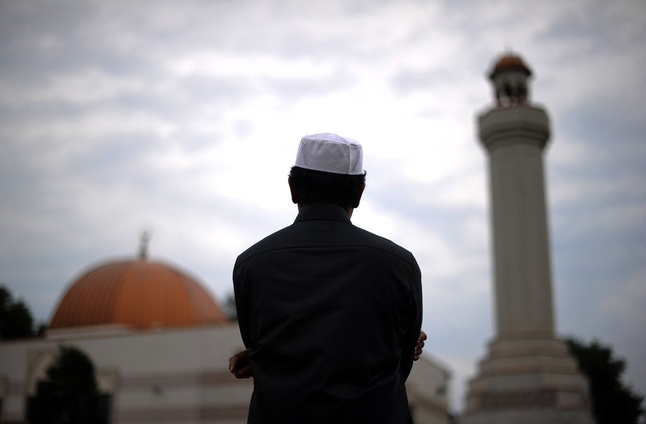

Success Criteria: By the end of the lesson students will be able to describe the five pillars of Islam and be able to recount other basic tenets of this major religion.

Islam is one of the major religions in the world with over a billion people who identify as Muslim. Many news stories involve Muslims and religious beliefs. As so many people identify as Muslims, we are going to devote a class period to better understanding what Islam is. It is also important to note that there are many different beliefs within Islam – not everyone believes the same thing.

Class Discussion: What do students know about Islam? What are some common stereotypes? Are there any Muslim students in class who would like to contribute to the discussion?

Task: Write down the word ‘stereotype’ into your Red Books along with the definition below from the Oxford Dictionary:

Stereotype: “a widely held but fixed and oversimplified image or idea of a particular type of person or thing.”

Read the following article: “What is Islam” by the BBC (British Broadcasting Corporation) at:
https://www.bbc.co.uk/bitesize/topics/zpdtsbk/articles/zrxxgwx

Poster Assignment

After reading the article, create a one-page poster in your Red Book titled: “This is Islam.” The purpose of the poster is to introduce Islam to people who know little about it. Include 1 image (hand drawn) and many key dot-points. DO NOT COPY WORD FOR WORD – re-word the information. Place you dot-points under the following headings: be sure to include the following words – The Qur'an, Imam. Mosque, Makkah, the Five pillars of Islam.

What is Islam?

The word 'Islam' in Arabic means submission to the will of God.
Followers of Islam are called Muslims. Muslims believe there is one true God Allah (the Arabic word for God).
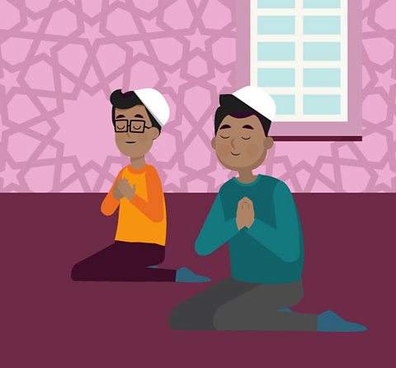

What do Muslims believe?
Muslims believe that Islam was revealed over 1,400 years ago in Mekkah, Arabia through a man called Muhammad.
Muhammad is so respected that it is usual for Muslims to say 'peace be upon him' whenever they mention his name.
Muhammad is believed by Muslims to be the last prophet sent by God (Allah). They believe God sent prophets to mankind to teach them how to live according to His law.
Jesus (Isa), Moses (Musa) and Abraham (Ibrahim) are other respected prophets.

Five Pillars of Islam
The Five Pillars of Islam are an important part of Muslim life. They are five things that a Muslim must do so they can live a good and responsible life. They include:
- The declaration of faith (Shahada)
- Praying five times a day (Salat)
- Giving money to charity (Zakah)
- Fasting during the month of Ramadan (Sawm)
- A pilgrimage to Makkah at least once in a lifetime (Hajj)

What is the holy book of Islam
The Muslim holy book is called the Qur'an. Muslims believe this to be the word of Allah as dictated to Muhammad.
They also have the Sunnah, which Muslims believe to be the practical example of Prophet Muhammad.
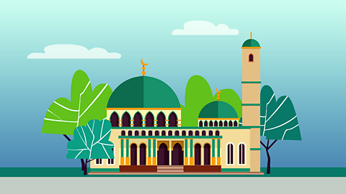

Where do Muslims worship?
Muslims worship in a building called a mosque. On Friday at noon, the most important of the weekly services is held. When Muslims pray, they must always face Makkah in Saudi Arabia. Many Muslim men will wear a small cap called a taqiyah when they pray.

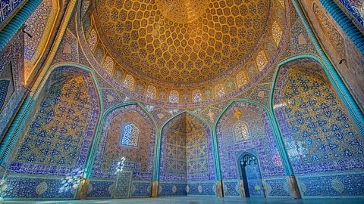
Mosque
Mosques are places of worship for Muslims all over the world. Mosques usually have rules like leaving shoes outside and dressing modestly.

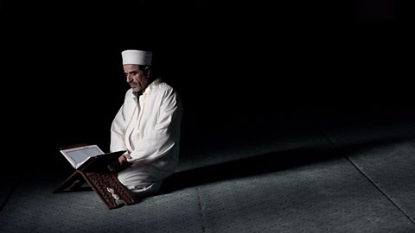
Imam
Imams lead worship in a mosque and are important community figures. They are there to offer spiritual guidance and life advice for the Muslims in their community.

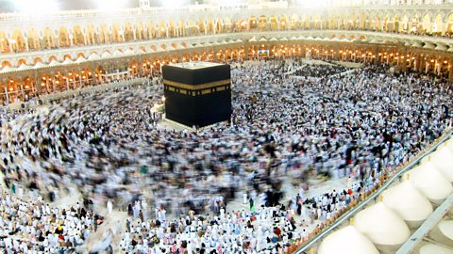
Makkah
Makkah is the holiest city in Islam. It is Muhammad’s birthplace and also the place the Qur'an was revealed. Hajj is a huge yearly pilgrimage to Makkah, attracting several million Muslims from all over the world. All Muslims (as long as they are healthy and able to travel) try to do Hajj at least once in their life.

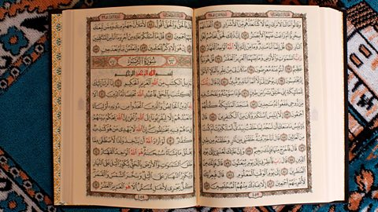
The Qur'an
The Qur'an is the most important book in Islam. Muslims believe it was revealed to Muhammad by Allah (God) through the Angel Jibreel. It has details on the existence of Allah, morality, and historical events.
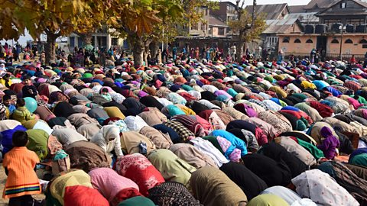
Salah (prayer)
Salah (or prayer) is very important to Muslims. Many Muslims pray five
times a day and they must be facing the direction of Makkah.

