Year 10 – Week 6 Lessons 1 & 2
Peer Pressure & Vaping


Success Criteria: Students will be able to recognize the risk factors that predispose teenagers to engage in vaping and the short and medium-term impact on their mental and physical health of those who engage in such actions.

Lesson 1, Task 1: Go to the website – ‘The Facts of Vaping’ at: https://vapingfacts.health.nz/the-facts-of-vaping/

In your Red Book write Week 6 Lessens 1 & 2 – Vaping, Health & Peer Pressure.

Task 2: Scroll down the page and click on ‘TAKE THE QUIZ.’
How well did you score out of 10? ____

Class Discussion: How did people score? How prone do you feel you are to doing something you do not want to do as a result of peer pressure?

Task 3: Watch the video with Dr. Murray Winiata and answer the following questions:

1. What is the biggest drawback to vaping? (1:20 sec. mark)

2. Does an E-cigarette produce smoke? (1:30 sec.)

3. Why is vaping effective in getting people to quit smoking? (1:50 sec.)

Click into the section on ‘Vaping and Pregnancy.’ Answer the following question:

4. What are the risks to pregnant mothers and their unborn child from vaping?

Click into the section on ‘Side Effects of Vaping.’ Answer the following questions:

5. List the various health complaints that can arise from vaping.

Task 4: Read the article, ‘Peer pressure at school influencing teen vape use’ at: https://www.news-medical.net/news/20191001/Peer-pressure-at-school-influencing-teen-vape-use.aspx

1. According to a new study, _______s play a major role in the sudden surge of e-cigarette use among teens.

2. A major problem with E-cigarettes is that teens often become addicted to ____________.

3. In what way is nicotine considered harmful?

4. Young people attending schools with high rates of vaping are more likely to believe that e-cigarettes are _____- ______ and less __________ than traditional cigarettes, regardless of if they smoke or not.

5. In which year did vaping rates soar in schools and why?

Task 5: Watch the video on Vaping and Peer Pressure at:
https://www.youtube.com/watch?v=LIyzUVfJpN4

Based on the video, write down at least 6 key dot-points:

1. Simah Herman was so addicted to vaping that she vaped at least every 15-minutes.
2.
3.
4.
6.

How do vaping companies use marketing and peer pressure to get more teenagers to vape?

Current Event
What is Christianity?
A Class Discussion


Success Criteria: By the end of the lesson students will be able to recount key information about Christianity in New Zealand, fundamental tenets of the religion, and be able to identify the names of some of the major branches.

Many Kiwis identify as Christians. It comprises the biggest single religious group in New Zealand, therefore it makes sense to have a better understanding of what is meant by Christianity. It is also important to observe that Christianity – like all religious groups, is comprised of a wide range of ideas and beliefs. Hence, there are many different branches of Christianity with which may have very different beliefs from one another. In this lesson we will look at the key beliefs held by the majority of people who identify as Christian.

Class Discussion: How would you define Christianity? What are some basic things that most people who identify as Christians, would believe? What are some common stereotypes? If any students who identify as Christian students wish to add anything – please feel free to do so.

Video: Watch the National Geographic clip “Christianity 101” (3:41 sec.)
https://www.youtube.com/watch?v=LvL3YXa0n2M

*Before you do, remember – ‘Millenia’ means a thousand years.
A ‘sect’ = a very small religious group
New Testament: the part of the Bible that discusses the life and teachings of Jesus Christ.

Answer the following questions based on the video clip:

1. Look up the word ‘monotheism.’ What does it mean?

2. Who do Christians believe is the son of God?

3. The Christian religion began about _____ years ago in the province of _____ in the Middle East.

4. The information about the early days of Christianity comes from 4 books called the _________ and were believed to have been written by four different people: ______, ______, _______, and __________.

5. According to the history of Christianity, Jesus had a father by the name of _________, and a mother named _______.

6. What job did Jesus have up to the age of 30?

7. According to the Gospels, the body of Jesus rose from the dead.

Task 2: Read the article below from the BBC, “What is Christianity?” and write down key dot-points into your Red Books under the heading ‘What is Christianity?”

What is Christianity?

Christianity is focussed on the life and teachings of Jesus Christ, who Christians believe to be the Son of God. Jesus was born in Bethlehem in the Middle East over 2,000 years ago.
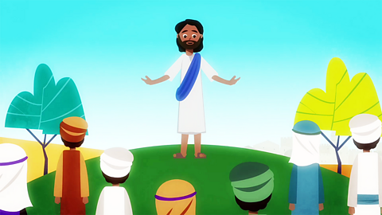

What do Christians believe?
Christians believe there is only one God, but that he is revealed in three different forms:
- God the Father
- God the Son
- The Holy Spirit
Christians model themselves on the life and teachings of Jesus Christ. Jesus taught people to love God and love their neighbour.
Christians believe that God sent Jesus to live as a human being in order to save humanity from the consequences of its sins - the bad things humanity had chosen to do which had separated them from God.
Christians believe that through the death and resurrection of Jesus this broken relationship with God is restored.
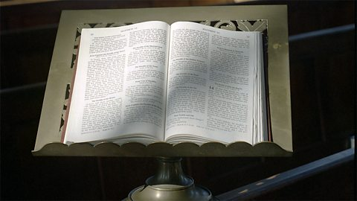

What is the Christian holy book?
The Christian holy book is the Bible. It is divided into the Old and New Testaments.
The New Testament explains how God sent his only son, Jesus Christ, to restore the broken relationship between people and God which had been caused by human wrong-doing.
Jesus was executed on a cross (Crucifixion) as a criminal by the Romans, and according to Christian teaching after three days he rose from the dead (the Resurrection).

Where do Christians worship?
Many Christians worship in churches. Some groups meet in homes and other buildings. 'Church' means the gathering of Christians as well as the building in which Christians worship. Their leaders are called priests or ministers.
Many churches hold a service called Communion, in which bread and wine are shared together, just as Jesus did with his followers before his death.

Task 3: Answer the following questions in your Red Books:

1. Go to the CIA World Fact Book online by Googling it online. Then go to the section on New Zealand. Next click into the category ‘People & Society” and look under the heading “Religions.”

1a. What percentage of Kiwis identify as Christian?

1b. List the top six types of Christianity in New Zealand.
Write the following definitions into your Red Book:

