Week 6: More Water Controversies

Lessons 1 & 2:

Sports Drinks Vs Energy Drinks Vs Plain Water

Do You Really Need to Drink Powerade to Replenish Lost Electrolytes? Probably Not


Sports and Energy drinks versus Water
Which is Better?

Success Criteria: By the end of the week students will be able to recount key differences and health impacts of sports drinks versus energy drinks versus plain water. In terms of the current event, students will be able to name the fundamental tenets of Christianity, and be able to identify the names of some of the major branches.

Go to the EPIC Database and click into the Australia and New Zealand Reference Centre.

Next, type in ‘sports drinks and health.’ Collect at least 3 articles for each topic and place them into a folder on your desktop. Read some of the relevant articles. Compare the health benefits and negatives for each three:

Benefits

Sports Drinks Energy Drinks Water

Negatives

Sports Drinks Energy Drinks Water

Task:

Which do most experts believe is better and why. Explain below in a paragraph.
Current Event: Religion in the News
What is Christianity?
A Class Discussion

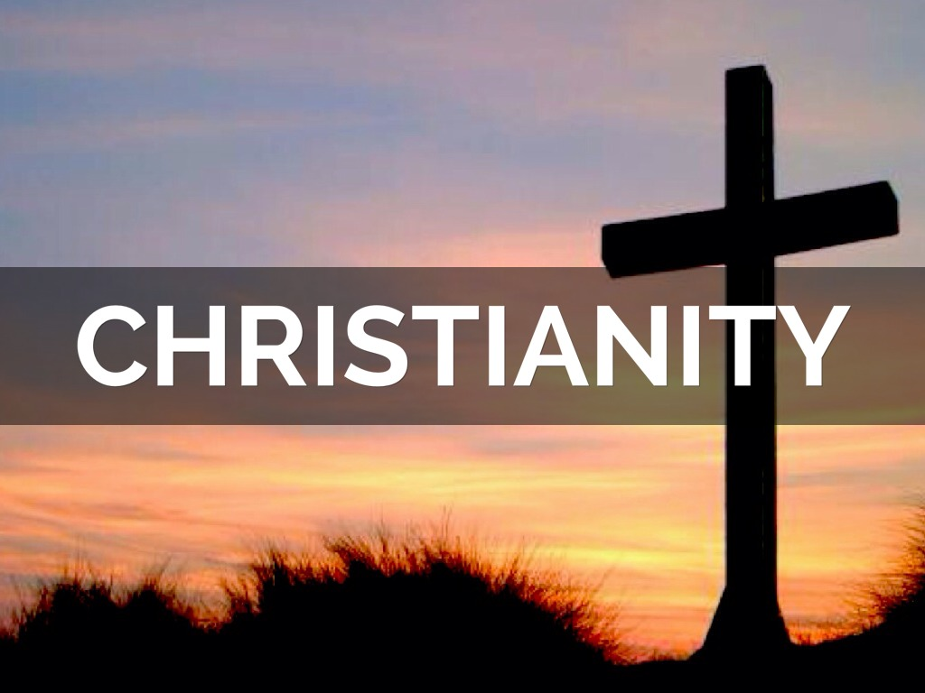

Success Criteria: By the end of the lesson students will be able to recount key information about Christianity in New Zealand, fundamental tenets of the religion, and be able to identify the names of some of the major branches.

Many Kiwis identify as Christians. It comprises the biggest single religious group in New Zealand, therefore it makes sense to have a better understanding of what is meant by Christianity. It is also important to observe that Christianity – like all religious groups, is comprised of a wide range of ideas and beliefs. Hence, there are many different branches of Christianity which have very different beliefs from one another. In this lesson we will look at the key beliefs held by a majority of people who identify as Christian.

Class Discussion: How would you define Christianity? What are some basic things that most people who identify as Christians, would believe? What are some common stereotypes? If any students who identify as Christian students wish to add anything – please feel free to do so.

Video: Watch the National Geographic clip “Christianity 101” (3:41 sec.)
https://www.youtube.com/watch?v=LvL3YXa0n2M

*Before you watch, remember – ‘millenia’ means a thousand years.
A ‘sect’ = a very small religious group
New Testament: the part of the Bible that discusses the life and teachings of Jesus Christ.

Answer the following questions based on the video clip:

1. Look up the word ‘monotheism.’ What does it mean?

2. Who do Christians believe is the son of God?

3. The Christian religion began about _____ years ago in the province of _____ in the Middle East.

4. The information about the early days of Christianity comes from 4 books called the _______s and were believed to have been written by four different people: ______, ______, _______, and ______.

5. According to the history of Christianity, Jesus had a father by the name of _________, and a mother named _______.

6. What job did Jesus have up to the age of 30?

7. According to the Gospels, the body of Jesus rose from the _____.

Task 2: Read the article below from the BBC, “What is Christianity?” and write down key dot-points into your Red Books under the heading ‘What is Christianity?” *The article has been modified by Mr B. to make it easier to read.

What is Christianity?

Christianity is focused on the life and teachings of Jesus Christ, who Christians believe to be the Son of God. Jesus was born in Bethlehem in the Middle East over 2,000 years ago.
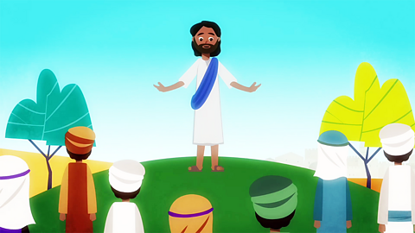

What do Christians believe?
Christians believe there is only one God, but that he is revealed in three different forms:
- God the Father
- God the Son
- The Holy Spirit
Christians model themselves on the life and teachings of Jesus Christ. Jesus taught people to love God and love their neighbour.
Christians believe that God sent Jesus to live as a human being in order to save humanity from the consequences of its sins - the bad things humanity had chosen to do which had separated them from God.
Christians believe that through the death and resurrection of Jesus this broken relationship with God is restored.
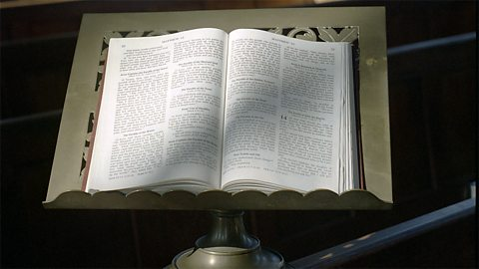

What is the Christian holy book?
The Christian holy book is the Bible. It is divided into the Old and New Testaments.
The New Testament explains how God sent his only son, Jesus Christ, to restore the broken relationship between people and God which had been caused by human wrong-doing.
Jesus was executed on a cross (Crucifixion) as a criminal by the Romans, and according to Christian teaching after three days he rose from the dead (this is known as the Resurrection).

Where do Christians worship?
Many Christians worship in churches. Some groups meet in homes and other buildings. 'Church' means the gathering of Christians as well as the building in which Christians worship. Their leaders are called priests or ministers.
Many churches hold a service called Communion, in which bread and wine are shared together, just as Jesus did with his followers before his death. In some churches, grape juice is used in place of wine.

Task 3: Answer the following questions in your Red Books:

1. Go to the CIA World Fact Book online by Googling it online. Then go to the section on New Zealand. Next click into the category ‘People & Society” and look under the heading “Religions.”

1a. What percentage of Kiwis identify as Christian?

1b. List the top six types of Christianity in New Zealand.
Write the following definitions into your Red Book:

Task 4: Basic vocabulary words:

1. Crucify

2. Resurrect

3. Communion

