Week 5 Global Studies

Pressure to Conform



Two Famous Studies and What they Mean for Teenagers
and Obedience to Authority

Success Criteria
Students will become familiar with two well-known studies in the history of the psychology of conformity – the Hofling Experiment and the Bickman study and the factors involved in why people are vulnerable to peer pressure or the pressure to conform brought on by the power of the situation.

This week’s Lessons:

Lesson 1. Current Events Analysis on the threat to New Zealand from Feral Cats

Lesson 2. Obedience and Conformity – the Bickman Study

Lesson 3. The Hofling Experiment

Week 5 Lesson 1:

Obedience to Authority

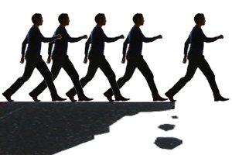

Psychologist Leonard Bickman investigated the effect of situational factors on the likelihood of obedience – specifically with regards to clothing worn by a person. He conducted a field experiment in Brooklyn, New York, using people walking on a street. He found that wearing a uniform gives authority a greater power to influence people's behaviour than not wearing a uniform. However, to affect levels of obedience, the uniform has to reflect a high degree of social power.

Task 1: Watch the video clip ‘Obedience: Obeying a man in uniform.’ It is narrated by Phillip Zimbardo, the former head of the American Psychological Association. https://www.youtube.com/watch?v=16QMQXIjYVU (4:22 Sec.)

Class Discussion: How surprised were you at how readily people were willing to obey another person based solely in what they were wearing? Do you think that you would have obeyed?
Task 2: Now watch the second clip: How obedient are you?
https://www.youtube.com/watch?v=4jcleVvgchs (3:50 sec.)

Task 3: Read the article, ‘How Obedient are You’ by Radhika Sanghani from the BBC, 16 November 2017.

Write key dot-points about article and what they experiment shows.

Week 5 Lesson 2

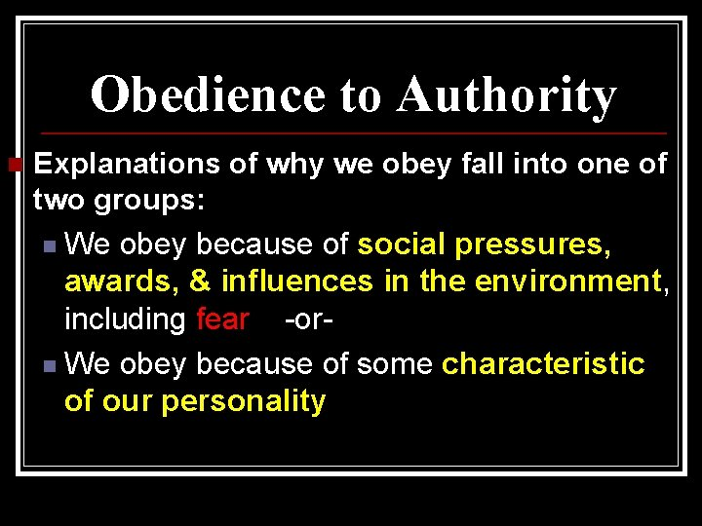

In 1966, psychiatrist Charles Hofling created a more realistic study of obedience than Milgram’s electric shock study by carrying out field studies on nurses who were unaware that they were involved in an experiment. In the natural hospital setting, nurses were ordered by unknown doctors to administer what could have been a dangerous dose of a drug to their patients. What would you have done?

Task 1: Watch the clip on the Hofling study:
https://www.youtube.com/watch?v=CDGZ9Ky4O8I (5:25 sec.)

Task 2: Read ‘The Hofling Nurse Study’ (February 2022) at: https://practicalpie.com/the-hofling-nurse-study/

In your Red Books, write down and answer the following questions that appear under the follow sections of the reading:
https://www.bbc.co.uk/bbcthree/article/098290e8-e675-444e-85b1-934ca9ae6c72
You do not need to write down the headings, just the questions and responses.

What Is the Hofling Nurse Study?
1. What experiment was Hofling trying to replicate?

How Did the Hofling Nurse Study Work?
2. What was Astroten?
3. How many people were involved in the study? What was their job?
4. What was written on the drug container?
5. What were the many reasons that the nurses should have declined the request to give out the drug?

The Results of the Hofling Hospital Study
6. How many nurses complied with the request?
7. In what way did these results parallel the findings of Stanley Milgram?

Current Event #3
What is Islam?
A Class Discussion & Assignment
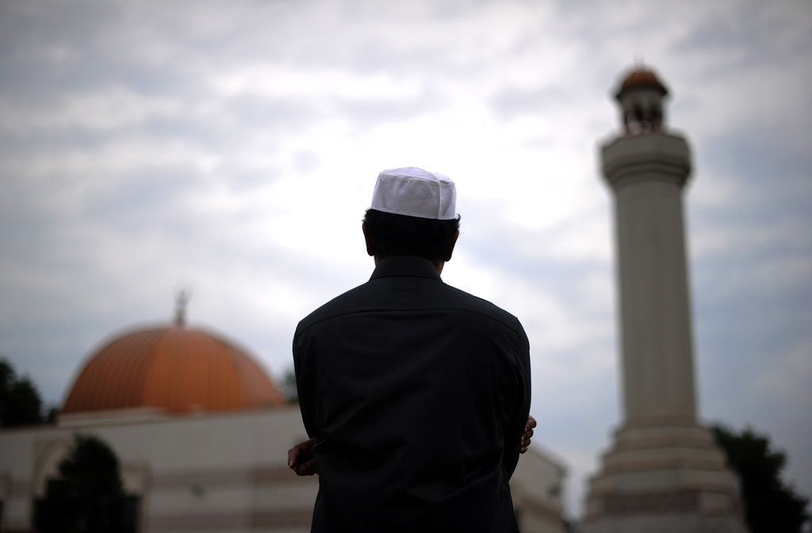

Success Criteria: By the end of the lesson students will be able to describe the five pillars of Islam and be able to recount other basic tenets of this major religion.

Islam is one of the major religions in the world with over a billion people who identify as Muslim. Many news stories involve Muslims and religious beliefs. As so many people identify as Muslims, we are going to devote a class period to better understanding what Islam is. It is also important to note that there are many different beliefs within Islam – not everyone believes the same thing.

Class Discussion: What do students know about Islam? What are some common stereotypes? Are there any Muslim students in class who would like to contribute to the discussion?

Task: Write down the word ‘stereotype’ into your Red Books along with the definition below from the Oxford Dictionary:

Stereotype: “a widely held but fixed and oversimplified image or idea of a particular type of person or thing.”
Read the following article: “What is Islam” by the BBC (British Broadcasting Corporation) at:
https://www.bbc.co.uk/bitesize/topics/zpdtsbk/articles/zrxxgwx

Assignment: After reading it, create a one-page poster in your Red Book titled: “This is Islam.” The purpose of the poster is to introduce Islam to people who know little about it. Include 1 image (hand drawn) and many key dot-points. DO NOT COPY WORD FOR WORD – re-word the information. Place you dot-points under the following headings: be sure to include the following words – The Qur'an, Imam. Mosque, Makkah, the Five pillars of Islam.

What is Islam?

The word 'Islam' in Arabic means submission to the will of God.
Followers of Islam are called Muslims. Muslims believe there is one true God Allah (the Arabic word for God).
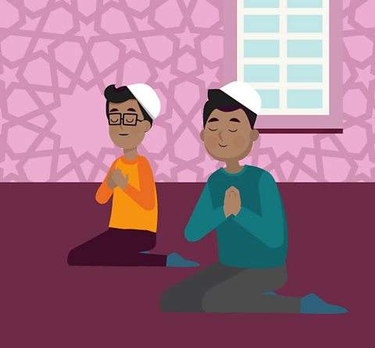

What do Muslims believe?
Muslims believe that Islam was revealed over 1,400 years ago in Mekkah, Arabia through a man called Muhammad.
Muhammad is so respected that it is usual for Muslims to say 'peace be upon him' whenever they mention his name.
Muhammad is believed by Muslims to be the last prophet sent by God (Allah). They believe God sent prophets to mankind to teach them how to live according to His law.
Jesus (Isa), Moses (Musa) and Abraham (Ibrahim) are other respected prophets.

Five Pillars of Islam
The Five Pillars of Islam are an important part of Muslim life. They are five things that a Muslim must do so they can live a good and responsible life. They include:
- The declaration of faith (Shahada)
- Praying five times a day (Salat)
- Giving money to charity (Zakah)
- Fasting during the month of Ramadan (Sawm)
- A pilgrimage to Makkah at least once in a lifetime (Hajj)

What is the holy book of Islam
The Muslim holy book is called the Qur'an. Muslims believe this to be the word of Allah as dictated to Muhammad.
They also have the Sunnah, which Muslims believe to be the practical example of Prophet Muhammad.
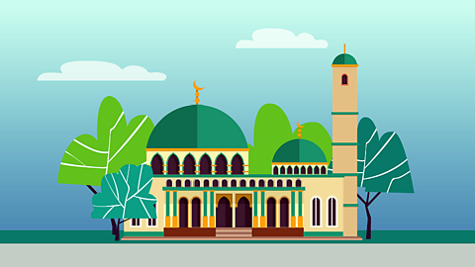

Where do Muslims worship?
Muslims worship in a building called a mosque. On Friday at noon, the most important of the weekly services is held. When Muslims pray, they must always face Makkah in Saudi Arabia. Many Muslim men will wear a small cap called a taqiyah when they pray.
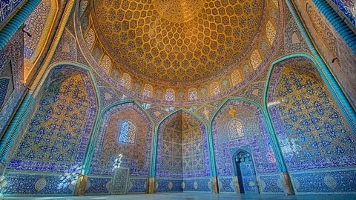
Mosque
Mosques are places of worship for Muslims all over the world. Mosques usually have rules like leaving shoes outside and dressing modestly.

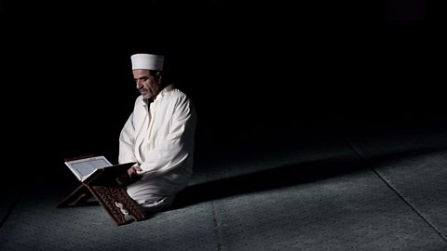
Imam
Imams lead worship in a mosque and are important community figures. They are there to offer spiritual guidance and life advice for the Muslims in their community.

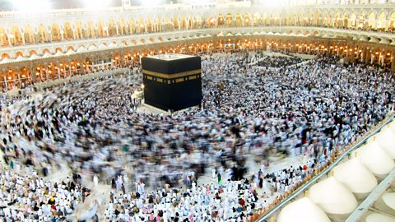
Makkah
Makkah is the holiest city in Islam. It is Muhammad’s birthplace and also the place the Qur'an was revealed. Hajj is a huge yearly pilgrimage to Makkah, attracting several million Muslims from all over the world. All Muslims (as long as they are healthy and able to travel) try to do Hajj at least once in their life.

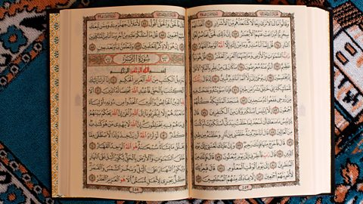
The Qur'an
The Qur'an is the most important book in Islam. Muslims believe it was revealed to Muhammad by Allah through the Angel Jibreel. It has details on the existence of Allah, morality and historical events.
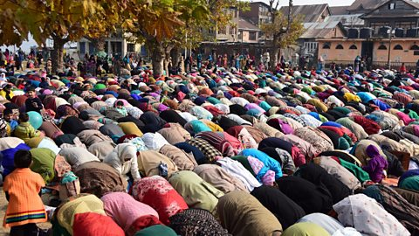
Salah (prayer)
Salah (or prayer) is very important to Muslims. Muslims pray five times a day and they must be facing the direction of Makkah.

