Week 5 Lesson 1:

Water Controversies in New Zealand
Microplastics

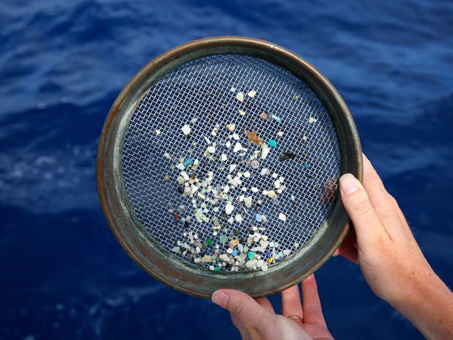

Success Criteria
Students will gain a basic introduction to the issue of microplastics in the water and air in New Zealand and potential harmful impacts on our health and the environment – and be able to recount specific impacts in both areas.

According to the Prime Minister’s Chief Science Advisor, micro (meaning tiny) plastics are a huge problem for New Zealand and are in our water supply. In today’s lesson we are going to research the extent of the problem. Get into pairs, then go to the Mission Heights Library online and access the EPIC databases. Once you have done this, click into the Australia and New Zealand Reference Centre. Do a basic key word search.
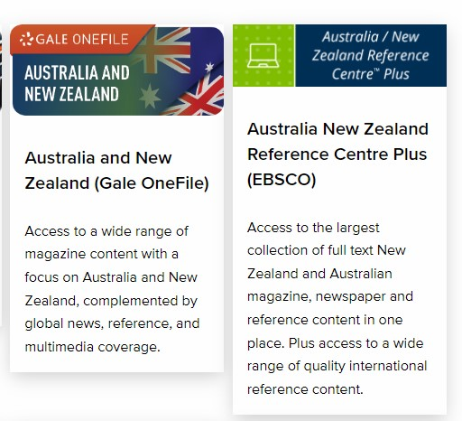
Above: Your screen should look something like this. Onvce you click into the specific database, it should look something this this – see below:

Tasks:

1. Type in ‘plastic’ – how many hits did you get?

2. Next type in ‘microplastics’ – how many hits did you get?

3. Now type in ‘microplastics and New Zealand’ – how many hits?

4. Under ‘microplastics and New Zealand’ – go to the ‘Relevance’ tab and hit newest first (this will give you a list of articles with the most recent first)

5. Find articles on the issue of microplastics and New Zealand and fill in information under the following headings using key dot-points that will be copies into your Red Books:

A. How do microplastics affect creatures that live in the marine (water) environment?

B. How big is the problem?

C. How are humans affected?

D. Key facts and Figures

E. Interesting Facts:

Week 5 Lesson 2

Working with your partner, you are to create a poster highlighting the problem of microplastics in New Zealand – explain how serious it is – and try to get people to take some type of action to reduce the problem. Include:

1. A catchy title
2. Where the microplastics were found?
3. What harm is it causing to marine life?
4. How is it harming people?
5. How do we make things better?

Week 5 Lesson 3:
Current Event in the News

The Coming Solar Tsunami
& the Kiwi Scientists Trying to Understand It

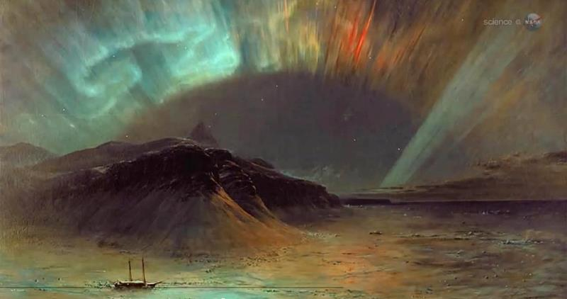

Success Criteria: By the end of the lesson students will be able to describe the Carrington Effect, recount several negative impacts from its appearance, and why we need to prepare for it.

Class Discussion:

How many students have ever seen the Northern or Southern Lights? What did it look like?
Has anyone ever heard of The Carrington Effect?

Task 1: Watch the video clip titled, “The Most Powerful Solar Storm in History and Why It Matters for Our Civilization” at: https://www.youtube.com/watch?v=CwUND3V74ew (9:28 sec.)

Answer the following questions in your Red Book:

1. What is a solar storm?

2. How did scientists discover that a giant solar storm hit earth thousands of years ago – and what does Carbon 14 have to do with it?

3. What are the consequences of a solar Tsunami hitting earth?

4. What can be done to prepare for the next event?

5. What are the odds that a major event will happen in he next 50 years? To answer this question, read the article below from TV NZ:

Reading:
Scientists Preparing New Zealand's Defences Against Solar Tsunami Threat
August 20, 2022 by Kaysha Brownlie NewsHub

A group of Dunedin scientists is already stepping up New Zealand's defence for when one happens.
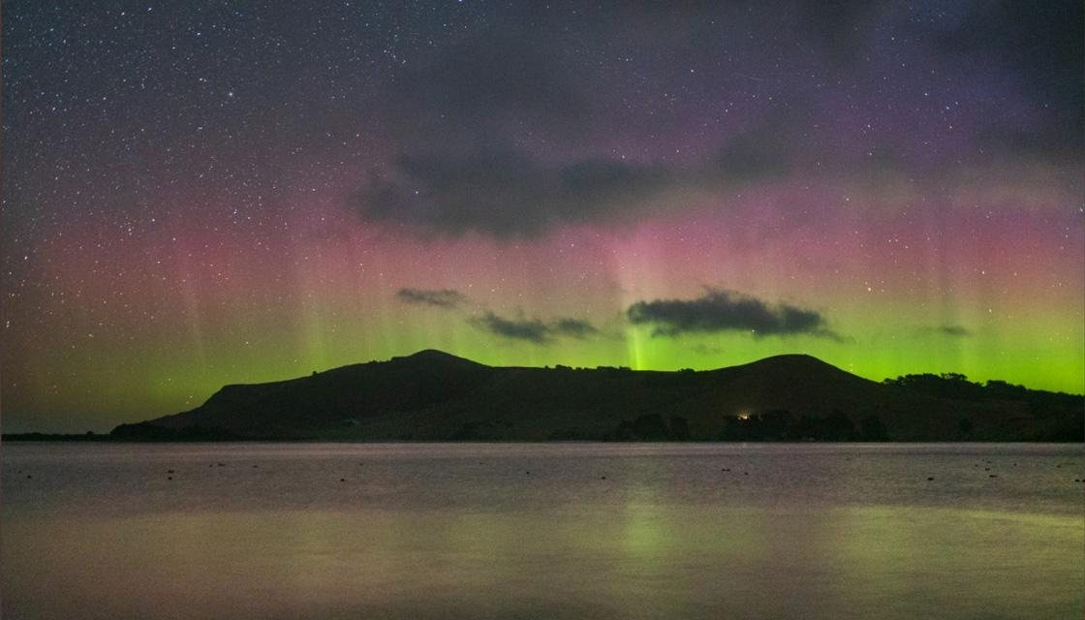
An Aurora Australis lights up New Zealand's skies

We see the sun every day but what most of us don't realise is it's currently moving into a phase of high activity. During this time, it produces more solar flares, as well as solar tsunamis.
"Solar flares are the biggest explosion in the solar system inside the atmosphere. They throw billions of tonnes of material out into space and that's a solar tsunami," explained Professor Craig Rodger, from the Otago University physics department.
There's roughly a 25 percent chance of an extreme event reaching Earth in the next 50 years.
"That's pretty high, much higher than us winning Lotto even in 50 years," Prof Rodger warned. It could cause an electrical blackout which is why he will travel to the Chatham Islands as part of a team installing a magnetometer.
"We need to better understand how magnetic fields vary across the country… We put a magnetic instrument up in Awarua near Invercargill, one in King Country, now we're putting one in the Chathams. That will give us good north, south, east, west coverage."
Unlike other natural disasters, we will know when a solar tsunami is coming. It takes 12 hours to reach Earth from the sun.
"If it's a very very big event, you could imagine the safest thing to do would be to turn the power grid off for a day or two and then we'd turn it back on - we'd have a power grid," Prof Rodger said.
A previous solar tsunami has proven planning is key. "The Carrington event was the largest solar storm ever recorded in history in 1859, it affected electrical infrastructure everywhere around the world including New Zealand," warned Otago Museum science engagement co-ordinator Toni Hoeta.
There wasn't a lot of electricity back then but today the world relies on it. It's worth stopping at this point to think about the number of electrical devices you rely upon as do hospitals, schools, businesses, laptops and phones.
"It can even affect GPS so imagine you're in the sky on an aeroplane and the GPS goes out of whack," Hoeta said. That being said, work is already underway to prepare for it.
"The good thing is that we're doing science with Transpower to prepare for this eventuality so we can mitigate (counter the effects of) and have… plans so it won't be as bad for New Zealand," Prof Rodger said.
"Don't prepare for it in the sense the world is ending, just know we might have limited power for a certain amount of time," added Hoeta. So best keep those batteries to hand.
*This article has been modified by Mr. Bartholomew to make it easier to read for students.

