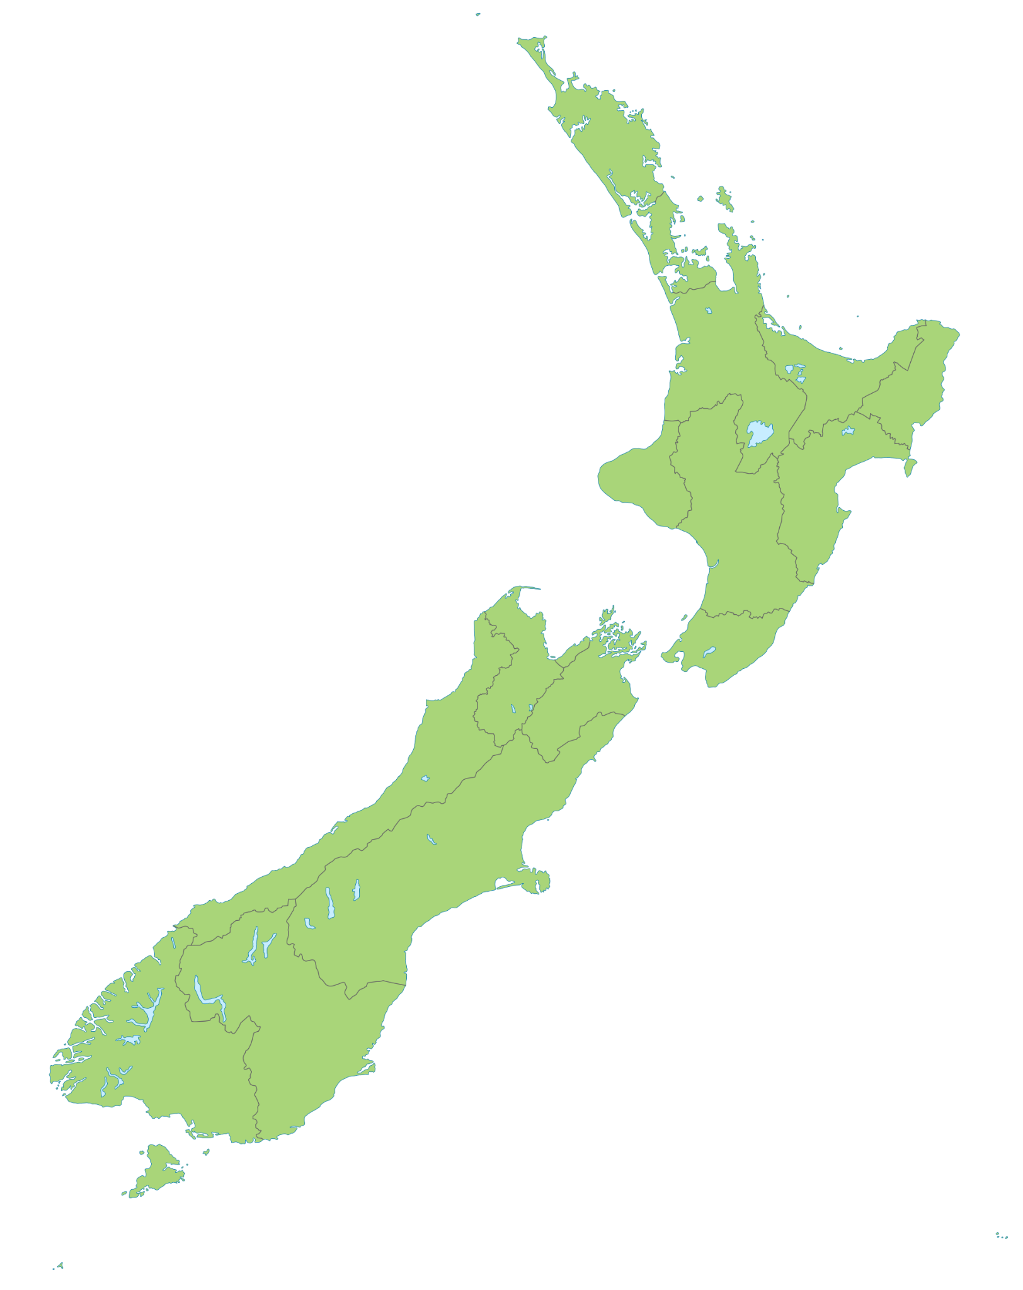

Te Waipounamu | Ōtepoti | Rakiura
Te Whanganui-a-Tara | Te Ika-a-Māui | Rotorua
Te Papaioea | Kirikiriroa | Whakatū
Wanaka | Taupō | Tamaki-makau-rau
Māwhera | Ahuriri | Kaikōura
Te Tihi-o-Maru | Waihōpai | Ōtautahi
Tauranga | Whangarei | Whanganui
Kaitaia

