Year 9 Fashion & Design: Safety in the Technology Room

Name:

This Assessment Task is finding out students understanding and application of safety in using Technological Products in the Technology rooms at MHJC.

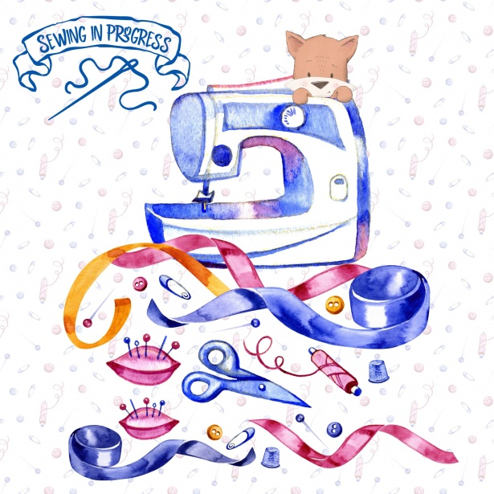
Assessment Task:
Select 1 Technological Product you frequently use in the technology room and create a digital presentation that informs the safe and correct way to use this product.
You can use any digital platform to create your presentation like slideshow, posters ...etc.
Your digital presentation should be original (your own work) and demonstrate a clear and accurate message to inform the function, correct and safe way of using the technological product.

Technological products could be: Sewing Machine, Pins, Iron, Scissors/Shears, T Shirt Heat press, Tape measure.

Use this template to gather your information for your digital presentation and submit to MHO with your digital presentation (2 documents).

You must complete Part A AND Part B of this assessment.

PART A - A Technological Product

Tasks for AT Standard (Identified and described the technological product and provided some supporting photos)

Identify and describe a Technological product:

- My Technological product name is:
- Insert image here (At)
- Describe your product. (At)
- Provide supporting photos (At)

Additional Task for Above (you need to complete the AT section also)
(Identified and described the technological product and it’s function and labelled most parts and provided supporting photos)

- Identify and describe its function (Above)

Additional Task for Beyond (you need to complete the At and Above section also)
(Clearly explained in detail the technological product and clearly explained its function and labelled all parts providing supporting photos)

- Clearly explain in detail what your technological product's function is/are.

PART B - Safe use and injury procedure

- Describe how to safely and correctly use your technological product with a procedure to follow when injury occurs.(At)

- Describe in detail how to safely and correctly use your technological product with a procedure to follow when injury occurs. (Above)

- Clearly describe in detail the correct and safe way to use this technological product with a procedure to follow when injury occurs. Give a detailed description of what to do and why (justification) at each step of the procedure. (Beyond)

Assessment Rubric

Criteria | WT | AT | ABOVE | BEYOND
 | You are yet to: | You have: | You have: | You have:
Technological product function | Identify and describe the technological product | Identified and described the technological product and provided supporting photos | Identified and described the technological product and it’s function and labelled most parts and provided supporting photos | Clearly explained in detail the technological product and clearly explained its function and labelled all parts providing supporting photos
Safety of use and injury procedure | describe the correct and safe way to use the technological product with a procedure to follow when injury occurs | described the correct and safe way to use the technological product with a procedure to follow when injury occurs | described in detail the correct and safe way to use the technological product with a procedure to follow when injury occurs | clearly described in detail the correct and safe way to use the technological product with a procedure to follow when injury occurs giving justification for each step in the process
Accuracy in writing | You have made errors in grammar, spelling and/or punctuation. These are intrusive and affect meaning | You have made errors in grammar, spelling and/or punctuation. These are intrusive at times, but reader can infer meaning | You have made some errors, but minimal reader inference is needed. Meaning is consistently clear | You have carefully edited your writing to ensure you have few (or no) intrusive errors. Meaning is consistently clear
Time management | You have not submitted your work by the due date | You have submitted your work by the due date | You have submitted your work by the due date | You have submitted your work by the due date

