Year 7 Global Studies, Term 3, 2023

Week 10 – Book Check & Writing Week



Success Criteria:

By the end of this week, students will be able to produce a basic essay containing at least three paragraphs that have been structured in the T-E-E-L format.

Lessons 1, 2 & 3:

1. At the start of Lesson 1, students will hand in their books to be assessed.

2. Students will be given lined paper with a sheet of colored paper at the back. They will use colored paper for taking basic notes and writing practice.

3. Based on the information provided below – students will write a basic essay. At the end of each lesson, I will collect your papers. It must be completed in class by the end of lesson 3 on Thursday.

Essay format should be in the P-E-E-L Writing Style.
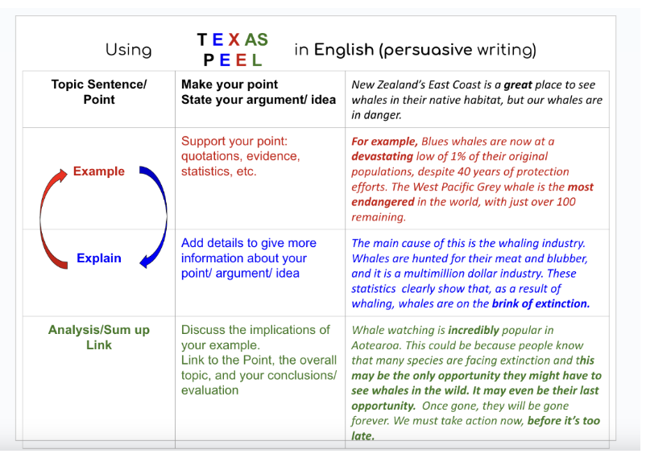

Your essay will be structured as follows:

Paragraph #1: Make the case for using mobile phones in New Zealand schools.

Paragraph #2: Make the case against using mobile phones in New Zealand schools.

Paragraph #3: Give me your opinion on this issue and support your position with supporting information.

DO NOT COPY. Write each paragraph in your own words and start with a clear topic sentence.

Information that may help you in constructing your essay – remember – DO NOT COPY – write in your own words.

Information to help you write your essay:

BANNING MOBILE PHONES
Here are 20 potential reasons in favor of banning mobile phones in middle schools:
- Reduced Distractions: Without phones, students are less likely to be distracted by texting, social media, or games during class.
- Improved Concentration: Students can focus better on their lessons without the temptation of their phones.
- Prevention of Cheating: Banning phones can reduce the likelihood of cheating during tests and assignments.
- Better Classroom Engagement: Students may be more engaged in class discussions and activities when not constantly checking their phones.
- Reduced Cyberbullying: Banning phones can help mitigate cyberbullying issues that may arise through texting or social media.
- Promotion of Face-to-Face Interaction: Students may develop better social skills by interacting with peers in person instead of via screens.
- Lessens Health Concerns: Some studies suggest that excessive phone use can lead to health issues like eye strain and sleep disturbances.
- Encourages Physical Activity: Without phones, students may be more inclined to engage in physical activities during breaks.
- Fosters Creativity: Students might become more creative and imaginative when not constantly relying on digital entertainment.
- Privacy Protection: Banning phones can help protect students' privacy and prevent unwanted photo or video sharing.
- Enhances Safety: Reducing phone use can prevent students from engaging in risky behavior or accessing inappropriate content.
- Promotes Responsible Use: It can teach students responsible phone use by setting boundaries during school hours.
- Equal Access: Ensures that all students have equal access to educational resources, regardless of their smartphone ownership.
- Teacher's Authority: Helps maintain the teacher's authority in the classroom by reducing disruptions.
- Better Time Management: Encourages students to develop time management skills without constant phone use.
- Prevents Theft: Reducing the presence of expensive phones can deter theft and protect students' belongings.
- Reduces Noise: Less phone use can result in quieter classrooms, improving the learning environment.
- Decreased Screen Time: Students spend less time staring at screens, which can benefit their overall well-being.
- Enhances Academic Performance: With fewer distractions, students may perform better academically.
- Preparation for Real World: Learning to manage phone use in school can prepare students for responsible use in the future.

USING MOBILE PHONES IN KIWI SCHOOLS
Here are 20 arguments in favor of allowing mobile phones in educational settings:
- Emergency Communication: Mobile phones provide students with a means to contact parents or emergency services in case of urgent situations.
- Parental Communication: Parents can reach their children easily for important messages or changes in plans.
- Research and Learning Tools: Mobile phones can serve as valuable educational tools, allowing students to access information and research online.
- Digital Resources: Mobile apps and the internet offer a wealth of educational resources, including e-books, language-learning apps, and educational games.
- Enhanced Learning: Mobile devices can facilitate personalized and interactive learning experiences, helping students better understand complex subjects.
- Organization: Students can use their phones for scheduling and time management, helping them keep track of assignments and activities.
- Digital Note-Taking: Mobile devices enable students to take digital notes, which can be more efficient and organized.
- Language Translation: Language translation apps can aid students in understanding foreign language materials.
- Accessibility Tools: Mobile phones offer accessibility features that can assist students with disabilities, such as screen readers and speech-to-text functionality.
- Communication Practice: Students can develop communication skills through responsible use of social media and messaging apps.
- Parent-Teacher Communication: Mobile phones facilitate communication between parents and teachers, allowing for timely updates on a student's progress.
- Digital Literacy: Learning to use mobile technology responsibly is an essential skill in the modern world.
- Real-World Preparation: Allowing mobile phones in school prepares students for responsible phone use in their future careers.
- Engagement and Participation: Mobile devices can be used for interactive classroom activities and polls, increasing student engagement.
- Critical Thinking: Encouraging students to use their phones for research and fact-checking promotes critical thinking skills.
- Integration of Technology: Embracing mobile technology aligns with the trend toward integrating technology into education.
- Cost-Effective: Mobile devices can be more cost-effective than traditional textbooks and resources.
- Global Awareness: Access to news and current events through mobile phones can promote global awareness and discussion.
- Parental Monitoring: Parents can monitor and guide their children's phone use to ensure responsible behavior.
- Digital Citizenship: Allowing mobile phones provides an opportunity to teach responsible digital citizenship and online etiquette.

