Market Day Plan
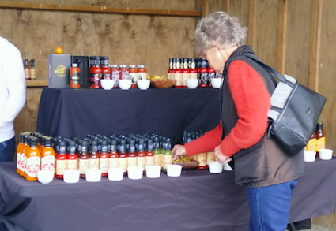




Table of Contents

Our group 3
Our Product 3
Team member roles & responsibilities 3
Market research -Our survey to customers 4
SWOT 4
Equipment and planning 4
Marketing 4
Finance 4
Packaging and presentation 4
Log Book 5

Our group
My team’s name is

My team’s logo looks like this

My team’s members are
- .
- .
- .
- .

Explore: Potential ideas about our Product
My team’s brainstorm included these product ideas

Focus:
My team’s chosen product is (describe it, perhaps with a photo illustrating the idea)

Team members’ roles & responsibilities
Our team members have these roles & responsibilities
Member 1
Role
Responsibility

Member 2
Role
Responsibility

Member 3
Role
Responsibility

Member 4
Role
Responsibility

Market Research - our survey to customers
Questions we asked a sample of potential customers were
- .
- .
- .
- .

Survey results (perhaps add graphs or a summary of answers to each question)
- .
- .
- .
- .

Survey analysis (answer ‘so what?’ and say how results will affect what you do for Market Day).
- .
- .
- .
- .

SWOT Analysis

Equipment and planning
Equipment and materials that we need

Marketing
How we’ll attract customers to buy our product (perhaps adverts, posters, face to face selling, etc)

Finance
A brief estimate of the costs and price (include estimated number of sales and thus estimated profit)

Packaging and presentation
The product will be presented this way

Logbook (A detailed description of your plan for each session)
lOG BOOK
Date
Who attended
Who was absent
Notes (include what was discussed and what next actions were agreed)

Date
Who attended
Who was absent
Notes (include what was discussed and what next actions were agreed)

Date
Who attended
Who was absent
Notes (include what was discussed and what next actions were agreed)

Date
Who attended
Who was absent
Notes (include what was discussed and what next actions were agreed)

Date
Who attended
Who was absent
Notes (include what was discussed and what next actions were agreed)

Date
Who attended
Who was absent
Notes (include what was discussed and what next actions were agreed)

Date
Who attended
Who was absent
Notes (include what was discussed and what next actions were agreed)

Date
Who attended
Who was absent
Notes (include what was discussed and what next actions were agreed)

Date
Who attended
Who was absent
Notes (include what was discussed and what next actions were agreed)

Date
Who attended
Who was absent
Notes (include what was discussed and what next actions were agreed)

Evaluation of Market Day
Use the link below to complete the evaluation:
Market Day Evaluation

Rubric to add

