Week 4: Lessons 1 & 2 –

‘Strange’ Foods from Different Cultures

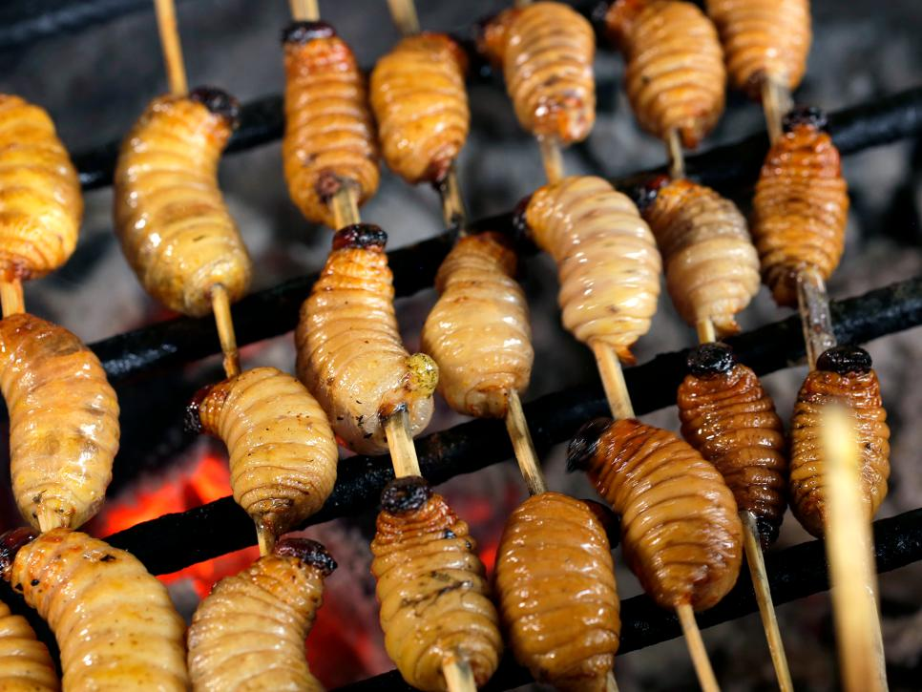

Success Criteria

Students will become familiar with a variety of unusual foods that are accepted in other cultures and basic vocabulary associated with these foods. By the end of the week, they will be able to recount key vocabulary words.

Class Discussion: Why is the word ‘Strange’ in quotation marks?

Has anyone in class ever eaten what we in New Zealand would consider to be a ‘strange’ food?

Class Discussion continued – read the following quote –

In learning about the other, about many ‘others,’ our conception of humanity is enlarged and enriched. We gain insight into the plasticity of human culture. We begin to see that our way of life is determined not so much by nature but by culture and history.
– David Mayberry-Lewis

What does this quotation mean?

Task: Look at the Reading titled ‘Strange Food.’ The article appears below. Once you have read the article, answer the questions and complete the vocabulary words.

Reading:

Strange Food
1. Crispy Tarantula Spiders
Fried tarantulas are a popular snack in Cambodia. During the dictator Pol Pot's regime, food was scarce and so the people resorted to eating these gigantic spiders. The head and body contain white meat, but the abdomen contains a brown coloured paste made up of eggs, excrement and organs. But they have proved to be well-liked and these days Cambodians eat them like candy.
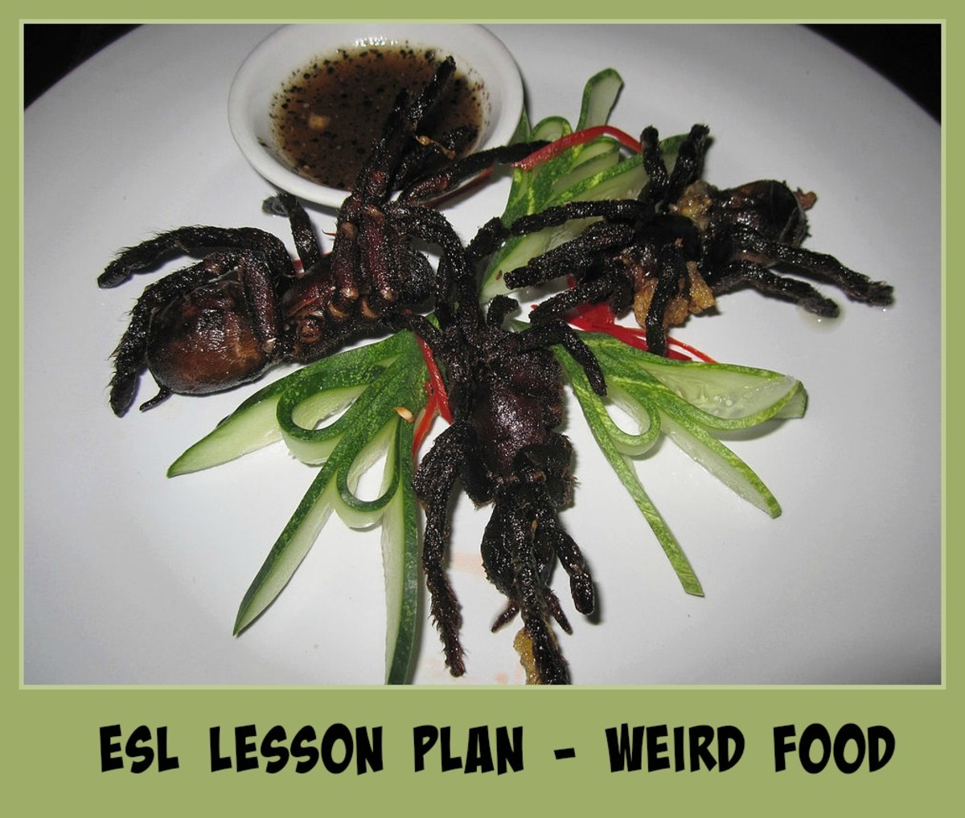
Thousand-year-old Eggs: These eggs aren't as old as they sound. The process takes from a few weeks to a few months. The eggs are preserved in a saline solution and the whites turn into a dark brown colour while the yolks turn to a dark green and grey colour. The eggs smell like a mixture of ammonia and sulphur.
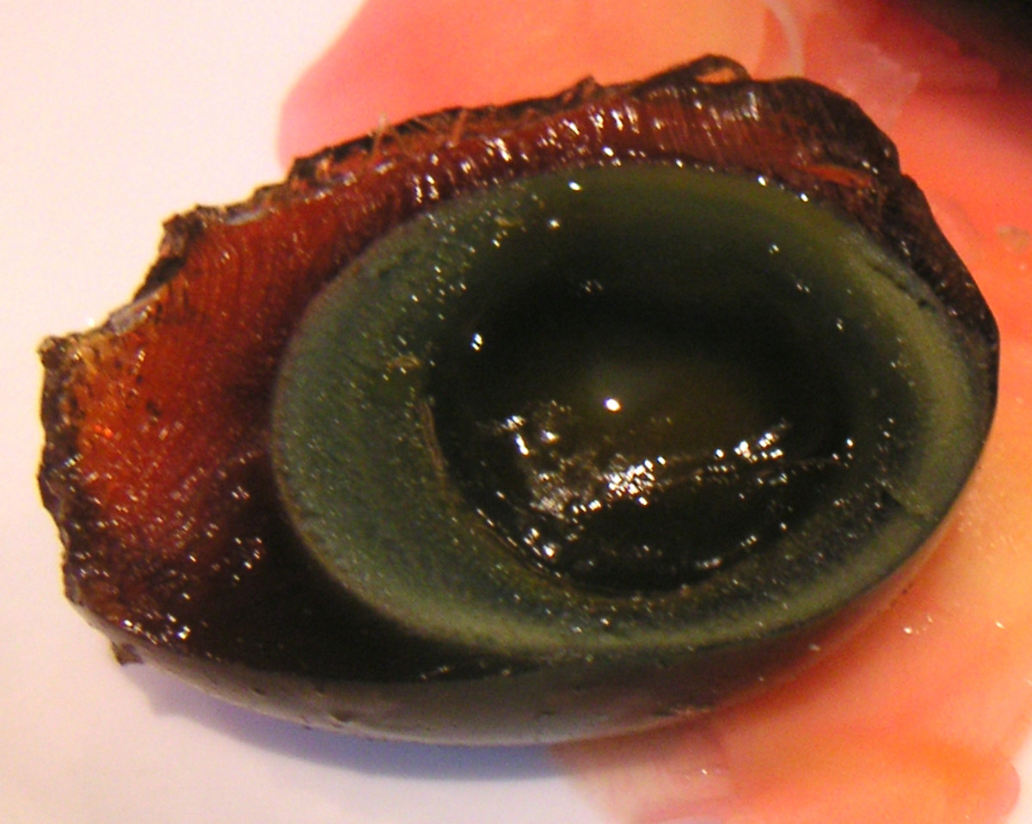
Balot: A balot is a developing duck embryo that is boiled alive and sold on the streets in Southeast Asia. Around 9 days after fertilisation the baby duck begins to form. They are cooked and then stored in sand to keep the eggs warm. Some countries prefer the ducks to be more developed. For example, in the Philippines the perfect egg is 17 days-old and the chick has not developed its beak, feathers or claws.

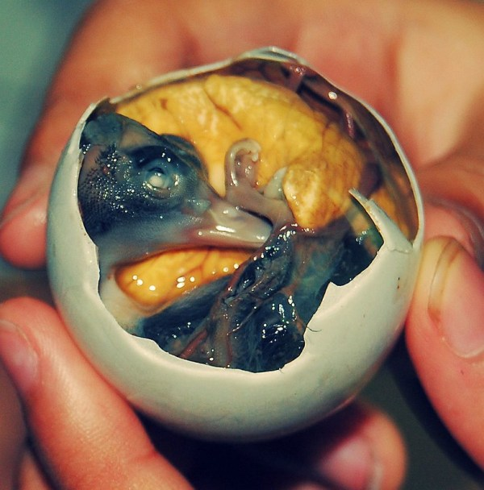

Hakarl - Dried Shark Meat
The rotting carcass of a basking shark is buried underground for a few months. Stones are placed on top of the shark so that the poisonous body fluids leak out. These fluids help the sharks survive the extreme cold waters, but are unsafe for human consumption until it has been hung out to dry for a few more months. The result? Rotten flesh that smells like a mixture of ammonia and fish.

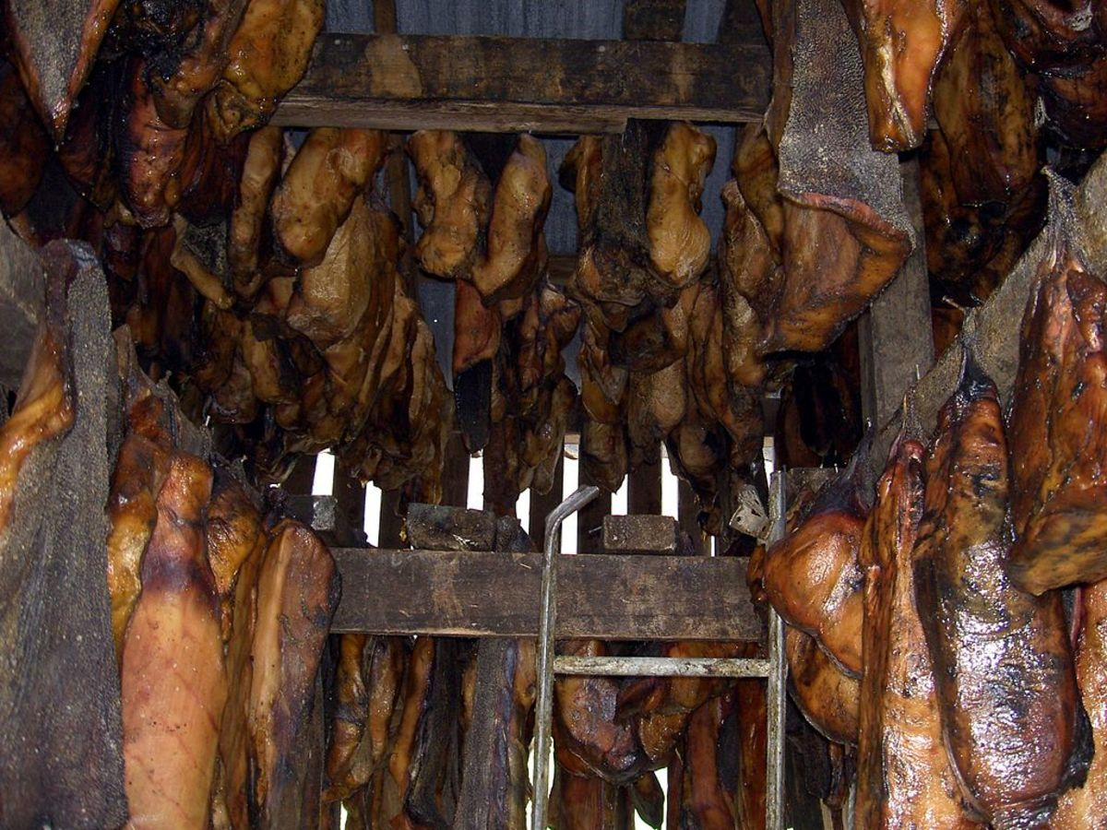
Bird's nest soup: One of the most expensive foods in the world is a Chinese dish that involves using a real bird's nest. Instead of using twigs to make a nest, this particular bird uses its own saliva. These red nests can cost up to $10,000.
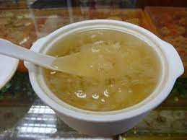

Fried-brain sandwich: Thinly sliced calves' brains were hugely popular in the United States. That is until people became worried about catching Mad Cows Disease (BSE). Cows' brains older than 30 months are no longer permitted in human food, though some restaurants still offer this dish. Chefs are now turning to pigs' brains instead, but as pigs' brains are smaller, they take longer to prepare and produce fewer slices.
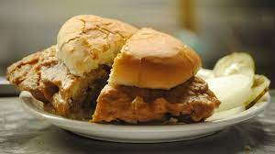
Ikiziuri: One of the most brutal dishes created is known as “Dead and Alive”. The recipe comes from Taiwan, where it is now illegal to serve it. Chefs cut open a fish and preserve the vital organs while they deep fry it. The fish is still alive as it is being cooked. Diners poke the head and eyes of the fish to watch it moving, alternatively you can ask the chef to put the filleted fish back into the tank to let it swim around until you are ready for seconds. Chefs claim it proves how fresh the fish is.
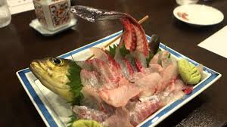
Nakji: This dish is quite dangerous and causes several deaths a year - it is not a meal for the faint-hearted. A live octopus is chopped into pieces in front of you and served with sesame oil. The octopus continues to squirm on your plate, but watch out! If you don't chew the poor creature properly, then the suckers on the tentacles can stick to your throat and cause you to choke.
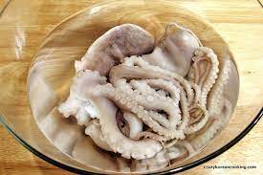

The United Nations Food and Agricultural Organisation estimates that 2 billion people rely on up to 1900 insects for food on a daily basis. Most people in the western world would not consider eating bugs as part of a healthy diet, but insects can be raised in small spaces without growth hormones and are low in fat and high in protein.

Reading Comprehension Questions
- Name the dishes that are dangerous to human health?
- Name the foods that mention a strong odour?
3. Which dish (if any) do you find the most disgusting?
4. If you had to eat a dish mentioned in the text for your next meal, which
would you choose?
5. What's the weirdest thing you've eaten?
6. Do you think any of the foods you eat would be considered strange by
foreigners?
7. If you had to choose between eating a rat & starving, would y?

Vocabulary Words:
- saline-
- beak-
- feathers-
- claws-
- saliva-
- twigs-
- filleted-
- squirm-
- suckers-
- choke-
What do the following food-related sayings mean? Look them up and explain.
1. Half-baked –
2. Eat us out of house and home -
3. Couch potato -
4. Variety is the spice of life -
5. There is no such thing as a free lunch -
6. Spill the beans -
7. Cool as a cucumber -
8. Bitter pill to swallow –

Week 4 Lesson 3:

Current Event Analysis
Advanced

The Earth is Warming & Humans are Causing It



Success Criteria
Students will gain a basic understanding of the growing threat from global warming. At the end of this lesson, they will be able to recount how humans are contributing to the recent surge in global temperatures and the effects of warming ocean temperatures.

During Term 2 we looked at major weather events in New Zealand. We also looked at global warming and saw the documentary ‘An Inconvenient Truth’ narrated by Al Gore. At that time, I noted that the evidence for global warming was indisputable – the only question was – what was causing it and that most scientists believed it was humans pumping CO² into the atmosphere creating the Greenhouse Effect.

The evidence for global warming being caused by human beings is now accepted by the scientific community to the point where even NASA has stated the evidence for humans causing it is clear and overwhelming.

NASA now reports that at 97% of active climate scientists believe that global warming is being caused by humans putting CO² into the atmosphere.

Task 1: Watch the NASA video on why Earth’s climate is warming and why humans are mostly responsible:
https://www.youtube.com/watch?v=pLU8v8fAw7s (8:40 sec.).
Task 2: Go to the website from NOAA – the National Oceanic and Atmospheric Administration which appears below. What NASA is to space, NOAA is to the Atmosphere. Use information from the video clip above and from the article below and then write a letter to a friend who believes that Global Warming is a hoax. What evidence would you present to change his or her mind?

https://www.climate.gov/news-features/climate-qa/what-evidence-exists-earth-warming-and-humans-are-main-cause

Current Event Analysis
Basic

Plastic Bags in New Zealand are Out
& Paperbags are In



Success Criteria
Students will gain a basic understanding of the new push to have supermarkets use paper bags and stop using plastic ones. By the end of the lesson, they will be able to list several reasons for the change and how it is expected to help the environment.

Read the Article below and answer the questions.

Reading: Banbury, Shem (2023). Kiwi Kids News, June 29. 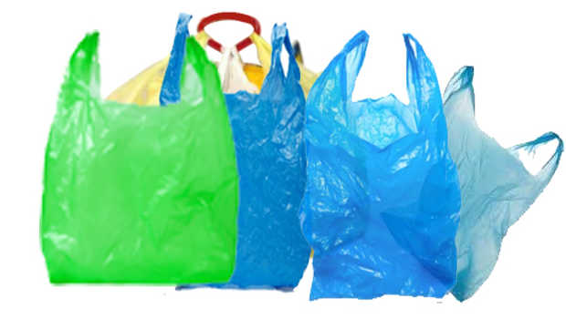
On Saturday, July 1, 2023, fruit and vegetable stores across the country stopped providing single-use plastic produce bags. This is part of the government’s plan to phase out hard-to-recycle plastic items.
The second step of the phase-out includes a ban on things like plastic spoons, knives and forks, plastic plates and straws.
However, people with disabilities or health conditions will still be able to access plastic straws.
The next phase of the ban, set start by 2025, and involves the use of plastic produce stickers that can degrade back into the environment. For now, fruits already packed in plastic can still be sold, so plastic stickers will remain on many fruits for the time-being.
In preparation for the upcoming changes, Jenkins Freshpac Systems, the largest producer of fruit labels in the country, has developed a compostable sticker. After 10 years of development, they have created a plant-based sticker that sticks to different fruits and remains in place during storage, transportation, and sale.
The company is also working on developing a home compostable glue for the labels. They believe they have a product that utilizes all home compostable ingredients, including the adhesive. They are currently doing tests and hope to achieve a breakthrough in home compostable adhesive within the next 12 months.
With these significant steps towards reducing single-use plastic, fruit and vegetable stores are leading the way in protecting the environment.
Questions:
1. In July of this year, what was banned in grocery stores across New Zealand?
2. In the near future what other plastic products are going to be banned?
3. What new sticker has Jenkins Freshpac Systems come up with and how will this help the environment?
4. Do you think that the move to paper bags is a good idea? Explain your answer.

