Food & YOUR Culture

Week 2 – The Week of July 24 to July 30, 2023

Can you guess this national dish pictured below?
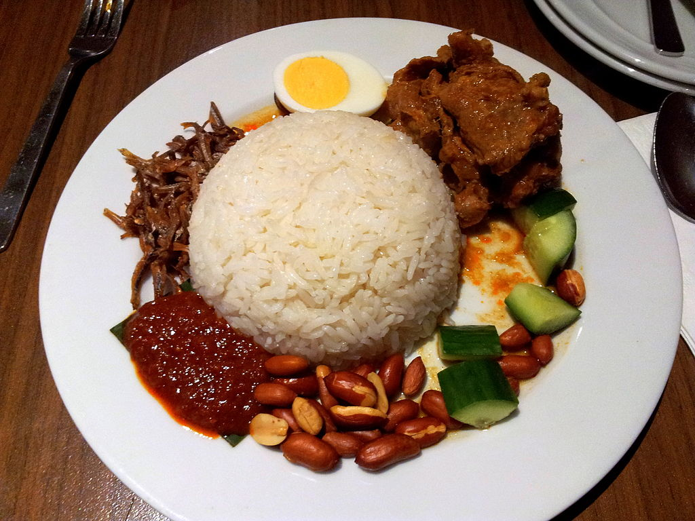

Week 2: Lesson 1: Food and YOUR Culture

Success Criteria

Students will become familiar with the relationship between food and their own cultural, religious or national backgrounds and be able to recount/describe the components of key international dishes and their traditions.

Tasks – Class Discussion

Task 1: In your Red Books write the Lesson Title and today’s date.

Class Discussion – What’s your country’s national food?

We will write down some of the ethnic groups and countries that students or their parents or grandparents come from. For example, your family may have originally migrated from Spain, Russia, Japan, South Africa, India or Fiji. Each country has a food tradition. For instance, if I were to say ‘hotdogs and hamburgers’ you might think of the United States. If I were to say ‘maple syrup,’ the word Canada may come to mind.

White Board: Let’s write on the board the different nationalities (countries) that students or their parents are from, and a food or meal that represents that country.

Country Food
Task 2: National Dishes:

Go online and look up the national dishes from the following countries. For instance, if you were looking up the national dish of Germany, you would Google “national dishes of Germany.”

1. Germany: Sauerbraten is a German pot roast dish which can be prepared using a variety of meats. The recipe includes such key ingredients as… It is usually made with beef and served with cabbage and potatoes.

2. New Zealand

3. Fiji

4. Italy

5. Spain

6. The United States

7. South Africa

8. Argentina

Homework: Ask your parents or grandparents for a favorite dish that reflects their ethnic background. For instance, if they originated from India – what is the national dish from the region they are from? There are usually several but have them name their favorite.

Look up the recipe and write it here.
What does it smell like?
What does it look like?
What does it taste like?
What does it feel like in your mouth?
Do you still eat this dish? How often?

National Dish/Food Presentation: Students are going to create and present a 1-2-minute presentation that describes a national dish from a particular country, region, or culture they and their family belong to. If there is a food that is associated with a particular religion, you could include that too.

There are 2 possible types of presentation – basic & challenging.

BASIC EXAMPLE:

For the basic presentation you choose one food. For instance, if you are from New Zealand, you might choose Hokey Pokey Ice Cream and describe it. See the example below.

An Example from New Zealand (Basic)
Student name: John Doe
Hokey Pokey Ice Cream


Hokey Pokey is New Zealand’s bestselling ice cream.

Where did it originate: No one knows where it began but it was sold in Tyrell Stores in New Zealand as early as 1892.

Describe it: Hokey Pokey ice cream can generally be described as plain vanilla with small lumps of what is commonly known as honeycomb toffee distributed throughout it.

The 5 senses:
It smells like butterscotch candy; it tastes sweet and cold.

Interesting Facts:
- It is estimated that New Zealanders eat about two million litres of hokey pokey a year.

- The largest maker of hokey pokey ice cream in New Zealand is Tip-Top.

Other possible basic foods from New Zealand: L & P Soda, Kiwi Burger
Pavlova, pineapple lumps

Example from New Zealand (Challenging)
Possible Food Dishes

Whitebait Fritter
Roast Lamb
Kumara
Hangi

What’s the history – when or where did it originate? Is it linked to a particular person, event or idea? What is it made of? How is it served? What does it look like, taste like, smell like, and feel like? Is it nutritious? How did it become so famous in New Zealand?

Week 2: Lesson 2: Students are to work on and complete their class presentations.

Week 2: Lesson 3: Students will present their class presentations.

Presentations are NOT to be done on Powerpoint – they must be written into your Red Books. You will stand in front of class and chat about it. You are encouraged to show us a picture of the food/meal.

