Food, Culture & Travel

Food is culture. Food is an identity, a footprint of who you are.
– Lidia Bastianich

Food for us comes from our relatives, whether they have wings or fins or roots. That is how we consider food. Food has a culture. It has a history. It has a story. It has relationships.
– Winona Laduke

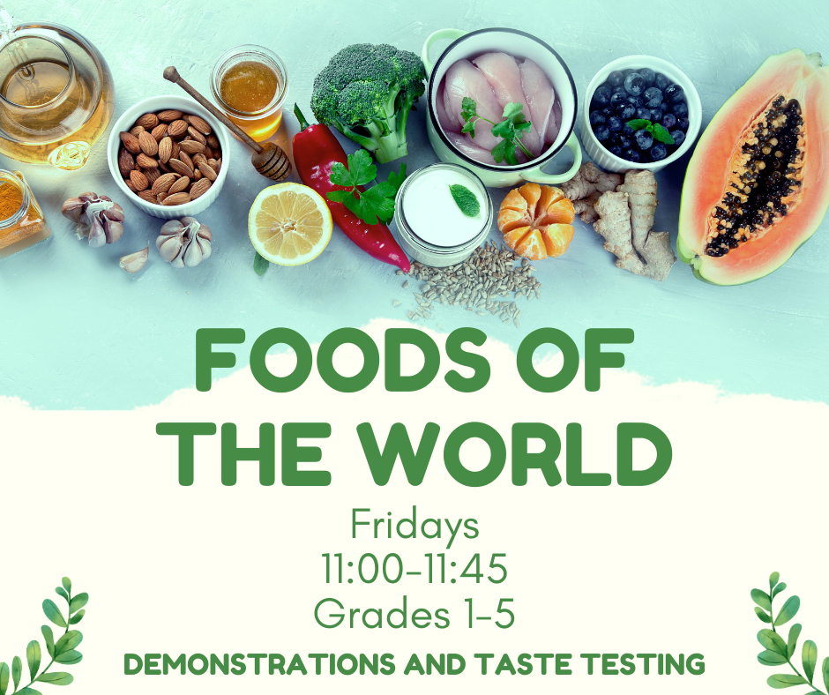

Food, Culture & Travel –
A Global Perspective

Why study food and culture?

What can we learn about our culture and one another through the foods we eat?

Food is much more than a tool for survival; it is also a source of pleasure, comfort, and security. And, while it nourishes our bodies, it can also nourish our families and our communities. Food is one of the most important and persistent aspects of tradition and culture. Throughout the world, food is used to celebrate holidays, rituals, and family gatherings. For special occasions—and even for daily meals—our culture often determines what, when, and how we eat. These traditions connect us to our history, our locale, and to one another.

Food cultures also represent the wisdom gained and shared through thousands of years of experimentation and observation. For example, the grains and beans found in many food traditions have been determined to provide the perfect combination of amino acids our bodies need. Although it may seem that kids today only eat pizza or hamburgers, your students are likely to represent a tremendous diversity of food traditions. Be sure to set the stage for an open and accepting classroom environment so that students will feel comfortable talking about their family food traditions.

(Source: https://www.nourishlife.org/teach/curriculum/activity-3-food-traditions/).

Week 1 Lesson 1 – The Week of July 17 to July 23, 2023

Task 1: Open your Red Books to two blank pages and at the top of the 1st page write in large letters the Unit Title “Food, Culture and Travel.”

Next write: ‘Week 1: Lesson 1 – An Introduction to Global Foods”

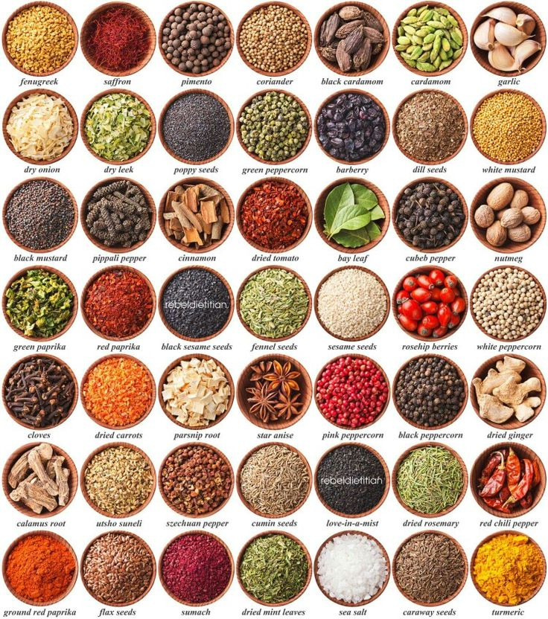

Week 1: Lesson 1:

Success Criteria:

Students will become familiar with key spices that are used to season food around the world, key facts about them and the significance of cooking our food with fire. By the end of the week students will be able to recount key information about several different spices as well as the benefits of cooking food with fire and what it meant for our brain development.

Spices Exercise

Class discussion: What is your favorite dish? What is your favorite spice? What does it look like – taste like – smell like? How does the texture feel in your mouth?

In the picture at the start of this lesson are 49 different plants that are added to dishes around the world for flavor and nutrition. Choose 10 and tell me 3 things about them. It is acceptable for this exercise to use Wikipedia if you like. Follow the example below:

Fenugreek Seeds:
1. It is grown around the world and used in many dishes in parts of India.
2. Its use can be traced back to the first century.
3. The word is from Latin meaning “Greek hay.”

Week 1: Lesson 2:

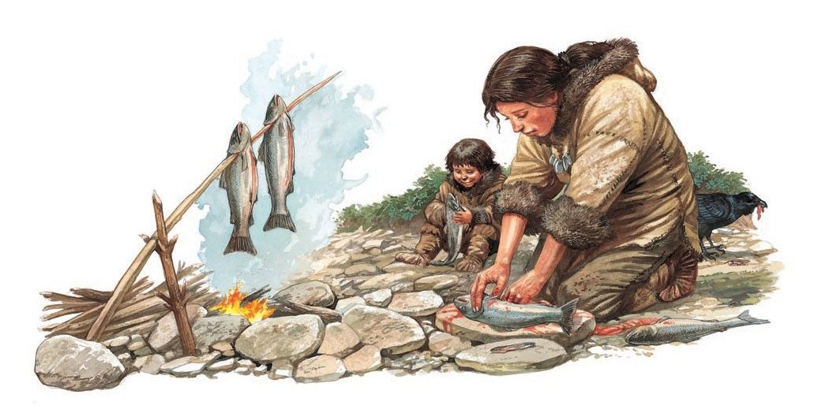
Today we are going to look at the history of food and the development of cooking.

Class discussion: What is better – raw or cooked food?

We are going to watch the video: “The history of food and the invention of cooking.” https://www.youtube.com/watch?v=YUk8LrLEiyk
We will start from the 8:00 sec. mark. Answer the following questions:

1. How has using fire to cook food helped humans? Name the 2 bonuses that humans get from cooking food with fire (9:50 sec. mark)

2. “Thanks to cooking, we have a new found surplus of _________ that went straight to our ________.” (9:30 sec.)

3. Of all the energy we expend, what percentage goes to fuel our brain? (10:00 sec.)

4. The Hadazbe people in Kenya are one of the few hunter-gatherer societies that exist in the world. What is the main food that they eat? It is the ______ from the ________ tree. They are packed with high levels of vitamin __? (12:00 sec.)

5. The Conga Robi berries are very sweet by they have 20 times the _____ than the average farmed berry (13:05 sec.)

6. How many varieties of plant and animal species do the Hadazbe people eat? (13:20 sec.)

7. How much more fiber do the Hadazbe people get in their day on average each day? (13:30 sec.)

8. How much more fiber is that compared to the average American diet?

9. Yes or No – the Hadazbe people get most of their food from meat?

10. Most of the Hadazbe diet consists of 4 things – name them:

a.

b.

c.

d.

11. What is the benefit of the Hadazbe diet? Their diet was not heavily based on meat but ______s.

12. In Australia, Aborigine food has some health benefits. Name some.

13. If we are to improve our health in the future, we need to learn some lessons from the past. Explain the meaning of this statement based on watching the video.

Week 1 Lesson 3:

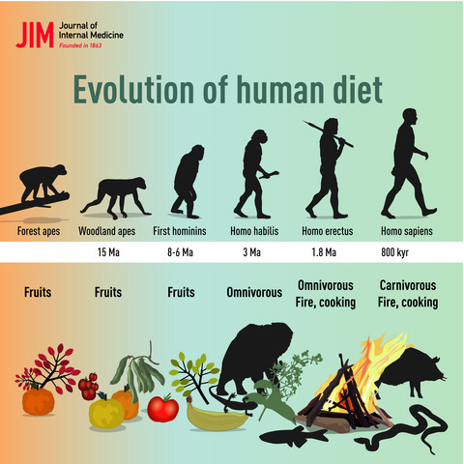

Task: Create a poster that highlights the importance of the Early Hunter-Gatherer diet. Explain the health benefits of what they were eating and explain why it is healthy.

Include:

1. A catchy, relevant title

2. At least one hunter-gatherer tribe

3. What were some of the foods they ate

4. Name some of the health benefits from eating these foods

5. Explain how the use of fire has changed humankind

