Food, Culture & Travel

Food is culture. Food is an identity, a footprint of who you are.
– Lidia Bastianich

Food for us comes from our relatives, whether they have wings or fins or roots. That is how we consider food. Food has a culture. It has a history. It has a story. It has relationships.
– Winona Laduke

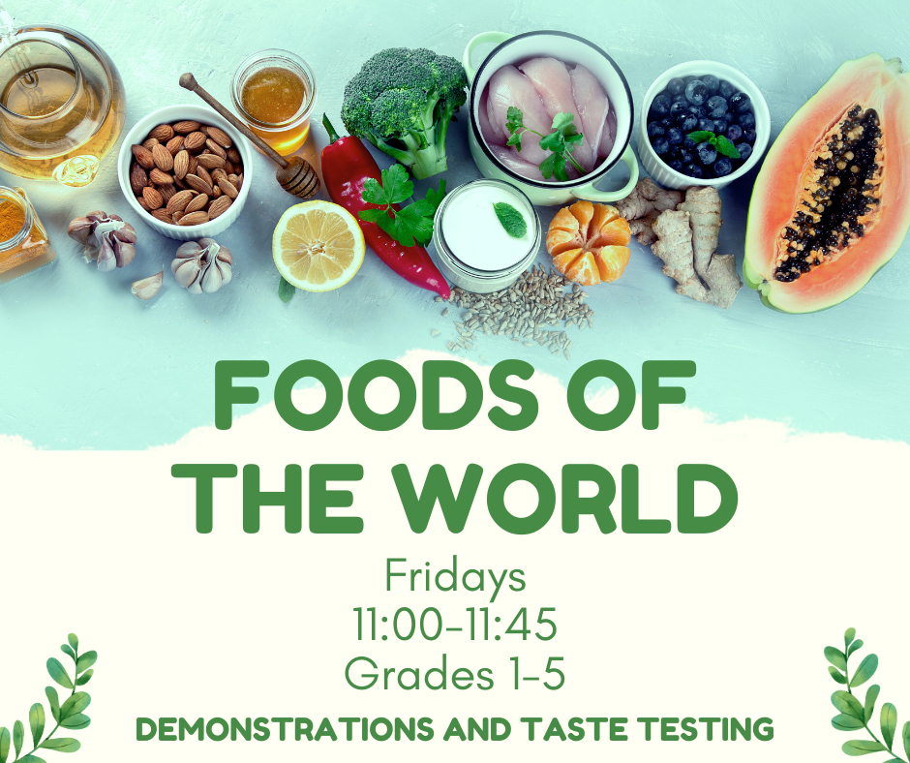

Week 2
Food, Culture & Travel –
A Global Perspective

Why study food and culture?

What can we learn about our culture and one another through the foods we eat?

Food is much more than a tool for survival; it is also a source of pleasure, comfort, and security. And, while it nourishes our bodies, it can also nourish our families and our communities. Food is one of the most important and persistent aspects of tradition and culture. Throughout the world, food is used to celebrate holidays, rituals, and family gatherings. For special occasions—and even for daily meals—our culture often determines what, when, and how we eat. These traditions connect us to our history, our locale, and to one another.

Food cultures also represent the wisdom gained and shared through thousands of years of experimentation and observation. For example, the grains and beans found in many food traditions have been determined to provide the perfect combination of amino acids our bodies need. Although it may seem that kids today only eat pizza or hamburgers, your students are likely to represent a tremendous diversity of food traditions. Be sure to set the stage for an open and accepting classroom environment so that students will feel comfortable talking about their family food traditions.

(Source: https://www.nourishlife.org/teach/curriculum/activity-3-food-traditions/).

Week 1 – The Week of July 17 to July 23, 2023

Task 1: Open your Red Books to two blank pages and at the top of the 1st page write in large letters the Unit Title “Food, Culture and Travel.”

Next write: ‘Week 1: Lesson 1 – An Introduction to Global Foods”

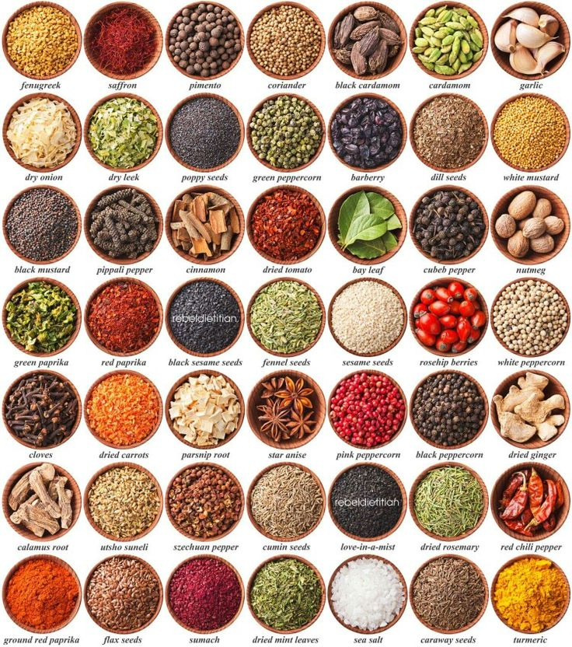

Week 1: Lesson 1:

Success Criteria:

Students will become familiar with key spices that are used to season food around the world, key facts about them and the significance of cooking our food with fire. By the end of the week students will be able to recount key information about several different spies as well as the benefits of cooking food with fire and what it meant for our brain development.

Spices Exercise

Class discussion: What is your favorite dish? What is your favorite spice?

Above are 49 different plants that are added to dishes around the world for flavor and nutrition. Choose 10 and tell me 3 things about them. It is acceptable for this exercise to use Wikipedia if you like. Follow the example below:

Fenugreek Seeds:
1. It is grown around the world and is used in many dishes in parts of India.
2. Its use can be traced back to the first century.
3. The word is from Latin meaning “Greek hay.”

Week 1: Lesson 2:

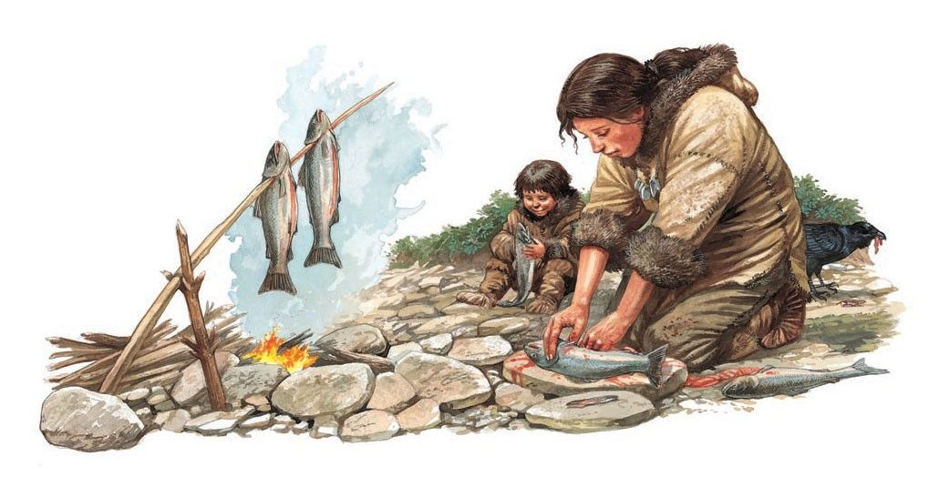

Today we are going to look at the history of food and the development of cooking.

Class discussion:

We are going to watch the video: “The history of food and the invention of cooking.” https://www.youtube.com/watch?v=YUk8LrLEiyk
We will start from the 8:00 sec. mark. Answer the following questions:

1. How has using fire to cook food helped humans? Name the 2 bonuses that humans get from cooking food with fire (9:50 sec. mark)

2. “Thanks to cooking, we have a new found surplus of _________ that went straight to our ________.” (9:30 sec.)

3. Of all the energy we expend, what percentage goes to fuel our brain? (10:00 sec.)

4. The Hadazbe people in Kenya are one of the few hunter-gatherer societies that exist in the world. What is the main food that they eat? It is the ______ from the ________ tree. They are packed with high levels of vitamin __? (12:00 sec.)

5. The Conga Robi berries are very sweet by they have 20 times the _____ than the average farmed berry (13:05 sec.)

6. How many varieties of plant and animal species do the Hadazbe people eat? (13:20 sec.)

7. How much more fiber do the Hadazbe people get in their day on average each day? (13:30 sec.)

8. How much more fiber is that compared to the average American diet?

9. Yes or No – the Hadazbe people get most of their food from meat?

10. Most of the Hadazbe diet consists of 4 things – name them:

a.

b.

c.

d.

11. What is the benefit of the Hadazbe diet? Their diet was heavily based not on meat but ______s.

12. In Australia, Aborigine food has some health benefits. Name some.

13. If we are to improve our health in the future, we need to learn some lessons from the past. Explain the meaning of this statement based on watching the video.

Week 1 Lesson 3:

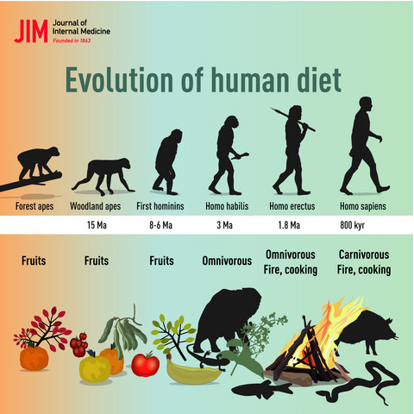

Task: Create a poster that highlights the importance of the Early Hunter-Gatherer diet. Explain the health benefits of what they were eating and explain why it is healthy.

Include:

1. A catchy, relevant title

2. Include at least one hunter-gatherer tribe

3. What were some of the foods they ate

4. Name some of the health benefits from eating these foods.

5. Explain how the use of fire has changed humankind.

Week 2 – The Week of July 24 to July 30, 2023

Can you guess this national dish pictured below?
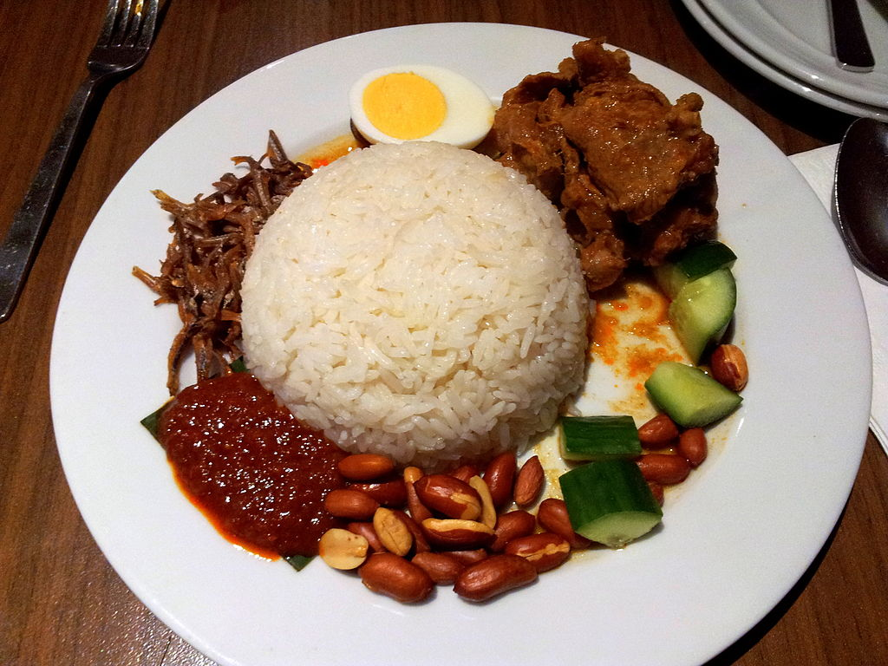

Week 2: Lesson 1: Food and YOUR Culture

Success Criteria

Students will become familiar with the relationship between food and their own cultural, religious or national backgrounds and be able to recount/describe the components of key international dishes and their traditions.

Tasks – Class Discussion

Task 1: In your Red Books write the Lesson Title and today’s date.

Class Discussion – What’s your country’s national food?

We will write down some of the ethnic groups and countries that students or their parents or grandparents come from. For example, your family may have originally migrated from Spain, Russia, Japan, South Africa, India or Fiji. Each country has a food tradition. For instance, if I were to say ‘hotdogs and hamburgers’ you might think of the United States. If I were to say ‘maple syrup,’ the word Canada may come to mind.

White Board: Let’s write on the board the different nationalities (countries) that students or their parents are from, and a food or meal that represents that country.

Country Food
Task 2: National Dishes:

Go online and look up the national dishes from the following countries. For instance, if you were looking up the national dish of Germany, you would Google “national dishes of Germany.”

1. Germany: Sauerbraten is a German pot roast dish which can be prepared using a variety of meats. The recipe includes such key ingredients as… It is usually made with beef and served with cabbage and potatoes.

2. New Zealand

3. Fiji

4. Italy

5. Spain

6. The United States

7. South Africa

8. Argentina

Homework: Ask your parents or grandparents for a favorite dish that reflects their ethnic background. For instance, if they originated from India – what is the national dish from the region they are from? There are usually several, but have them name their favorite.

Look up the recipe and write it here.
What does it smell like?
What does it look like?
What does it taste like?
What does it feel like in your mouth?
Do you still eat this dish? How often?

National Dish/Food Presentation: Students are going to create and present a 1-2-minute presentation that describes a national dish from a particular country, region, or culture they and their family belong to. If there is a food that is associated with a particular religion, you could include that too.

There are 2 possible types of presentation – basic & challenging.

BASIC EXAMPLE:

For the basic presentation you choose one food. For instance, if you are from New Zealand, you might choose Hokey Pokey Ice Cream and describe it. See the example below.

An Example from New Zealand (Basic)
Student name: John Doe
Hokey Pokey Ice Cream


Hokey Pokey is New Zealand’s bestselling ice cream.

Where did it originate: No one knows where it began but it was sold in Tyrell Stores in New Zealand as early as 1892.

Describe it: Hokey Pokey ice cream can generally be described as plain vanilla with small lumps of what is commonly known as honeycomb toffee distributed throughout it.

The 5 senses:
It smells like butterscotch candy; it tastes sweet and cold.

Interesting Facts:
- It is estimated that New Zealanders eat about two million litres of hokey pokey a year.

- The largest maker of hokey pokey ice cream in New Zealand is Tip-Top.

Other possible basic foods from New Zealand: L & P Soda, Kiwi Burger
Pavlova, pineapple lumps

Example from New Zealand (Challenging)
Possible Food Dishes

Whitebait Fritter
Roast Lamb
Kumara
Hangi

What’s the history – when or where did it originate? Is it linked to a particular person, event or idea? What is it made of? How is it served? What does it look like, taste like, smell like, and feel like? Is it nutritious? How did it become so famous in New Zealand?

Week 2: Lesson 2: Students are to work on and complete their class presentations.

Week 2: Lesson 3: Students will present their class presentations.

Presentations are NOT to be done on Powerpoint – they must be written into your Red Books. You will stand in front of class and chat about it. You are encouraged to show us a picture of the food/meal.

Week 3:

How One Food Spread Around the World


Week 3, Lesson 1: Students will finish their class presentations.

Week 3, Lesson 2 – How the Spanish Spread Chocolate Around the World

Success Criteria
Students will gain a thorough understanding of the history behind the cacao bean and how chocolate has changed over the years. They will also learn how the Spanish Empire controlled the production of cacao beans around the world.

Task 1: Write down today’s date and lesson. We will watch the video together as a class. As we do, take down key notes in your books.

Chocolate Production: https://www.youtube.com/watch?v=Tez9RZZIwC8

We will watch the documentary on the history of chocolate and occasionally stop and take notes.

Before we begin, write down the following definition:

Propaganda: information, especially of a biased or misleading nature, used to promote a political cause or point of view.

Key Information:

- The Scientific name for chocolate is Theobroma cacao
- This translates into “The Food of the Gods”
- Cacao is found only in the Tropics
- Part of human culture for over 2,000 years
- Mayans first known use of cacao by crushing it and making it into a beverage.
- before Europeans arrived
- Aztecs called it ‘Chocolatl’ (‘warm liquid)
- Aztecs had huge storehouses filled with cacao beans & used it as money
- A rabbit = 10 cacao beans; a mule = 50 beans
- It was used as money because it was
- a. portable. b. preserves well. c. highly prized.
- In 1519, Spanish explorer Hernando Cortez arrived in what is now Mexico, he was introduced to ‘Chocolatl’ and thought I was a wonder food, giving people boundless energy
- Spain planted the seeds in its tropical colonies and controlled the chocolate trade and making the country wealthy.
- In the 1800s, hardened chocolate was developed while the Swiss added milk to the recipe, leading to the mass production of candy bars and making it more affording to the common person. Prior to this time, it was mainly a drink of the elite and wealthy.

Week 3, Lesson 3 – Current Event on Food in the News

Read the article titled ‘Kids and Sports Drinks.’
https://foodandhealth.com/news-kids-and-sports-drinks/

Answer the following questions:
1. Are kids consuming more sports drinks or less?
2. What does Russ Ladwa think about kids and sports drinks?
3. Who were sports drinks first made for?
4. What percentage of kids consume sports drinks?
5. How much sugar should the average person eat in one day?
6. How much sugar is in one bottle of a typical sports drink?
7. Look at the orange ‘Sugar Math’ Chart. What is the key message?
8. Have a look in packaged items you may have in your bag that you brought top school for lunch. Look at the label. How many grams of sugar are listed?
9. Write a one paragraph summary of the article.

Week 4: Lesson 1 & 2 –

‘Strange’ Foods from Different Cultures

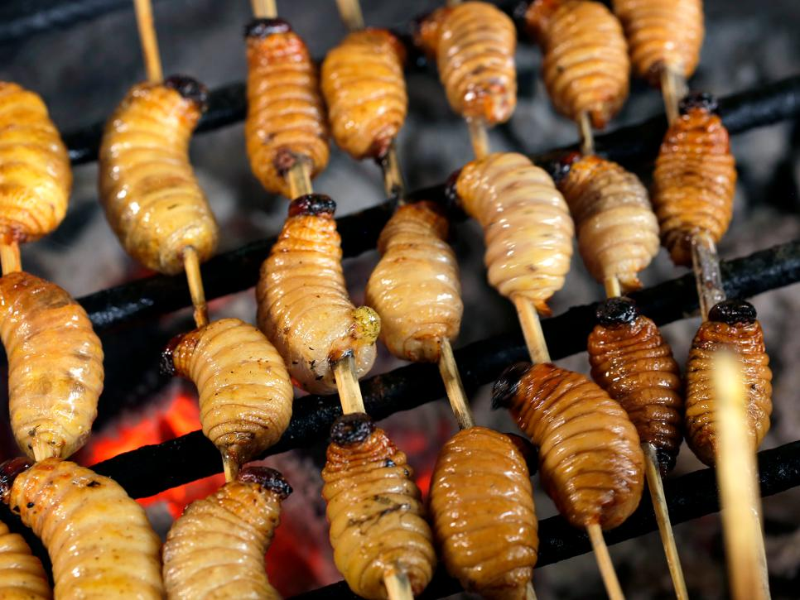

Success Criteria

Students will become familiar with a variety of unusual foods that are accepted in other cultures and basic vocabulary associated with these foods. By the end of the week, they will be able to recount key vocabulary words.

Class Discussion: Why is the word ‘Strange’ in quotation marks?

Has anyone in class ever eaten what we in New Zealand would consider a ‘strange’ food?

Class Discussion continued – read the following quote –

In learning about the other, about many ‘others,’ our conception of humanity is enlarged and enriched. We gain insight into the plasticity of human culture. We begin to see that our way of life is determined not so much by nature but by culture and history.
– David Mayberry-Lewis

What does this quotation mean?

Task: Look at the Reading titled ‘Strange Food.’ The article appears below. Once you have read the article, answer the questions and complete the vocabulary words.

Reading:

Strange Food
1. Crispy Tarantula Spiders
Fried tarantulas are a popular snack in Cambodia. During the dictator Pol Pot's regime, food was scarce and so the people resorted to eating these gigantic spiders. The head and body contain white meat, but the abdomen contains a brown coloured paste made up of eggs, excrement and organs. But they have proved to be well-liked and these days Cambodians eat them like candy.
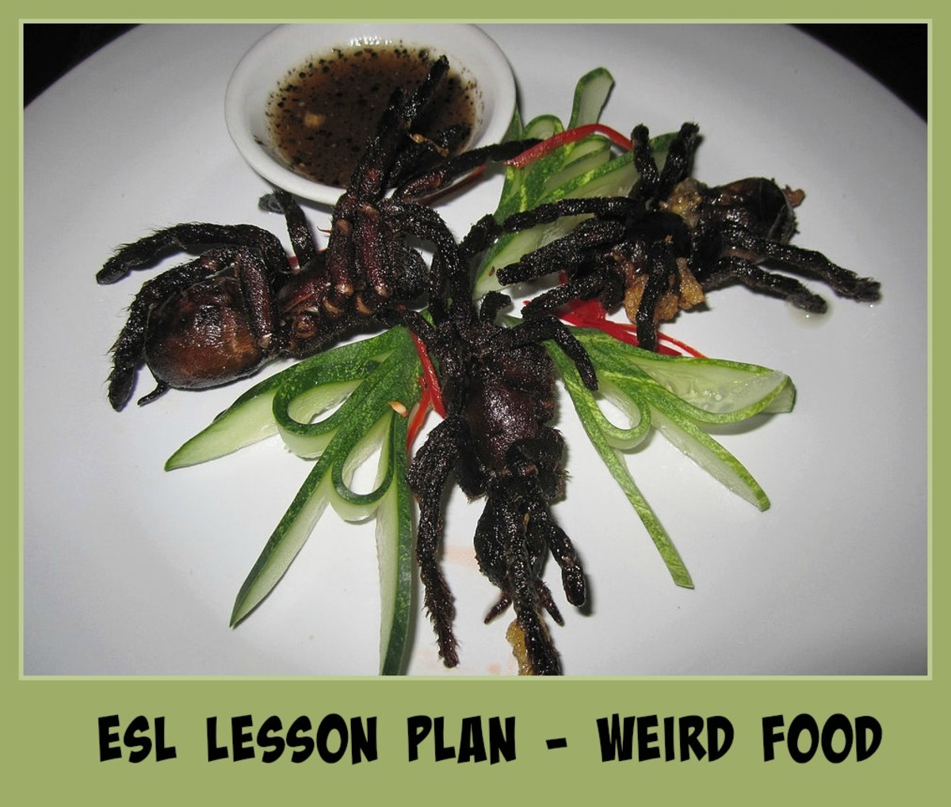
Thousand-year-old Eggs: These eggs aren't as old as they sound. The process takes from a few weeks to a few months. The eggs are preserved in a saline solution and the whites turn into a dark brown colour while the yolks turn to a dark green and grey colour. The eggs smell like a mixture of ammonia and sulphur.
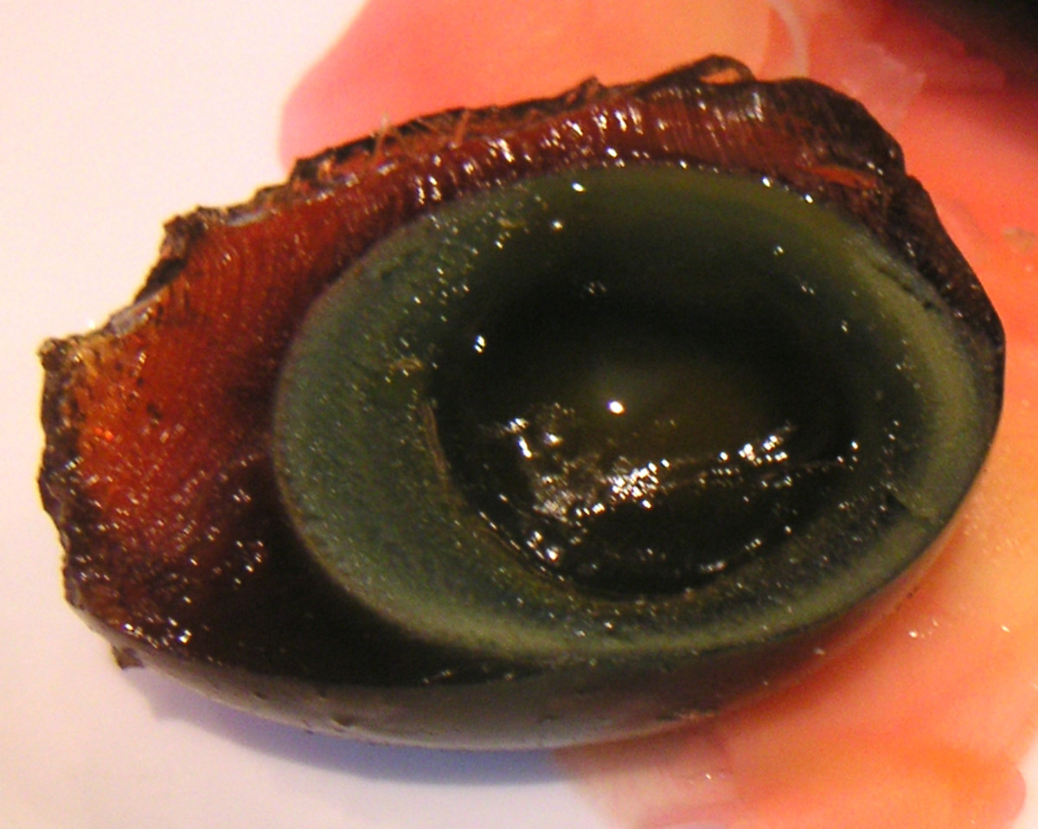
Balot: A balot is a developing duck embryo that is boiled alive and sold on the streets in Southeast Asia. Around 9 days after fertilisation the baby duck begins to form. They are cooked and then stored in sand to keep the eggs warm. Some countries prefer the ducks to be more developed. For example, in the Philippines the perfect egg is 17 days-old and the chick has not developed its beak, feathers or claws.

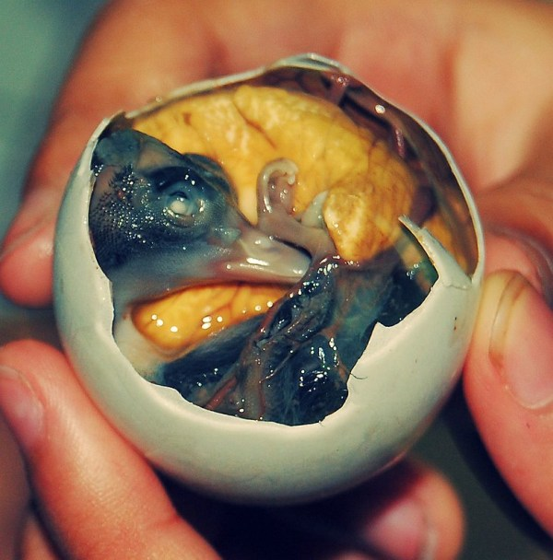

Hakarl - Dried Shark Meat
The rotting carcass of a basking shark is buried underground for a few months. Stones are placed on top of the shark so that the poisonous body fluids leak out. These fluids help the sharks survive the extreme cold waters, but are unsafe for human consumption until it has been hung out to dry for a few more months. The result? Rotten flesh that smells like a mixture of ammonia and fish.

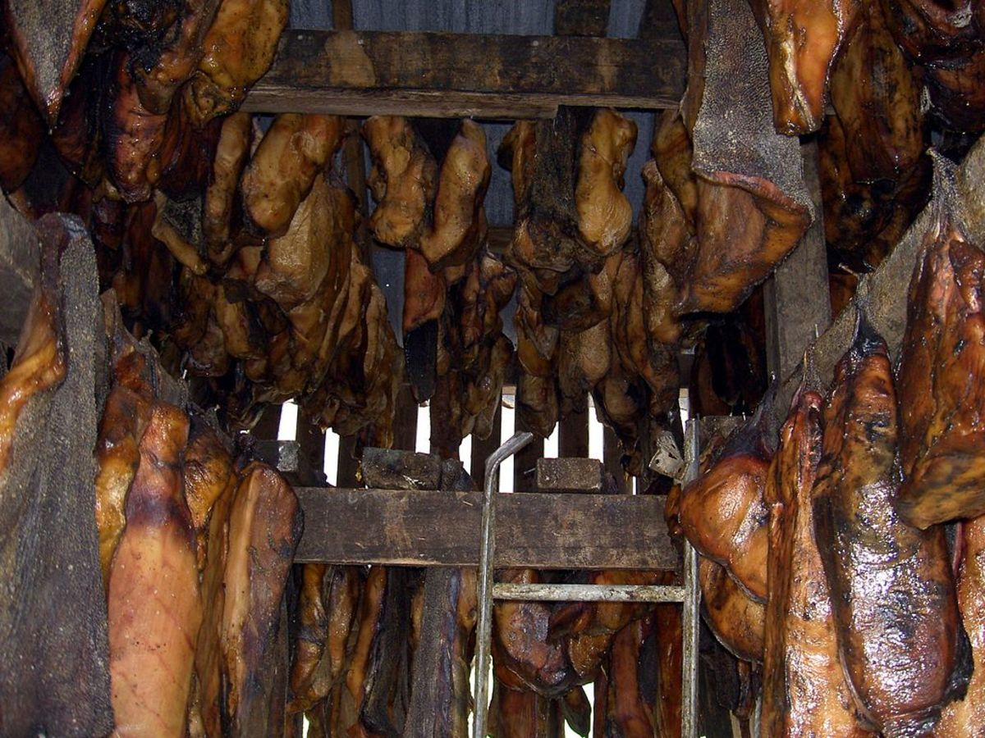
Bird's nest soup: One of the most expensive foods in the world is a Chinese dish that involves using a real bird's nest. Instead of using twigs to make a nest, this particular bird uses its own saliva. These red nests can cost up to $10,000.
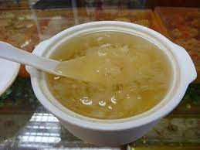

Fried-brain sandwich: Thinly sliced calves' brains were hugely popular in the United States. That is until people became worried about catching Mad Cows Disease (BSE). Cows' brains older than 30 months are no longer permitted in human food, though some restaurants still offer this dish. Chefs are now turning to pigs' brains instead, but as pigs' brains are smaller, they take longer to prepare and produce fewer slices.
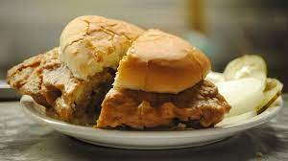
Ikiziuri: One of the most brutal dishes created is known as “Dead and Alive”. The recipe comes from Taiwan, where it is now illegal to serve it. Chefs cut open a fish and preserve the vital organs while they deep fry it. The fish is still alive as it is being cooked. Diners poke the head and eyes of the fish to watch it moving, alternatively you can ask the chef to put the filleted fish back into the tank to let it swim around until you are ready for seconds. Chefs claim it proves how fresh the fish is.
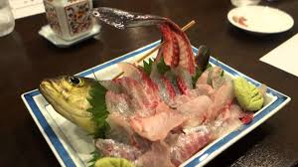
Nakji: This dish is quite dangerous and causes several deaths a year - it is not a meal for the faint-hearted. A live octopus is chopped into pieces in front of you and served with sesame oil. The octopus continues to squirm on your plate, but watch out! If you don't chew the poor creature properly, then the suckers on the tentacles can stick to your throat and cause you to choke.
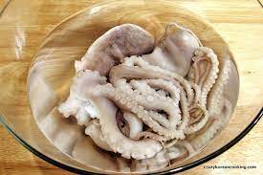

The United Nations Food and Agricultural Organisation estimates that 2 billion people rely on up to 1900 insects for food on a daily basis. Most people in the western world would not consider eating bugs as part of a healthy diet, but insects can be raised in small spaces without growth hormones and are low in fat and high in protein.

Reading Comprehension Questions
- Name the dishes that are dangerous to human health?
- Name the foods that mention a strong odour?
3. Which dish (if any) do you find the most disgusting?
4. If you had to eat a dish mentioned in the text for your next meal, which
would you choose?
5. What's the weirdest thing you've eaten?
6. Do you think any of the foods you eat would be considered strange by
foreigners?
7. If you had to choose between eating a rat & starving, would y?

Vocabulary Words:
- saline-
- beak-
- feathers-
- claws-
- saliva-
- twigs-
- filleted-
- squirm-
- suckers-
- choke-
What do the following food-related sayings mean? Look them up and explain.
1. Half-baked –
2. Eat us out of house and home -
3. Couch potato -
4. Variety is the spice of life -
5. There is no such thing as a free lunch -
6. Spill the beans -
7. Cool as a cucumber -
8. Bitter pill to swallow –

Week 4 Lesson 3:

Current Event Analysis

Letter to a Friend on Global Warming

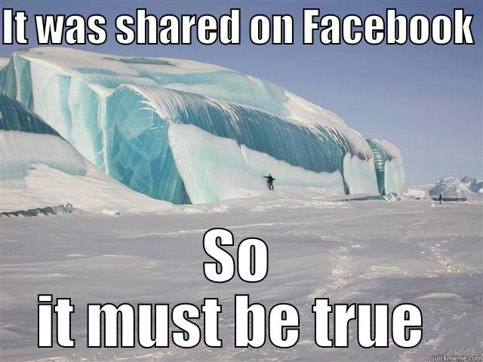

During Term 2 we looked at major weather events in New Zealand. We also looked at global warming and saw the documentary ‘An Inconvenient Truth’ narrated by Al Gore. At that time, I noted that the evidence for global warming was indisputable – the only question was – what was causing it and that most scientists believed it was humans pumping CO² into the atmosphere creating the Greenhouse Effect. Because this is considered by many to be the greatest threat to have ever faced humanity – it is important that there is no misunderstanding on this issue. The evidence for global warming being caused by human beings is now accepted by the scientific community to the point where even NASA has stated the evidence for humans causing it is clear and overwhelming.

Go to the website from NOAA the National Oceanic and Atmospheric Administration. What NASA is to space, NOAA is to the Atmosphere. Read the article and then write a letter to a friend who believes that Global Warming is a hoax. What evidence would you present to change his or her mind?

https://www.climate.gov/news-features/climate-qa/what-evidence-exists-earth-warming-and-humans-are-main-cause

Week 5: Junk Food and Western Culture

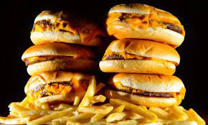

Week 5 Lesson 1: Western Culture & The Great Junk Food Experiment

Radio New Zealand interviewed an expert on a study involving advertisements on junk foods that target Kiwi kids. Watch to the interview:

“Kids exposed to 'enormous amounts of junk food advertising': RNZ Checkpoint.”

https://www.youtube.com/watch?v=3Zqr6V8M_Jg

1. How many junk food ads are Kiwi kids being exposed to every day on average?

2. What is the proposed solution?

3. How much money is eating junk estimated to cost New Zealand each year in health costs and lost productivity?

4. What diseases are being driven by poor diet?

5. Tobacco use has long been the number 1 health cost in New Zealand, but not anymore. What health condition is the new number one cost to health now in New Zealand?

Class discussion: How serious of a problem do students think that eating fast food is in New Zealand?

How many times do you eat fast food in an average week? Do you think this is too many times?

Draw a line down the middle of the page and make a list of the advantages and disadvantages of eating takeout food.

Eating Takeaway

Advantages Disadvantages

Week 5 Lesson 2: Western Culture & Junk Food – What’s in it?

What the video – ‘Why we can't stop eating unhealthy foods.’ Health Professor Laura Schmidt of the University of California outlines how big corporations get people hooked on junk foods and what we can do to fight back.

1. What is the main ingredient that is being used to get us to like junk food?

2. How do researchers try to get people addicted to eating items like Dorito’s corn chips?

3. In 1903, what addictive substance was banned from Coca-Cola?

4. Since 1903, what 2 addictive substances have been used in Coca Cola?

5. What percentage of all foods in the average grocery store have sugar added to them?

6. What adult disease are doctors now seeing in children that is linked to sugary drinks?

7. What is the main cause of non-alcoholic fatty liver Disease?

8. Does educating people about making healthy choices have a history of working?

9. What is the solution?

Week 5 Lesson 3: Western Culture & Junk Food – What’s in it?

How much junk food can we eat as part of a healthy diet? Read the article ‘How much junk food can you 'get away with' and still be healthy?’ by Christie Brissette:

Write a summary of the main points of the article under the following headings:

JUNK FOOD AND FAST FOOD DEFINED

LONG-TERM EFFECTS OF EATING JUNK FOOD

SHORT-TERM EFFECTS OF JUNK FOOD

A FEW DAYS OF JUNK FOOD

ONE JUNK FOOD MEAL

Do you think that the writer is qualified to offer advice of this subject? Support your position.

