Week 10:
In-depth Current Event Analysis

The Facts about Vaping


Success Criteria: Students will be able to recognize the risk factors that predispose teenagers to engage in vaping and the impact on their mental and physical health of those who vape.

Task 1, Task 1: Go to the website – ‘What does Vaping Do? New Research Shows Damage and Addiction,’ April 26, 2023 by Lara Salahi. After you have read the article which appears below, answer the questions that appear after it. Write the questions and responses into your Red Books.

WebMD Health News

What Does Vaping Do? New Research Shows Damage and Addiction
Written by Lara Salahi
April 26, 2023 – Jake Warn calls vaping “a toxic artificial love.”
Jake, of Winslow, ME, was 16 years old when he began vaping. Unlike cigarettes, vaping can be odorless, and its smoke leaves no trace – allowing him and his friends to use the devices in school bathrooms without fear of being caught.
He would use an entire cartridge containing the vape liquid, the equivalent to smoking one pack of tobacco cigarettes, within one school day. By fall semester of his first year in college, Jake said he had increased his use even more.
“It got pricey, so that’s when I really started to notice” the extent of his dependency, he said recently.
Vaping rates among teenagers in Maine doubled from 15.3% to 28.7% between 2017 and 2019, while Jake was in high school. In 2021, 11% of high schoolers across the nation said they regularly smoked e-cigarettes, and an estimated 28% have at least tried the devices, according to the CDC.
The FDA classifies e-cigarettes as a tobacco product because many contain nicotine, which comes from tobacco. Like Jake, the habit is likely to carry into adulthood for many who start in their teenage years, experts say.
Electronic nicotine delivery systems (ENDS) such as vapes have been touted by their makers and some in the medical field as a healthier alternative to cigarettes and as a way to help smokers give up the habit.
But, that’s not how Jake – who had never used traditional cigarettes – picked up vaping, or how he sold the idea to his mother.
“’It’s all organic and natural flavoring, it’s just flavored water,’” Mary Lou Warn recalled her son saying to her. She researched the health effects of vaping but didn’t find much online. But “I knew they were dangerous because you don’t put anything in your lungs that isn’t fresh air.”
A determined athlete in high school, Jake found his asthma worsened as he transitioned to college, especially when he ran a track meet or played in a soccer game.
Mary Lou Warn noticed changes off the field, too.
“He was coughing constantly, he wasn’t sleeping well, he wasn’t eating well,” she said. “I knew the addiction was taking over.”
Vaping irritated Jake’s throat, and he would get nosebleeds that he couldn’t stop, she said.
Since Warn first looked into the effects of e-cigarettes on respiratory health back in 2017, many studies have examined first-time smokers who never used combustible tobacco products and the short-term health outcomes. Studies suggest that vaping may worsen bronchitis and asthma, raise blood pressure, interfere with brain development in young users, suppress the immune system, and increase the risk of getting a chronic lung disease. Other research on mice and cell cultures has found the vapor or extracts from vapes damage the chemical structure of DNA.
Still, the limited number of long-term human studies has made it hard to pinpoint what the health outcomes of e-cigarette users will be in the future. Conclusive studies linking commercial cigarette use to deaths from heart disease and cancer didn’t emerge until the mid-1950s, decades after manufacturers began mass production and marketing in the early 20th century.
Years could pass before researchers gain a clearer understanding of the health implications of long-term e-cigarette use, said Nigar Nargis, PhD, senior scientific director of tobacco control research at the American Cancer Society.
“There hasn’t been any such study to establish the direct link from [vaping] to cancer, but it is understood that it [vaping] may promote the development of cancer and lung damage and inflammation,” she said.
For decades, advocates built awareness of the harms of tobacco use, which led to a sharp decline in tobacco-related illnesses such as lung cancer. But, Hilary Schneider, Maine’s director of government relations for the American Cancer Society Cancer Action Network, said she fears the uptick in the use of vapes – especially among those who never smoked or those who use both combustible and e-cigarettes – may reverse declines in the rates of smoking-relating diseases.
Multiple studies suggest inhaling chemicals found in e-cigarettes – including nicotine-carrying aerosols – can damage arteries and inflame and injure the lungs.
Vapes “basically have created a pediatric tobacco-use epidemic,” Schneider said. “What we’re seeing is unprecedented tobacco use rates, higher rates than we’ve seen in decades.”
One reason many young people start vaping is the attraction to flavors, ranging from classic menthol to fruits and sweets. A handful of states have banned or restricted the sale of flavored vapes.
“It’s new and it’s just been marketed in a way that we’re really fighting the false narrative put out there by makers of these products that are trying to make them appealing to kids,” said Rachel Boykan, MD, a clinical professor of pediatrics and attending doctor at Stony Brook Children's Hospital in Stony Brook, NY.
The flavor “Red Bull,” in particular, hooked Jake. And though he wasn’t aware of it at the time, nicotine packed into the pods may have kept him from quitting: The average nicotine concentration in e-cigarettes more than doubled from 2013 to 2018, according to a study by the Truth Initiative and the CDC.
The immediate risks of nicotine on the developing brain are well-documented. Studies suggest that nicotine – which is found in vape products – may impact adolescents’ ability to learn, remember, and maintain attention.
But many adolescents and young adults who use e-cigarettes say that vaping helps ease anxiety and keep them attentive, which also adds to the complexity of their dependency, according to Boykan.
Nicotine “actually interrupts neural circuits, that it can be associated with more anxiety, depression, attention to learning, and susceptibility to other addictive substances,” she said. “That is enough to make it very scary.”
Jake also said a social environment where so many of his friends vaped also made it difficult for him to quit.
“You’re hanging out with your friends at night, and all of them are using it, and you’re trying to not to,” he said.
Jake eventually took a semester off from college for an unrelated surgery, and he moved home and away from his vaping classmates. He eventually transferred to a different college and lived at home, where no one vaped and where he wasn’t allowed to smoke in the house, he said.
“He came home and we took him to a doctor, and they didn’t know quite how to handle kids and addiction to e-cigarettes,” Mary Lou Warn said.
Not fully understanding the long-term health implications of e-cigarette use has stopped many health care providers from offering clear messaging on the risk of vaping to current and potential users.
“It’s taken pediatricians time to ask the right questions and recognize nicotine addiction” from vaping, said Boykan, who's also chair of the American Academy of Pediatrics section on nicotine and tobacco prevention and treatment. “It’s just hit us so fast.”
But once pediatricians do identify a nicotine dependency, it can be difficult to treat, Boykan said. Many pediatricians now recognize that e-cigarette addiction may occur in children as early as middle school.
“We don’t have a lot of evidence-based treatments for kids to recommend,” she said.
Will Vaping Be a ‘Phase'?
Aware of his vaping dependency and the possible risks to his long-term health, Jake, now 23, said he’s lessened his use, compared to his college days, but still struggles to kick the habit for good.
“I’d like to not be able to use all the time, not to feel the urge,” he said. “But I think over time, it’ll just kind of phase out.”
But his mother said quitting may not be that simple.
“This will be a lifelong journey,” she said. “When I think of who he is, addiction is something he will always have. It’s a part of him now.”

QUESTIONS:

1. How do we know that the information on vaping is likely to be reliable? (Go to the ‘About WebMD’ Section and read what it says about the site). Here is the link:
https://www.webmd.com/lung/news/20230426/vaping-research--shows-damage-and-addiction

2. When it comes to health, it is important to have up-to-date information with the latest studies. How up-to-date is this article?

3. How reliable is the writer. Google the name ‘Laura Salahi writer’ and tell me her job and why she is likely to be a reliable source.

4. Between 2017 and 2019 in the U.S. state of Maine, how much did vaping rise among teenagers?

5a. In 2021, based a survey of teens across the entire country, what percentage of teens said they vaped regularly?
5b. Among the same group, how many said they had tried vaping?

6. Vaping does not contain tobacco, so why is it classified as a tobacco product?

7. What health problems did Jake have that were attributed to vaping? (Do not just list one or two – list them all).

8. Since 2017, a number of new studies on vaping have been done. What do they suggest?

9. Has the link between vaping and cancer been proven?

10. Complete the following sentence: Multiple studies suggest that ________ chemicals found in e-cigarettes – including ________ - __________ ___________ - can damage __________ and _______ and injure the lungs.

Task 2: Watch the video on how one Vaping Company Tried to Hook Kids: the Case of JUUL:



How JUUL Got Millions of Kids Hooked on Nicotine
https://www.youtube.com/watch?v=7fVxHavnih4 (8:46 sec.).

1. What is the name of the first ever e-cigarette? (1:01 sec.)

2. In what ways has JUUL tried to market e-cigarettes that is similar to the way tobacco companies once tried to advertise cigarettes? (2:00 to 5:00 sec. mark).

3. Explain how JUUL targets kids. In what ways have they tried to get kids to vape?

4. JUUL was taken to court for marketing to children. They lost. How much did they have to pay? (6:20 sec. mark)

Task 3: Using Peer Pressure to get People to Smoke

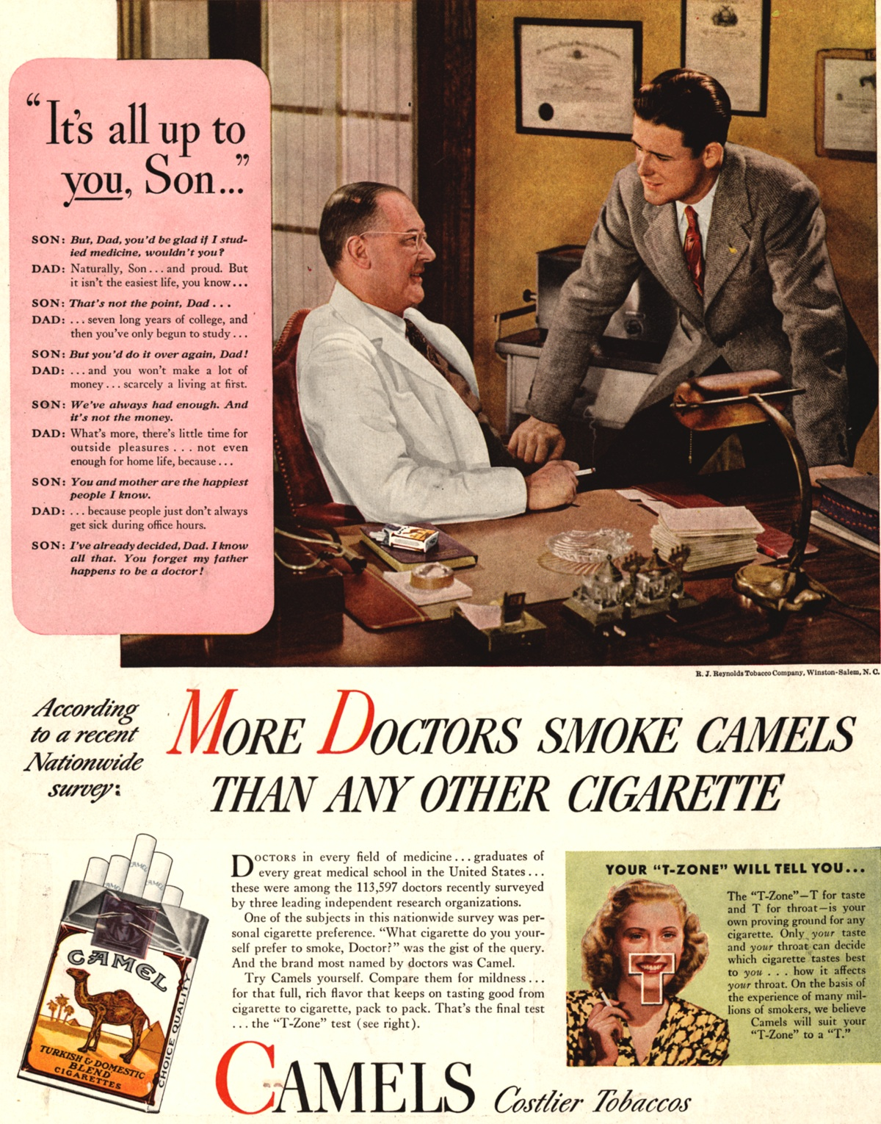

Task 4: Look closely at the ad on the previous page encouraging people to smoke. Next, watch the short clip below on how tobacco cigarette companies once tried to get people hooked on smoking cigarettes:
https://www.youtube.com/watch?v=E6BMH2ugVQY (1:02 sec.)

1. Was this an effective ad at the time it aired in 1949? Support your position.

Task 5: What does the science say about the safety of e-cigarettes?

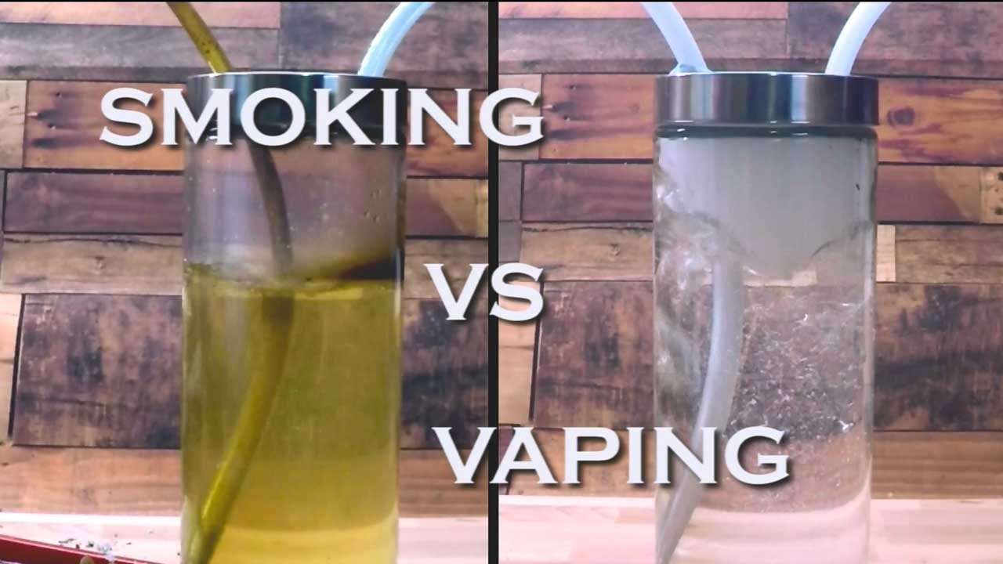Watch the video below and summarise the research on the harm caused by cigarettes in comparison to vaping.
https://www.youtube.com/watch?v=1OPvAsYUrYw (5:42 sec.)

1. Watch the first 2 and a half minutes of the video. What evidence is there that vaping is safer than smoking tobacco cigarettes?

2. Now watch the second half of the video. What evidence is there that vaping hams health? In what ways does vaping appear to harm human health?

Task 6: Vaping and Wanting to Fit In



Read the article, ‘Peer pressure at school influencing teen vape use’ at: https://www.news-medical.net/news/20191001/Peer-pressure-at-school-influencing-teen-vape-use.aspx

1. According to a new study, _______s play a major role in the sudden surge of e-cigarette use among teens.

2. A major problem with E-cigarettes is that teens often become addicted to ____________.

3. In what way is nicotine considered harmful?

4. Young people attending schools with high rates of vaping are more likely to believe that e-cigarettes are _____- ______ and less __________ than traditional cigarettes, regardless of if they smoke or not.

5. In which year did vaping rates soar in schools and why?

Task 7: Vaping and Peer Pressure



Watch the video on Vaping and Peer Pressure at:
https://www.youtube.com/watch?v=LIyzUVfJpN4

Based on the video, write down at least 6 key dot-points:

- Simah Herman was so addicted to vaping that she vaped at least every 15-minutes.

How do vaping companies use marketing and peer pressure to get more teenagers to vape?

