Week 7:

How a 15-Year-Old Farm Boy Who Invented Television
& Changed the World

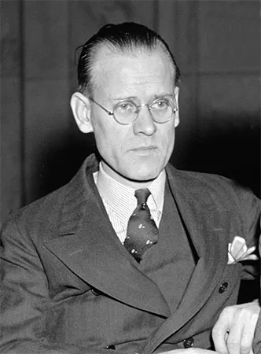

Philo Farnsworth

Selection Criteria:
Students will become familiar with the invention of television and how a 15-year-old boy was able to create one of the greatest inventions in history. By the end of the week students will be able to recount key details of his story and create a timeline of key events in his life.

Lesson 1: No school due to the King’s Birthday

Lesson 2: We will watch the documentary on the life of Philo Farnsworth ‘The Invention that Changed the World’ and take basic notes on key events and dates in his story.
https://www.youtube.com/watch?v=KV27xoxbR3I

Lesson 3: Students will write a newspaper article on key events in the life of Philo Farnsworth and create a Timeline of at least 5 key events in his life.

*For a broad ‘big picture’ overview of his life – see:
https://kids.britannica.com/students/article/Philo-Farnsworth/322999

