Week 6

Kiwi Inventors & Inventions: Placard Exercise

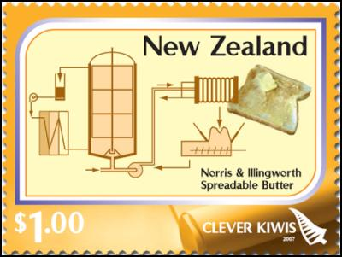

Lessons 1 to 3

Selection Criteria: Students will become familiar with the histories underpinning 12 different Kiwi inventions and the stories behind them. By the end of the week students will be able to recount six key facts about each invention and be able to describe how it was an advance on existing technology.

The lessons from this week MUST be done in class using the placards. During each class, students will work in pairs and share one of the 12 information sheets. NONE OF THIS LESSON IS TO BE DONE ONLINE. For students who may be away, they can catch up on any lessons they have missed during lunch or Focus Friday.

Your teacher will hand out the placards.

You must complete FOUR placards each class including answering the SIX questions per placard. That’s 24 questions in all per class.

