Week 6 - Year 8

Conducting Basic Research for your Survival Assessment

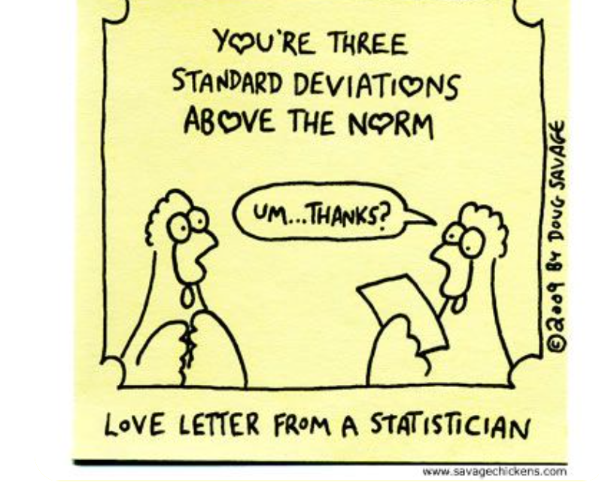

Success Criteria
Students will become familiar with how to conduct basic Global Studies research and by the end of lesson 2 will be able to conduct relevant and efficient searches on specific topics using key databases on the Mission Heights Library EPIC system including Academic OneFile, MasterFile, and the Australia & New Zealand Reference File.

Lesson 1: Students will be introduced to student expectations for the new Assessment. As a class we will review and discuss the different types of evidence and its usefulness, reliability and relevance. We will go over the handout on how to conduct basic research.

Lesson 2: As a class students will practice accessing and searching the EPIC Database.

Lesson 3: Work on the Assessment during class time.

