Week 6
Mātauranga Māori and Astronomy


Success criteria:
At the end of this week, students will have a basic understanding of Mātauranga Māori in relation to astronomy, and how Māori used the stars to navigate the ocean, plant crops by season of the year, harvest kaimoana, and to tell the time.

Week 6 Lesson 1 & 2:
Māori astronomy

Task 1: In you Red Book, at the top of a blank page write Week 1, Lesson 1, today’s date, and the heading ‘Revisiting Māori astronomy.’

Task 1b: In your Red Books write down the following definitions and use the word in a sentence. The first one has been done for you as an example:

1. dense: compacted and close together.

Example: The fog was so dense that airplanes could not fly into Wellington.

2. Tāne

3. ethnographer

4. compass

5. align

6. waiata

7. rākaunui

8. kaumatua

9. revitalize

10. Matariki

11. narrative

12. kōrero

Task 2: Next go to the website: ‘‘Revitalising Māori astronomy’ at:
https://www.sciencelearn.org.nz/resources/1274-revitalising-maori-astronomy

Watch the documentary, ‘Rākaunui, full Moon, Garden Today but don’t Fish,
And answer the following questions in your Red Books.

1. How were the stars important for Māori life and how is it related to Māori Whakapapa? (4:45 second mark)

2. Where do Māori believe they originally came from?

3. Much of Māori astronomical knowledge – tātai arorangi started to be lost after the early Europeans arrived in New Zealand. Why? (7:00 sec. mark).

4. Some people look down on Māori stories as being silly. Why is this wrong? (8:00 sec. mark)

5. How is the ‘SMART group’ trying to save the history of Tātai arorangi (9:00 sec.).

6. What are some of the uses of astronomy in Māori life (13:25 sec mark).

7. The Māori used the stars to tells the season and time? How could they tell when it was Winter (13:40 sec.)?

8. What star did they look for to tell it was Summer?

9. The Matariki was important because each year when it appeared it ________ the Māori calendar.

10. Māori have a big connection with planting and harvesting crops. When there was a full moon, crops were thought to grow better (16:15 sec.). How did they believe this happened?

11. How were the stars important in navigating? (17:25)

12. Navigators used a ________ compass to navigate

Homework: Make sure your Red Books are set up and are up-to-date.

Week 6 Lesson 3
Current Event Analysis – Global Studies

New Study on Global Warming Raises
Alarm Bells for New Zealand

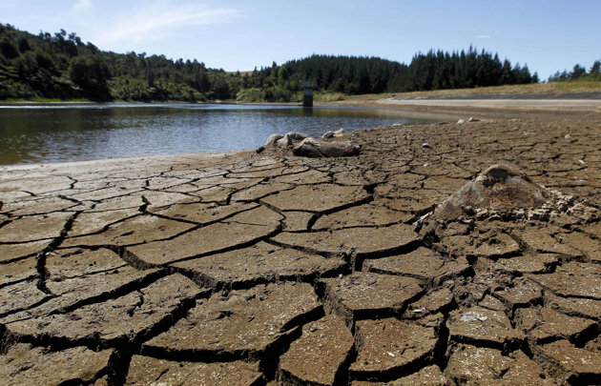
A recent study says that more needs to be done to combat the effects of global warming on Kiwis.

Task 1: Read the article below (Read the article – ‘Alarming new statistics reveal New Zealand's sea level could rise 30cm in next 10 to 20 years,’ By Samantha Hayes, NewsHub, May 1, 2022.

Task 2: You may find it helpful to watch the video that appeared with this story.

https://www.newshub.co.nz/home/new-zealand/2022/05/alarming-new-statistics-reveal-new-zealand-s-sea-level-could-rise-30cm-in-next-10-to-20-years.html (7:34 sec.)

Alarming new statistics reveal New Zealand's sea level
could rise 30cm in next 10 to 20 years
New climate change research has pinpointed the places in New Zealand where sea level rise will greatly outpace the global prediction of 30cm by 2060. For parts of Auckland and Wellington, 30cm of sea level rise isn't 40-50 years away, but just 10-20. By 2060 it’s approaching a metre in some places. That’s because combined with rising sea levels, parts of New Zealand are slowly sinking. It is predicted that by 2060, some people will have to abandon their homes and businesses and retreat from the coast.
The study's lead scientists are Richard Levy and Tim Naish. "I was shocked. I mean I knew it was bad, I knew we were getting sea level rise, we know that, I've been a climate scientist for 20 years, but I was shocked at how quickly it can happen," Naish told Newshub. "As we were going through it the surprises just kept coming," Levy added.
While Kiwis have all been getting on with their busy daily lives, the changes have been occurring and in climate change terms, it's happening at light-speed. "Like most people, I thought we had more time. We don't, we literally have a decade or two before in places like this we're gonna be at decision points about whether you look at some sort of managed retreat," Naish told Newshub.

So who's in the firing line?
Auckland's Britomart will flood. The north-western motorway, Tamaki Drive, Napier's brand new airport, Nelson's airport while Christchurch and Dunedin have big problems too.
Levy and Naish have spent the last five years working on this groundbreaking new sea-level rise study.
They've drilled sediment and ice cores to look millions of years back into the past, painstakingly reconstructing a precise climate record to inform their future projections. It's the cutting edge of climate research.
The whole world has been using one sea-level rise prediction - 30cm by 2060 if we limit warming to 2C - and New Zealand has used it too.
But there's one big factor that until today hasn't been included in the calculations, vertical land movement.
We know New Zealand has a dynamic coastline - it can move up and down in a dramatic way, just like we saw with the Kaikoura earthquake. But there are also constant tiny movements, just millimetres a year.
It might not sound like much but when you add any sinking to global sea-level rise it makes a massive difference. That's why some places in New Zealand will experience two or three times the global average of the sea level rises and we didn't know that until today. "When you weave that in with the ice sheets melting, the glaciers melting and the global oceans rising - in some places it happens twice as fast," Naish said. "We get twice as much sea-level rise than we expected so it's a big deal."
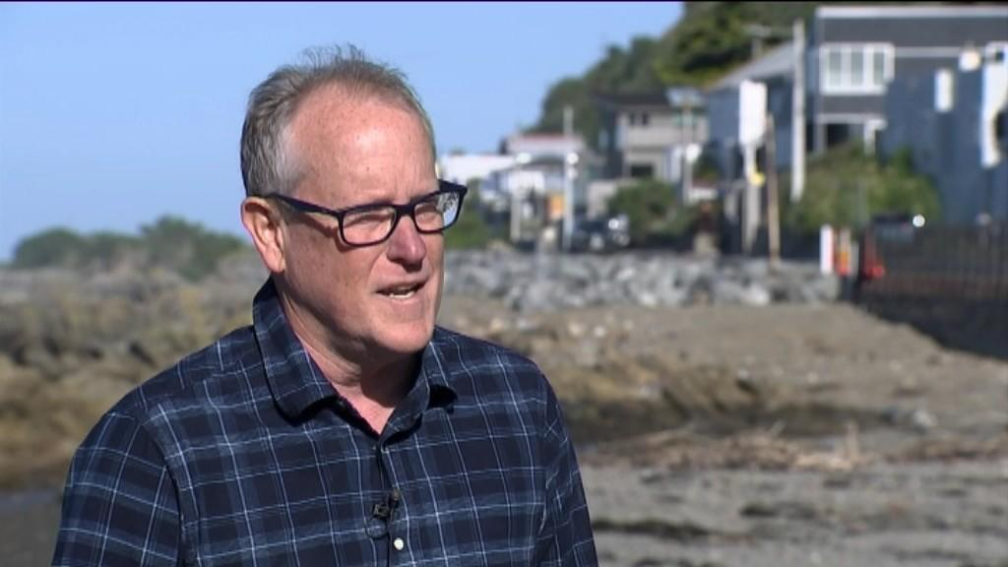Study's lead scientists Tim Naish Photo credit: Newshub
In areas where land is subsiding - such as Auckland and Wellington - town planners no longer have 40 or 50 years to deal with this. In just 10 or 20 years many homes, roads and rail lines will need to be raised, protected with sea walls or abandoned.
"Auckland was a big shock to us," Levy said. "It's one of those things where people think 'oh it's not gonna affect me, I don't have to worry about it' but the information we've produced is really making it clear that you do need to be concerned, you do need to pay attention," Levy said.
There have been a lot of moments over the last 30 years where scientists and climate activists have thought this is the moment that people will sit up and pay attention and do something about this and those moments have passed us by.

So what does sea level rise look like?
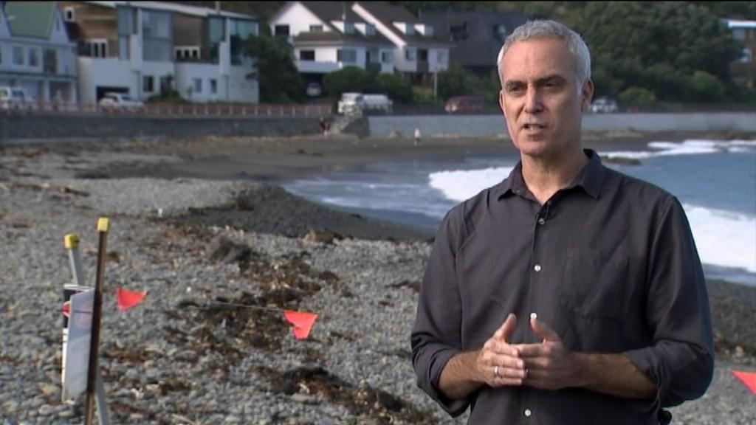
Study's lead scientists Richard Levy. Photo credit: Newshub
"We respect the science, we believe in the science, now get on and start developing those adaptation plans, start drilling down bay by bay, community by community to get the best strategies in place and then actually start spending money sorting it out to the degree that is reasonable."
"I do think that decision-makers will start to act on that because they're gonna have to," Shaw added.
This is a red alert, a siren blaring at the loudest it can go.

Task 3: In your Red Book write today’s date and write out the answers to the following questions, followed by your answer.

1. Write a newspaper headline about the danger of climate change to Kiwis – one that will get peoples’ attention.
2. Create a series of key dot-points in your own words. You should be able to generate between 7 and 10 main points.

Extension question: If you have time, give your position on global warming. How serious of a threat is it? What needs to be done to reduce the impact here in New Zealand?

