Week 5
The History of Te tāpoi Māori (Māori Tourism)

Lesson 1: Selling the Benefits of New Zealand

Selection Criteria: Students will become familiar with the concept of e tāpoi Māori (Māori tourism) and be able to recount key events in the history including The Terraces and the notion of authentic versus inauthentic Māori tourism.

Task 1:
As a class we will Watch the video put out by the New Zealand Government “100% Pure New Zealand – Official Tourism Ad.”
https://www.youtube.com/watch?v=B6PcZDVyohE (2:00 sec.).

Class Discussion: How is the New Zealand Government trying to attract tourists? What are some of the key selling points? Do you think it is effective?

Task: Everyone has their own strengths and weaknesses. Countries are no different. New Zealand has strengths and weaknesses when it comes to trying to get people to come here to visit as tourists.

Break up into groups of 2 or 3. Go to the official Government site for the 100% Pure New Zealand Tourism Campaign at: https://www.newzealand.com/int/

One half of the class will click on the link that says ‘North Island Destinations’ while the other half will click into the link that says ‘South Island Destinations.’ Your teacher will tell you which one to choose.
Draw a line down the middle of a page in your Red Books. On one side write ‘Strengths’ and on the other write ‘Weaknesses.’ Under ‘strengths’ list in dot-points form the key selling points of the various places shows. Under ‘Weaknesses’ list dot-points highlighting some challenges/difficulties tour operators have in trying to get overseas tourists to visit.
‘________ Island Destinations’

Strengths Weaknesses

Near the end of class, each group will contribute to a list of strengths and weaknesses that your teacher will write on the board and you will write into your books.

Week 5 Lesson 2

The Story of New Zealand’s 8th Wonder of the World – The Pink & White Terraces near Rotorua

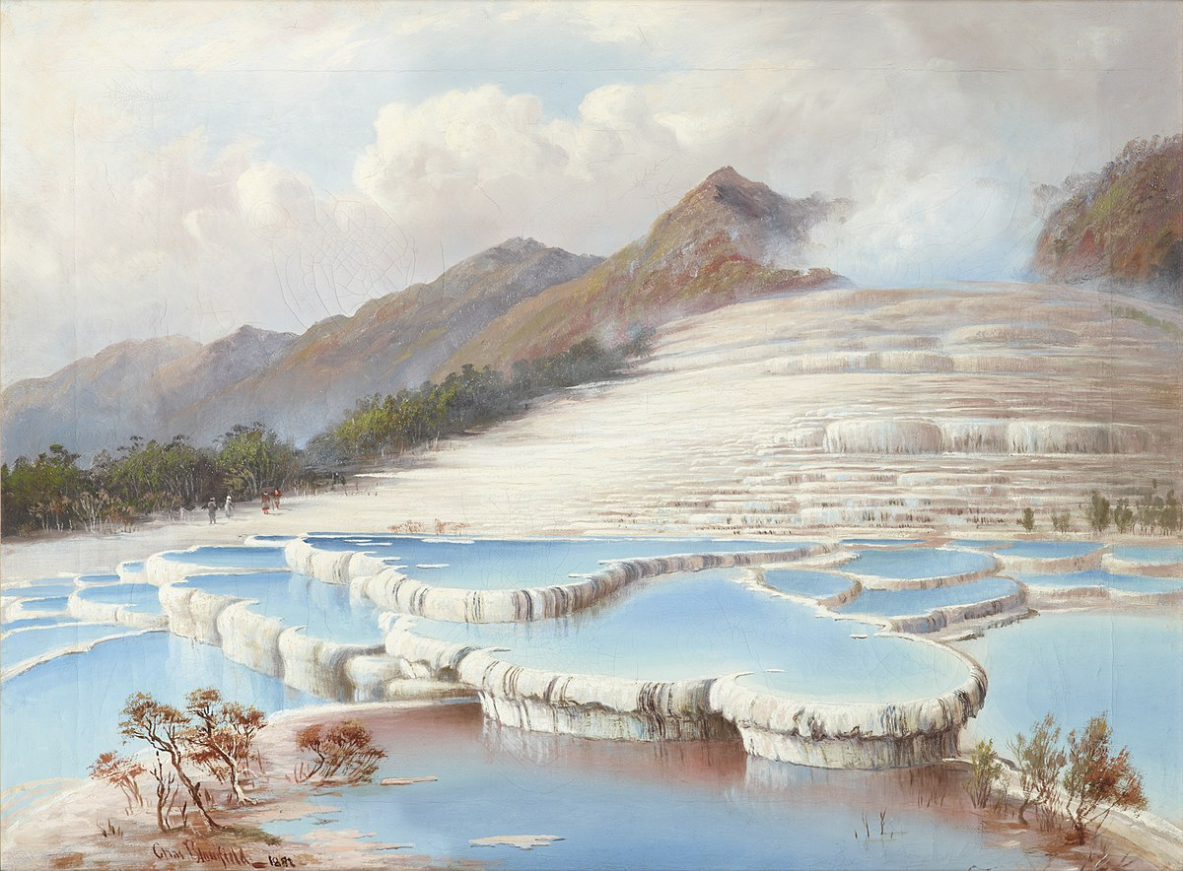

Class discussion: How many examples of Māori tourism can you name?

Task: Watch the video clip on the famous pink and white terraces of New Zealand.
https://www.youtube.com/watch?v=YSysQrNR850

Now read the following are on the history of the Terraces.

Geothermal Tourism: The Terraces

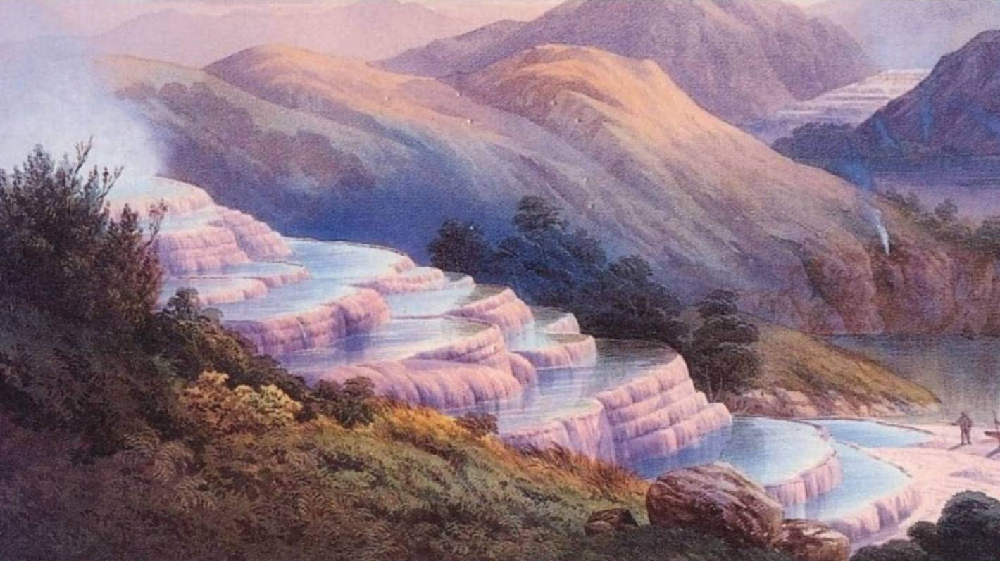

Māori have been a constant presence in New Zealand tourism, but the nature of their involvement has changed over time. Hot springs were used by Māori for treating illness, cooking, heating and bathing. They were also the early focus of tourism.

The hot springs in the central North Island are within the tribal area of two different Maori iwi (tribes): Te Arawa and Ngāti Tūwharetoa. Traditions about this geothermal region trace its origin to Ngātoroirangi, a tohunga (priest) who was riding on a canoe. One day he was freezing on Mt. Tongariro and called out to his sisters to bring fire to New Zealand from Hawaiki, the ancestral homeland of the Maori. They did, and this is said to be the origin of the geothermal areas.

During the 1800s, people from all over the world traveled to New Zealand for one reason – to see the famous pink and white terraces. They were once a dominant feature on the shores of Lake Rotomahana near Rotorua. They were so spectacular that many people referred to them as the 8th Wonder of the World. The Pink and White Terraces were the original New Zealand tourism destination.

The Creation of the Terraces
The Terraces were formed over hundreds of years. Rich geothermal water from boiling geysers flowed downhill to Lake Rotomahana. As the water cooled, the sand crystalized it formed The Terraces and pools. The pink colour of the pink terrace was due to chemicals in the water known as sulphides.

Early tourism in New Zealand

People would travel from far and wide to see the terraces and bath in the pools they created. A settlement was created at Te Wairoa with accommodation for these visitors and a cultural tourism industry was created by local Māori who entertained the guests and became the first Kiwi tourism guides.

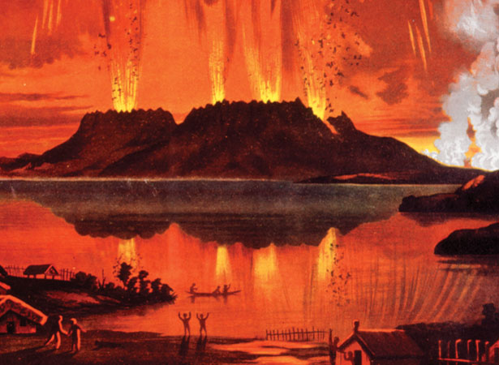

Pink and White Terraces were buried by the Mount Tarawera Eruption

When Mount Tarawera erupted on June 10th, 1886, Lake Rotomahana also erupted, The Terraces were pused under water, and several other smaller villages were destroyed. Photographs and paintings were all that was thought to have remained of these beautiful natural wonders.

Just after midnight on June 10th, the people of Te Wairoa were woken by a sequence of smaller earthquakes, followed by a much larger one, and finally massive explosions. For more than four terrifying hours, rocks, ash and mud bombarded the peaceful village. These were hours of loss and total devastation.

With the loss of this beautiful natural wonder came a sobering reality. The Tarawera eruption changed the New Zealand landscape dramatically and resulted in the loss of around 150 lives. New Zealand’s 8th Wonder of the World was gone.

The Aftermath

Before The Terraces were lost, local Māori controlled the tourism of the site.
The Tūhourangi people controlled access to the Pink and White Terraces. From the 1850s a sign at Te Wairoa displayed the set fees for guides and transport to the terraces. The wealth generated by Tūhourangi’s success in tourism saw pāua-shell eyes on carvings replaced by gold sovereigns – a sign that local Māori were thriving as a result of so many visitors coming to see The Terraces. Income from tourists gave Māori economic independence and made up for difficulties in sustaining agriculture in thermal areas. In Rotorua, Māori retained control over all major geothermal areas.

The eruption of Mount Tarawera in 1886 disrupted tourism and caused economic hardship for Tūhourangi and other iwi. Instead of providing aid, the government continued purchasing Māori land. By the end of the century the Crown owned most of the land in the Rotorua and Taupō districts which contained thermal springs. Local Māori had lost much of their land and their tourism income.

Today Maori have more control of their history and culture and how it is presented to tourists in Rotorua. But the problem of attracting tourists

After reading the article, answer the following questions by including key dot-points below:

1) Describe the early history of Māori in Rotorua including the nearby Terraces.

2) How did Māori lose control of The Terraces and tourism in Rotorua in general?

3) When the Government took control of Māori tourism in Rotorua, they were accused of not using authentic Māori culture. This is a big problem even today. Look at the photo below. Some businesses in New Zealand have been caught using fake Māori – that is – people from other cultures dressed up as Māori with fake tattoos to get more tourists and save money.

Explain why this is not acceptable and highly offensive to Māori people? Why it is important for Māori to be in control of how their culture is presented to the outside world?

Key definitions:
Geothermal:
Agriculture:
The 7 wonders of the world:

100% Fake Māori Tourism

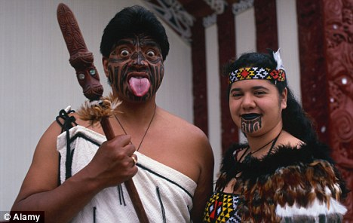

This photo appeared in the Australia Daily Mail in 2010 and exposed how at the time some tourism operators were using fake Māori to take part in Māori dances and rituals. Neither person in the photo is of Māori heritage, yet they were dressed in Māori attire, wore fake tattoos, performed Māori dances, and stood in front of a marae.

If you were a person of Māori descent, how would this make you feel? Imagine if you were of Indian heritage and traveled to India and visited the Taj Mahal (a famous Indian site) and they had backpackers dressed as Indians doing Indian dances?

This is known as cultural appropriation.

Task: Write down the definition of cultural appropriation below:

Cultural appropriation occurs when members of a majority group adopt cultural elements of a minority group in a way that is disrespectful.

To find out more – read here –
https://www.abc.net.au/news/2010-01-25/backpackers-act-maori-in-tourism-stunt/308304

Similar examples of so-called fake Māori tourism have happened recently.

Week 5 Lesson 3

The Māori Privilege Debate

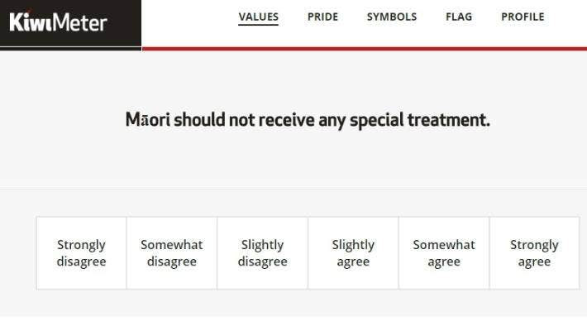

Should Māori be given special treatment due to their past mistreatment by the Government – and if they receive special treatment – is this not unfair for other Kiwi citizens?

The past treatment of Māori in Pukekohe and across the country can help non-Māori to better understand the need for government policies that are intended to create a society that strives to be fair and treat everyone equally. That is why it is important to address the issue of Māori privilege – a subject that upsets many non-Māori Kiwis. This is the notion that Māori receive special benefits from the Government – and that it is unfair to non-Māori. After all, the argument goes, everyone in New Zealand should be treated equally. To treat Māori differently and by giving them special benefits that other groups don’t receive – it is a form of racism against non-Māori people.

The argument against special treatment

The argument goes something like this: giving special privileges to compensate for past injustices, is unfair and against the principles of our democracy where every citizen should be treated equally. In short, it is reverse racism. Special housing loans and university scholarships given to some people based solely because they are Māori. The Māori All Blacks. Treaty rights. Fishing rights. Special seats in Parliament. On the one hand, it is argued giving Māori special treatment is unfair.

The argument for special treatment

It is worth recalling that Māori were colonized by the British for their resources, after which they signed a treaty which led to a series of wars in which they lost most of their lands. Their numbers were reduced by disease and they were sent to schools where they were often not allowed to practice Māori customs. Their population dropped from 150,000 in 1769 to 42,000 by 1896. Māori language was banned in so-called Māori schools and students were beaten for speaking their native tongue as the number of Māori speakers plummeted from 95 percent in 1900 to just five percent in 1980. For decades, Māori were not allowed to participate in rugby tours against South Africa. Even when the ban was lifted in 1980, they were only allowed to go as ‘honorary whites.’

The segregation in Pukekohe was followed by widespread discrimination in employment and housing in many parts of the country. These events are a testament to the need to compensate for the current situation that Māori find themselves. Today Māori are disadvantaged in every major social indicator, from cradle to grave.

Māori men and women die several years younger than their non-Māori counterparts, have higher rates of illness, infection, and psychiatric disorders. Māori have much higher death rates for stroke, heart disease, and cancer, and are two times more likely than non-Māori to forego collecting a prescription due to the cost. On average, Māori income is lower, employment is mostly in low-paying primary and semi-skilled jobs, and their housing quality is poorer. They are more likely to be suspended from school or expelled, increasing the prospect of juvenile criminality. Any discussion of the challenges faced by Māori today must include an understanding of how we got here and their treatment today. For instance, based on the 1971 census, there were 153 Māori undergraduates from New Zealand universities. This compared to 27,898 non-Māori who were attending at the same time.

Māori are just 17% of the population but over 50% of the prison population. Part of this reason has to do with stereotypes held by the rest of society. For instance, once convicted of a crime, Māori are more likely to be sent to prison than non-Māori. Eighteen per cent of Māori convicted of a crime receive a prison sentence, compared with 11 per cent of Pākehā. This may reflect the widespread view that Māori are more likely to engage in criminal acts.

One recent study found that most Maori experience racism on a daily basis – Read here:
https://www.rnz.co.nz/news/ldr/438895/most-maori-experience-racism-every-day-new-research

For instance, this study found that 89 percent of Māori said they were less likely to receive assistance because they were Māori, and most had been followed, watched or asked to open their bags in a shop. A quarter of those surveyed said they were followed all the time or often.
Eighty-seven percent had seen other Māori being treated unfairly in shops. Most Māori (79 percent) said that non-Māori media negatively portrayed Māori all the time or often, and of the 71 percent of Māori with a Māori name, most (53 percent) had to explain or spell their name regularly.

Task: Write a Letter –
Imagine that you recently overhead friend talking on their phone, complaining that that Maori receive too much free stuff from the Government. Write a letter to her in which you:
1) Define the term ‘Māori Privilege’
2) Explain why you can understand why some non-Māori are against the idea of helping Māori when they receive no obvious benefit. To them it seems unfair.
3) Make the case that the New Zealand Government should help Māori with special programs and benefits.

