Week 5 Global –

Kaitiakitanga (Māori Guardianship)
The Week of May 22 to 28

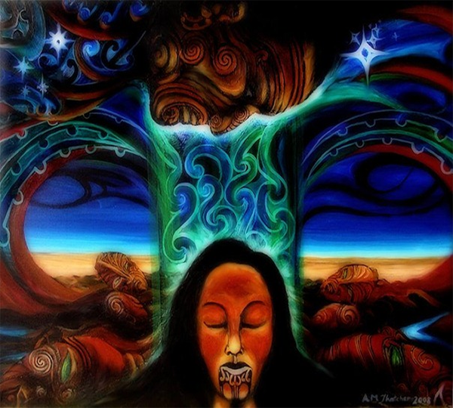

This week will look at the traditional concept of kaitiakitanga which is part of a complex, social, cultural, economic and spiritual system that has been established through long association of iwi and hapū with land and waters. In Lesson 3 we will be focusing on a current event on feral cats in New Zealand - which we will relate to kaitiakitanga later in the week.

Success Criteria
Students will be able to recite key definitions in relation to kaitiakitanga and how this concept relates to mana, tapu, mauri, and rāhui.

Week 5, Lessons 1 & 2

Māori Guardianship


Task 1. In you Red Book, write ‘Lesson 1: ‘Māori Guardianship.’

Task 2. We will watch the video: KAITIAKITANGA - THE UMBRELLA WAY OF LIFE, as a class at: https://www.youtube.com/watch?v=BTTN_V5ZcBc

Class discussion on ‘What is Kaitiakitanga ?’

Task 3: Write into your books, the following definition of Kaitiakitanga:

Kaitiakitanga means guardianship and protection. It is a way of managing the environment, based on the Māori world view. A kaitiaki is a guardian. This can be a person or group that cares for an area such as a lake or forest. They are given that role by the local iwi.

Task 4: We are going to look at the story of Kaitiakitanga – guardianship and conservation. Go to: https://teara.govt.nz/en/kaitiakitanga-guardianship-and-conservation/page-1

And read sections 1 to 7. Answer the following questions in your Red Books:

Section 1: Understanding Kaitiakitanga
Read this section for pleasure – it is an overview. There are no questions to answer.

Section 2: Connected to nature
What is the difference between ‘Tangata whenua’ and ‘Taunaha whenua?’

Section 3: Traditional kaitiakitanga
Give 4 examples where customary practices have kept a balance between a community and nature.
a.
b.
c.
d.

Section 4: Kaitiaki – guardians
List all of the different definitions of the word ‘Tiaki.’
a.
b.
c.
d.
e.

f. hunga is a group with _______ purpose.

g. In Maori culture, what does a kaitiaki do?

h. Can an animal be a kaitiaki? If yes, provide an example.

Section 5: Key Concepts
Define the following words:

a. Mana
b. Tapu
c. Mauri

Section 6: Rāhui – prohibitions

a. Define the word ‘Rāhui.’
b. Give an example.

Section 7: Kaitiakitanga today

a. Name 3 examples of Kaitiakitanga in action.
b. Define the word stewardship.

Task 3: Create a poster in your Red Books that highlights at least 3 elements of ‘Māori Guardianship. What are key themes we have discussed?

Week 5 Lesson 3:

Current Event on the Problem of Feral Cats in Aotearoa New Zealand.

Students have a choice of doing either the Basic or the Advanced Assignment.



Resources: Word document attachments

a. Basic Current Event

b. Advanced Current Event

