

In this task, you will create a brochure in Spanish to showcase your school. The brochure should include descriptions of your school, subjects, facilities, and timetable. Use your creativity to design an appealing and informative brochure. Consider using headings, subheadings, bullet points, and images to enhance the visual presentation. Here are the sections you should include:
- Portada (Cover):
  - Design an eye-catching cover that represents your school.
  - Include the school name, logo, and any other relevant visuals.
- Descripción de la Escuela (School Description):
- Describe your school in terms of: name, size, appearance, how many students, mix of one gender, public or private.
- Materias (Subjects):
  - List the subjects you study at your school.
  - Highlight your favorite subjects and explain why you enjoy them.
- Instalaciones (Facilities):
  - Describe the facilities available at your school.
  - Include information about the sports facilities, computer lab, cafeteria, and any other amenities.
  - Highlight any special features or resources that make your school stand out.
- Horario (Timetable):
  - Present a sample timetable to give an overview of a typical day at your school.
  - Include the subjects you have, their duration, and any breaks you have throughout the day.
  - Feel free to use a table or a visually appealing format.
- Información Adicional (Additional Information):
  - Provide any additional information that potential students or parents may find helpful.
  - Include contact details, admission procedures, or any upcoming events.
Remember to use accurate vocabulary, grammar structures, and descriptive language throughout the brochure. Be creative with the design, layout, and use of images to make it visually appealing.
Resources in MHOL
https://docs.google.com/document/d/12i-3N-Bk49AuZn_aZCdv6sd91xzP9UeKMcuqvM16-vw/edit
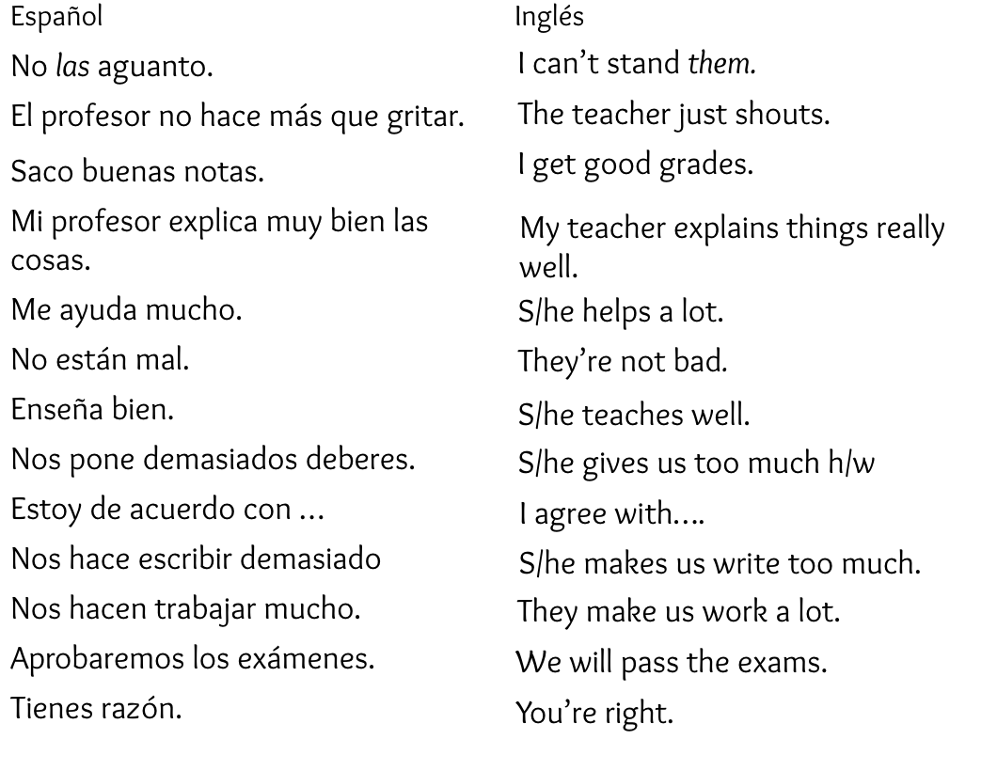

Assessment TAAB Rubric
Student ability of providing a description in a familiar context

Criteria | Working Towards | At | Above | Beyond
Content | You have provided superficial information of the required sections | You have provided some information with some accuracy and detail information | You have provided most of the information with overall accuracy and detail | You have provided all the information required with accuracy and detail
Language features | You have used simple sentence structures to demonstrate a simple understanding of the Spanish language | You have used some language features that demonstrates an understanding of the Spanish language | You have used a range of language features that shows accurate control of the Spanish language | You have used an extensive range of language features that demonstrates fluency in the Spanish language
Grammar | You have yet to include basic vocabulary and grammatical concepts | You have included some variety of vocabulary and grammatical concepts | You have included several vocabulary and grammatical concepts | You have included a wide range of vocabulary and grammatical concepts
Time Management | You have not submitted your assessment | You have submitted your assessment late | You submitted your assessment by the due date | You submitted your assessment by the due date
Overall | WORKING TOWARDS the curriculum expectation | Working AT the curriculum expectation | Working ABOVE the curriculum expectation | Working BEYOND the curriculum expectation

