Week 10:

Student Role-playing

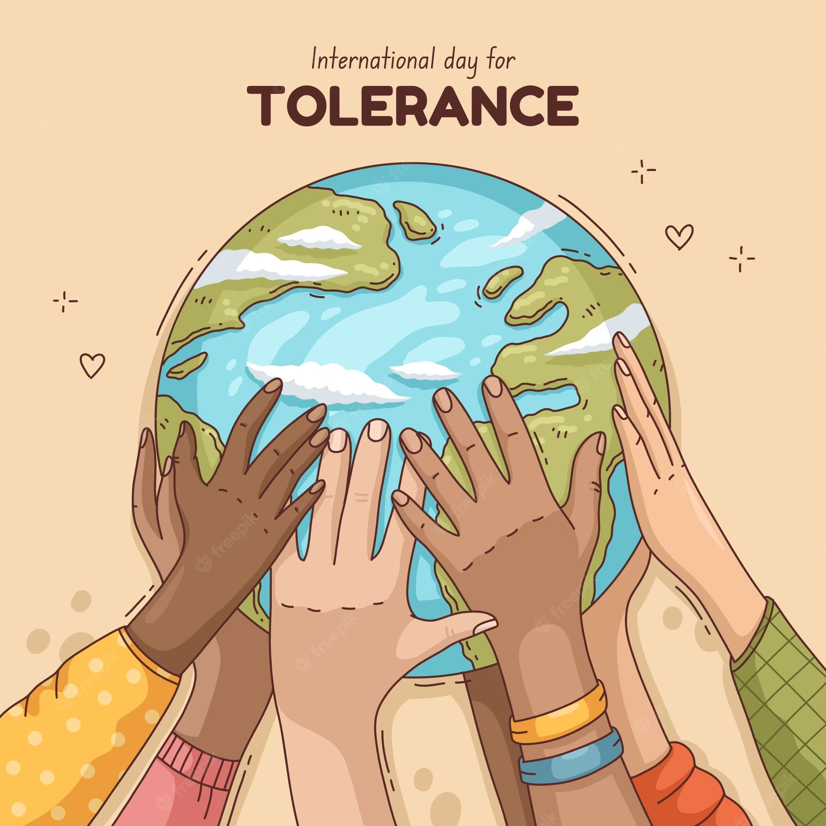
Week 10: Role-play

Success Criteria
Students will solidify and expand their knowledge and familiarity with the history of exclusion in New Zealand in relation to several different minority groups (Māori, Indian, Chinese, Pacifica peoples) and they will be able to engage in role playing and exhibit empathy with their marginalization in society.

Lesson 1: Students will finish their plays by the end of class.

Lesson 2: Students will present their plays.

Lesson 3: There is no Lesson 3 as our third class is scheduled for Good Friday.

