Week 8

Icon Presentations & Current Events


Success Criteria: Students will finish presenting their icon presentations in class, then they will complete two current event assignments. By the end of the week they will be able to recount key details from from both current events including the 5 W’s: Who, what, when, where, and why.

Lesson 1: Completion of Icon Presentations in Class

Lesson 2: Current Event Analysis
Did Giant Crocodiles once swim in
the Waikato River?



Believe it or now – and do believe it because it’s absolutely true – during the 1880s, some people believed that a giant crocodile once roamed the Waikato River on the North Island. Our story begins in September 1886, when …
Read the article on Great Waikato Crocodile Hunt of 1886 at: https://timespanner.blogspot.com/2008/12/great-waikato-saurian-hunt-of-1886.html
1. Who were the first two witnesses?
2. What happened when Constable Wild looked for the creature?
3. How was the story reported in the Waikato Times newspaper? Did they try to hype it up to get more readers or were they skeptical?
4. How did some of the Auckland newspapers sensationalize the story?
5. At the end of the article, what does the writer conclude was responsible for the monster sighting?
6. You can go to the New Zealand National Archives online and read one of the newspaper reports for yourself at: https://paperspast.natlib.govt.nz/newspapers/WH18871108.2.17

7. Some experts believe that what people were seeing in the Waikato was a large seal? See: https://www.stuff.co.nz/national/95338327/waikato-farmer-surprised-by-sunbather-on-his-property

8. What is your opinion? How is it possible a crocodile could survive in the river for so long? Where did it come from? Isn’t it more likely that people were misidentifying a large seal from a distance?

Current Event Analysis: Week 8 Lesson 3
Fitness Trackers
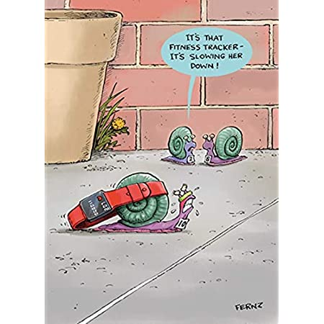
So you’re outdoors and getting fresh air and exercise. Great!
And you’re tracking every step you take.
But just how Safe is your Fitness Tracker?

Watch the video – ‘Dangerous Side Effects Reported From Popular Fitness Trackers’ at: https://www.youtube.com/watch?v=NNpBgX284Sk

According to a CBS News report, there have been several complaints from people who claim that the fitness tracker they were wearing, gave them shocks. After watching the clip, l want you to complete the following Tasks in your Red Books

Task 1: Write a short summary making the case that fitness trackers can be dangerous. What is the evidence?

Task 2: Write an evaluation of how accurate this report is. Make the case that fitness trackers ARE safe based on what was reported in the second half of the article. Also, you may wish to comment on how old this report is, and if you found many similar reports online.

