Week 9

A Migrant’s Experience

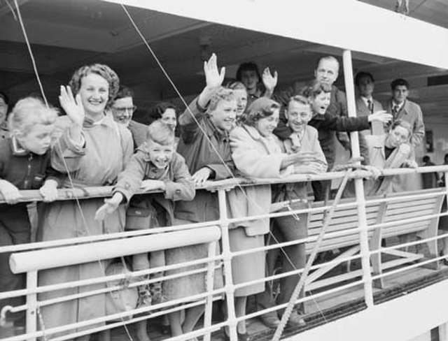

Lessons 1, 2 & 3:

Students will work on their ‘Migrant’s Experience’ Assessments in class.

I will be here to assist any student to complete their assessments.
If the are unable to locate a migrant, one will be provided for you.

The Assessment is due at the end of the last lesson of this week.

The Assessment questions appear below:

Global Studies Mountains Whanau – Term 1 2023

The Migrant Experience
Assessment

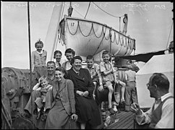

Date given & due: Week 7 Lesson 3 & due Week 10 Lesson 1
Class time given: 3 Sessions (Week 10 at the end of Lesson 1)
Format: A booklet, hand-written or word processed
or a poster with teacher approval

Students will:
Interview a person who migrated to New Zealand and collect information to create a booklet which describes their experience.

Instructions:
- Find an adult to interview who migrated to New Zealand (They must be 18 and older).
- Use the interview questions provided at the end of this handout.
- Create 5 headings and place the information under one of the 5 headings. Include the interview transcript with your booklet.

Your information should appear in 5 sections:

- An Introduction
- A. Migrant’s name
- B. Family situation (what other nuclear family members migrated with them to New Zealand). *Nuclear family = ONLY the mother, father, sister, brother.
Possible sentence starter: When ________ first came to New Zealand, they arrived with their….
- Leaving Home

- Identify what the migrant brought from their old country (at least two items)
- Identify what things the migrant left behind (for example, pets, a house and car)

- Push & Pull Factors
- Your model should show at least 3 push and/or pull factors for their country of origin and New Zealand.

4. Adapting to their New Life
- Write a paragraph describing the differences between their life in their home country and their life in New Zealand (for example, clothing, food).

Possible Sentence Starter:
There were many differences between life in _________ and New Zealand. One such example is…

- Write a paragraph about the challenges faced in their first year due to: language differences (e.g., limited ability to speak English), finding work, cultural differences, getting around. What has your migrant done to overcome some of these challenges?

Possible Sentence Starter:
During their first year in New Zealand, ______ _________ faced many challenges. One difficulty that had to be overcome involved………

5. A Visual

- Include at least one relevant visual – these may be of your migrant, their country of origin or anything you have referenced in your interview. These may be hand-drawn, photographs or sourced from the internet. If from the internet they must be referenced. The picture should include a caption (a few words under it describing what the picture is about)

Interview Questions you will need
to ask to Complete the 5 Sections:

1. Information required for the Introduction

- What is your first and last name?
- Are you married?
- Do you have children?
- What year did you come to New Zealand?
- What country do you come from?

2. Information you need to talk about them leaving their origin

- What things did you bring with you? (List two)
- What things did you leave behind? (List two)

3. Information you will need to create a Lee’s Migration model

- List some good things about the country you migrated from
- List reasons why you left your country
- List some reasons for migrating to New Zealand
- What are some negative aspects of living in New Zealand

4. Information you will need to describe their new life

- What are the differences between your home country and New Zealand? (e.g. food, weather, language, customs, education, culture)
- What challenges did you face when you came to New Zealand? (e.g. language, getting a job)
- What did you do to help you with these challenges?

5. They may have some pictures that will help you

- Do they have any photographs I could copy for my assignment?

Planning Sheet for Students with
English as a Second Language

1. Information required for the Introduction

- What is your first and last name?
- Are you married?
- Do you have children?
- What year did you come to New Zealand?
- What country do you come from?

2. Information you need to talk about them leaving their origin

- What things did you bring with you? (List 2 things)
- What things did you leave behind? (List 2 things)

3. Information you will need to create a Lee’s Migration model

- Why did you leave your country? List some reasons.
- Why did you think that New Zealand was a good place to live?
- What things about New Zealand do you not like and not like?

4. Information you will need to describe their new life

- What are the differences between your home country and New Zealand? (e.g. food, weather, language, customs, education, culture)
- What difficulties did you face when you came to New Zealand? (e.g., language, getting a job, different food, weather)
- What did you do to help you with these challenges?

5. They may have some pictures that will help you
- Do they have a photo you could copy for your assignment?

