Week 99

The Early British Migrants in
New Zealand

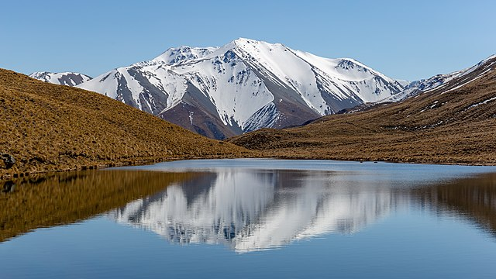
The lure of distant lands: Lake Mystery, Canterbury (Source: Wiki Commons)

Lesson 1:
Longing for a Better Life

Success Criteria
Students will become familiar with the push and pull factors affecting British citizens and their decision to migrate to New Zealand during the 19th century (1800s). By the end of the week they will be able to identify and recount an array of factors affecting their migration and challenges faced once they arrived in their new country.

During the 19th century (1800s), many people from four main parts of the world decided to migrate to New Zealand and create a new life for themselves and their families.

Task 1: As a class we will take turns reading pages 4 and 5 of the Ruth Naumann book, The Tauiwi: The Later Immigrants.

Class Discussion: Why do you think the new migrants to New Zealand were mostly from Europe and Asia and not North and South America?

Do any students know if any of their relatives may have migrated from Britain (England, Scotland, Wales & Ireland) to New Zealand at this time?
Class Discussion continued – your teacher will write on the board – we will come up with a list of a few push and pull factors for 19th century British citizens migrating to New Zealand.

Task 2: Answer the following questions in your Red book. Be sure to rewrite the question when you answer it. See question 1 as an example.

1. What is the meaning of Tauiwi? (see bottom of p. 4)

Sentence starter: The Māori word Tauiwi can be defined as later immigrants. Tauiwi means ______ _________ or foreign _____.

2. List some of the reasons why people left their home country to start a new life in New Zealand.
Sentence starter: There are several different reasons why people have migrated to New Zealand including….

3. What were some of the dangers faced by new migrants while making the journey by ship?`

4. Look at the image that appears on the top section of page 5 and write into your Red books the following heading: ‘How Early Settlers Changed the Environment.’ Underneath this heading and using dot-points, list at least 10 ways that these new settlers changed the environment. The first 2 have already been done.

- Cleared forest for farms
- Built fences
- Dug the ground for ____. ______, and ________.

Task 3: Read p. 8 and name some differences between upper class and lower class people in Britain at this time. Create the 2 columns below in your Red books and draw a line down the middle of the page separating them. I have started with some examples:

Upper Class (rich influential people) Working Class

Only the wealthy went to school It was difficult to move up in class

Could not vote for Members of
Parliament

Week 8 Lessons 2 and 3:

Come to New Zealand for a ‘Sweet As’ Time!

Poster Project
Your may work in pairs

Read pages 9-11 of The Tauiwi: The Later Immigrants by Ruth Naumann.

Task 1: Imagine you are living in New Zealand and the year is 1850. Create a poster that can be used to entice British citizens living in England, Scotland, Wales, and Ireland, to voyage to New Zealand and begin a new life. Some people used advertisers to cleverly get people to leave Britain and migrate to New Zealand. You must be truthful – you cannot lie, but you can exaggerate because that is what was commonly done at the time. For instance, on may ships there was even a hospital section, but on the negative side medicine was not very advanced! Remember, prospective passengers had to meet certain requirements (see p. 10).

Your poster should have:

1. A catchy, relevant title
2. Explain clearly how migrating to New Zealand will change their lives for the better
3. Some people worried the Māori were savages who would try to eat them! What could you tell them about Māori culture to make them feel less worried?

Feel free to use colored pencils to make your poster more attractive.

Here is an example of an ad to get people in Scotland to migrate to New Zealand:

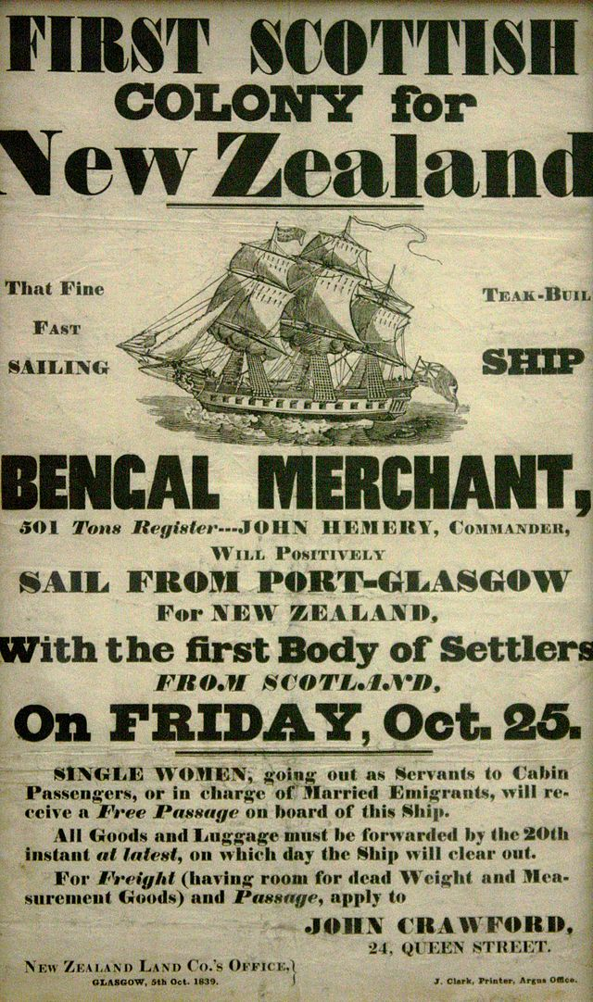
To get some ideas, have a look at these old New Zealand tourism posters from the early 20th century. Each of these posters are from Wiki Commons. Your poster should have more text than these and be closer to the poster above.

