Week 5: Growing Up Māori in Pukekohe –
A Case Study

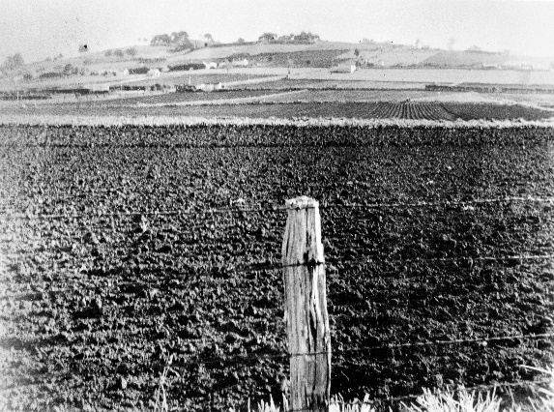
Pukekohe Hill 1956 – photo by Donald Trevor Hunt.

Success Criteria
Students will gain an understanding of what it was like for Māori to grow up in the South Auckland community of Pukekohe and the various forms of racial segregation (separation) and discrimination that took place there from the 1920s to the early 1960s and the impact that it had on local Māori. By the end of the week students will be able to list several different types of intolerance that occurred, why it took place, and how it negatively impacted Māori.

Lesson 1 Intolerance has Consequences

Task 1: Write ‘Week 5, Lesson 1: Growing Up Māori in Pukekohe – A Short Case Study’ into your Red book and watch the video clip below:

“No Māori Allowed: Kuia sheds light on Pukekohe’s dark past” at https://www.youtube.com/watch?v=A_fG_m48Hew&t=3s (3:11 sec.).

Use earphones to listen but if you cannot speak fluent Māori, be sure to click the button that gives you English subtitles because the presenter speaks in Māori. If you do not have earphones, watch the video without sound using the closed caption.

Task 2: Next we will read pages 15-20 in Chapter 2 of We Don’t Serve Maori Here out loud in class and answer questions 1 to 3. This should not take long as there are several photos. After we finish reading together, as a class we will discuss and answer questions 1 and 2 below, together. Students are to answer question 3 on their own – if not completed in class it becomes homework.

1. Examine the Pukekohe Maori Death Register figures for 1938. What information and conclusions can be drawn from the Table? (see p. 20).

2. From 1925 to 1962, what four major diseases were responsible for most deaths in Pukekohe for residents aged 14 and under? Research each of these conditions. Create 3 columns on a page using a ruler and make 3 headings: ‘Disease,’ ‘Symptoms,’ and ‘How poor housing contributes to the appearance and spread of diseases’ (see p. 20). To find this information, simply Google “poor housing” and the disease you are looking at.

3. Referring to the Māori sections of Pukekohe as ‘The Reservation’ or ‘The Dark Side’ can be viewed as inappropriate. Why? Look up the history of reservations in North America. In recent years, the use of such phrases as ‘Off the reservation’ have been viewed as racist. Explain. What is the implication for Māori living on ‘The Reservation?’ What is being implied?

Lesson 2 The Maori-Only School in Pukekohe

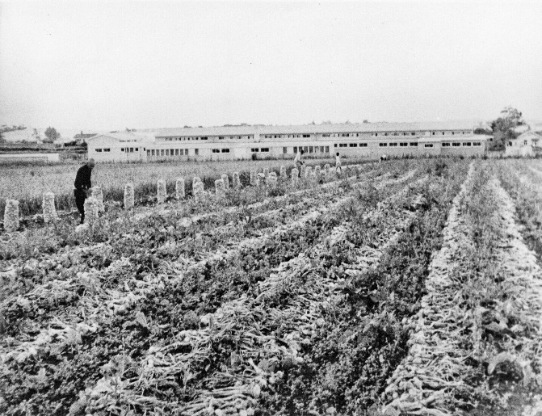
Pukekohe Native-Only School in 1956. Photo by Donald Trevor Hunt

Task 1: In your Red books write down Week 5, Lesson 2, ‘The Maori-Only School in Pukekohe.’

Task 2: We will take turns reading pages 21-25 in class out loud.

Task 3: We will watch a short video clip on the Maori-Only school on TVNZ on Demand between 26:40 sec to 30:32 sec. (clip = 3.56 sec.)

Task 4: Students will break up into groups of 4 to 5. On pages 21-25, the book discusses the Maori-only school in Pukekohe. In your group, complete the following questions in your Red Books:

1. At the top of a blank page in your Red Books, write the heading ‘Advantages’ and ‘Disadvantages’ of the Maori-Only School in Pukekohe. Draw a line down the middle of the page. Write key dot-points for each column.

The Maori-Only School in Pukekohe

Advantages Disadvantages

2. Once you have completed your columns, answer the following question (which you will write into your books):

One of the reasons given by European parents for creating a separate school was the health threat posed by Māori students. Based on what you have read, and in your opinion, was this threat justified? Explain your response.

Lesson 3: Segregated at the Movies

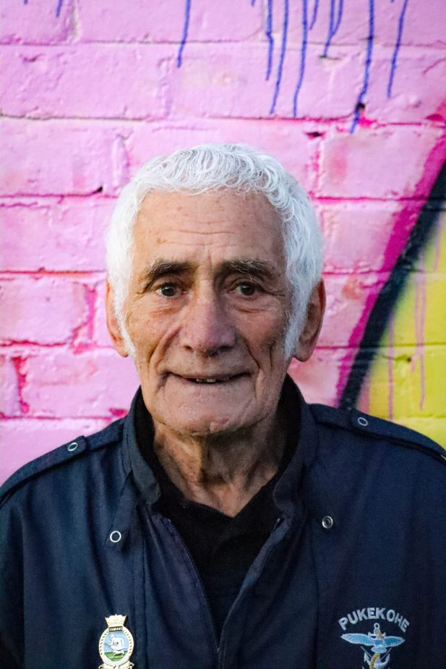
Pukekohe resident Massey Hiku in 2022. Years earlier he
was physically abused at the movies sit sitting in the non-
Maori section. Photo by Nyle Turuwhenua

Read pages 27-32 which describes how Māori were segregated in the cinema, then answer the following questions in your Red Books. As you answer each question, be sure to incorporate the question in your own words as we have done in previous lessons. For example: ‘List five types of animals in the Auckland Zoo.” A possible response would be: ‘The Auckland Zoon holds many different types of animals – five of which are lions, tigers, monkeys, zebras, and elephants.”

5. How did the opening of the Regent Cinema in 1958 contribute to the decline in racism at The Strand? (p. 26)
Possible sentence starter: “When the Regent Cinema opened in Pukekohe in 1958, it contributed to the decline of racism at the rival Strand theatre because…”

6. Even before the opening of the Regent, what actions were some Māori taking to get around the restrictions at The Strand? (pp. 30-32)

7. What actions did Maori Affairs Minister Ralph Hanan take to stop Māori discrimination at The Strand? What was his argument? (pp. 28-29)

8. What does the treatment of ex-Tuakau College principal Te Rangihiwinui (Hiwi) Tauroa, say about popular attitudes toward Māori in neighbouring Tuakau during the 1940s? (p. 32)

9. This year marks the 80th anniversary of the incident involving Motiram Wallabh, the Indian man who refused to move from his seat at the Pukekohe cinema in 1933. Imagine you are a reporter for the New Zealand Herald. Write an article that summarises the case (see p. 30) and why it is significant.

10. Māori rarely challenged the segregation they encountered in Pukekohe. Why were they so reluctant to engage in protests or civil actions such as sit-ins or boycotts? (p. 31)

*Note: Words like ‘Maori-Only School’ and ‘Maori Affairs’ do not have macrons above the letter ‘a’ to denote the long vowel pronunciation. Even today some Māori in the Pukekohe area do not use macrons. They use ‘aa’ instead. Hence, the word ‘Māori’ is spell ‘Maaori.’ The word ‘whānau is spelled ‘whaanau.’ This is a good example of cultural variation within a sub-cultural group (a smaller group within a larger group). Both spellings are technically correct depending on the local custom, but one is preferred. In a similar way, in the United States the word ‘colour’ is spelled ‘color.’ Both are correct, but depending on where you live, one is preferred.

