Week 8:

The Dawn Raids

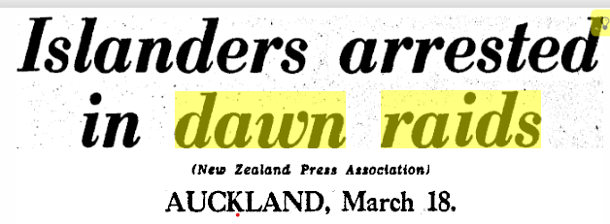

The Christchurch Press, March 19, 1974

Success Criteria
Students will be able to recount the historical backdrop to the Dawn Raid including social and economic reasons for attempting to deport migrant Pacifika workers during the early 1970s, in addition to being able to explain why these raids are considered instances of racial discrimination and intolerance.

Activities
1. Reading
2. Writing
3. Viewing and note-taking

Lesson 1 The Dawn Raids – An Introduction

Task 1: We will take turns reading the following text out loud in class:

After the Second World War ended in 1945, the Kiwi economy boomed as there was a great demand for New Zealand farm goods overseas including wool, meat and dairy products like milk and cheese. Industries in New Zealand that used these materials to make products, had a labour shortage so the government encouraged workers from the nearby Pacific Islands to come here and work – mostly in factory jobs. Those who came from the Cook Islands, Tokelau and Niue were automatically given Kiwi citizenship, while those from Tonga, Samoa and Fiji had to get short-term work visas, with the expectation that later on, they would be able to apply for and receive citizenship. Some of these openings were for that required a great deal of hard physical labour like forestry worker or less popular ‘dirty’ positions such as cleaner.

Many of these workers had their visas expire, but no one seemed to care much because Kiwi businesses were desperate for workers. Things were going good until the economy started to turn bad and by the early 1970s, and many companies began laying off workers The first to go were the one’s with expired work visas. They were known as over-stayers.

During the early 1970s, the New Zealand police began to raid the homes of Pacific Islanders who they suspected had overstayed their visas or work permits. Many were deported back to the Pacific Islands. As police would often show up unannounced early in the morning when most people were likely to be home, these attempts to catch overstayers and send them back became known as the Dawn Raids. At the time, many politicians justified the raids on account of the poor economy, but they did not treat other overstayers the same. There were many people of European ethnicity whose visas had expired – from places like the United States, Canada and Europe and there was no push to arrest and deport them. As a result, today people view the Dawn Raids as an episode of racial discrimination against a group that was an unpopular minority.

Class Discussion:

- Who has heard of the Dawn Raids?

- Does anyone have any information they would like to share of stories you may have heard from relatives who were involved in these raids?

Task 2: Vocabulary of the Raids – look up the following definitions and write them down.

1. Activist:
2. Arrest
3. Civil Rights
4. Dawn Raid
5. Deportation
6. Immigration
7. Overstayer
8. Polynesian Panthers
9. Protest
10. Visa
11. Work Permit

Task 3: We will watch the video: from Radio New Zealand – ‘Untold Pacific History – The Dawn Raids.’ Take basic notes on key points.

Week 8 Lessons 2 & 3:

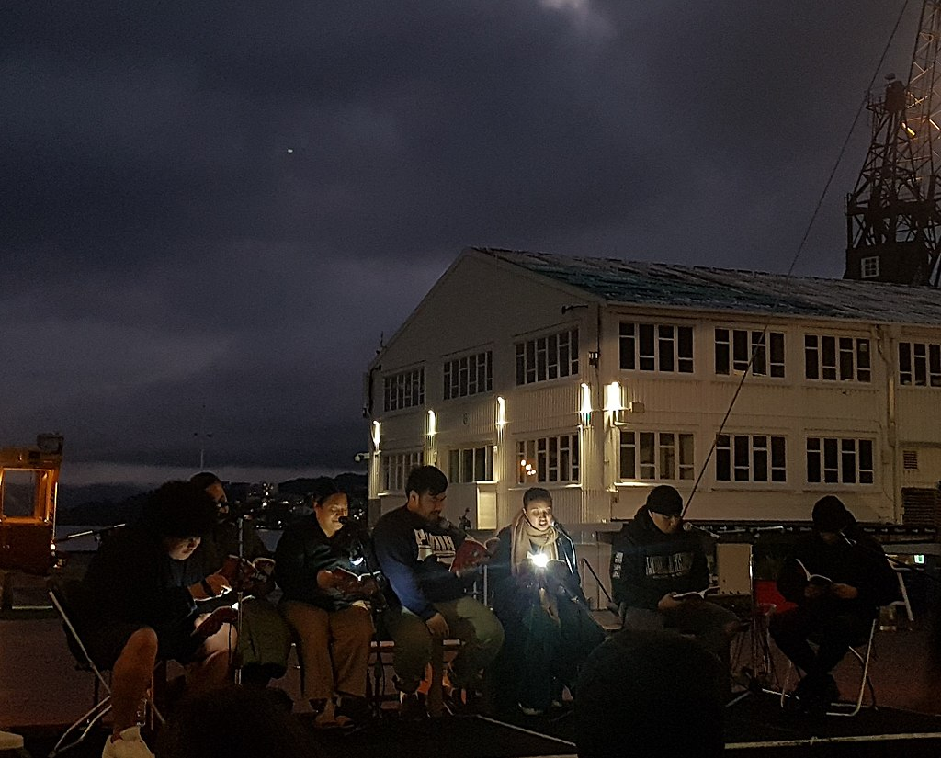
Above: a ceremony remembering the Dawn Raids on the 50th anniversary of the start of the event.

Tasks 1 & 2: Today we will view the video clip of New Zealand Prime Minister Jacinta Ardern apologizing for the Dawn Raids:

https://www.youtube.com/watch?v=jgRbO4QiDwc
1:17 sec.

The apology was a very emotional subject for many watching in the audience who broke down in tears. Part of the apology involved the Prime Minister taking part in a Samoan ifoka ceremony:
https://www.youtube.com/watch?v=VGoM1sSZsds
(2:42 sec.)

Task 3: Read the article below which goes into detail about the significance of the ifoka ceremony that Jacinta Ardern participated in.
https://thespinoff.co.nz/atea/02-08-2021/dawn-raids-ceremony-explained-why-jacinda-ardern-sat-under-a-woven-mat

Letter writing: Imagine a relative of yours living overseas has just contacted you after seeing Jacinta Ardern’s apology on TV. They wee especially enthralled by the ifoka ceremony and they ask you to explain it for you as you are a Kiwi.

In your own words, describe the ceremony, and the meaning of the objects used.
Be sure to explain the meaning of the words “ifo,” “va,” and ‘“soli le va.” What does the phrase “E pala ma’a, ae lē pala upu” mean and why is it significant for the ceremony?

Lesson 3 Poster Project

Create a poster or static image that is intended to raise awareness about the significance of the Dawn Raids for Pacifika peoples. Include why this was a major event in New Zealand history. What were some of the injustices that occurred during the raids? You may also wish to include Jacinta Ardern’s apology and the future vision of Pacifika people in this country.

Your poster should include an accurate, catchy title, and a symbol of equality. I do not want you to create any images on your computer or use clip art. Write in on one or two pages of your Red Books and do it by hand. Stick figures are fine!

