Week 7:

A Short History of Asian Discrimination in New Zealand

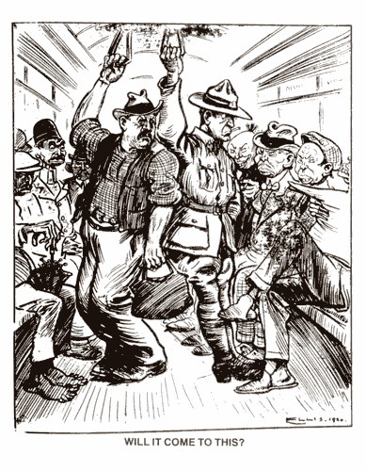
Image from the Free Lance newspaper, June 6, 1920.

Success Criteria
Students will become familiar with the history of Asian exclusion and discrimination in New Zealand over the past 150 years, including a discussion of official government policies aimed at discouraging people of Indian ethnicity from coming here – and visual representations in the form of how they were depicted in cartoons, and how these images reflected wider racial and cultural stereotypes. They will also be able to explain how such broad labels as ‘Indian’ are inexact terms that refer to a broad array of people with diverse customs, religious beliefs and traditions.

Activities
1. Reading
2. Writing
3. Participating in class discussion
4. Static Image Creation/Analysis

Lesson 1: The Indians Must Go!

Task 1: Reading and Discussion

From the late 19th century (1800s) to the mid-20th century (1900s), Asians migrating to New Zealand faced many obstacles. With more and more arrivals, there was a growing realisation that these ‘strange’ newcomers posed a grave threat to Kiwi society. Their culture and customs were widely seen as inferior to the dominant European culture, and there were fears they would take jobs from ‘real’ Kiwis. Meanwhile, those Asians who owned their own business were also viewed as an economic threat. As many had little wealth, they were willing to toil for long hours and were viewed by many European business-owners as a threat to their livelihood. This was especially true in places like Pukekohe, whereby the early 1920s, the local European market gardeners who grew vegetables for sale, were upset that local Indian and Chinese migrants were starting to dominate the vegetable market, often selling their product at a cheaper price and taking away some of their customers.

Worst of all, Chinese and Indian migrants were widely viewed as a danger to the future of the ‘white race’ as there were fears that they were interbreeding with other ‘races’ especially Māori, with the result being a new inferior race. Of course, this was not true – there is no such thing as an Indian race, but such views were widely held and taught in school biology classes of the time.

The Story of Indians in New Zealand

Task: Go to the Te Arra Encyclopedia of New Zealand online at: https://teara.govt.nz/en/map/1819/india-pakistan-and-bangladesh
and answer the following questions:

*NOTE: The word ‘Indian’ is a broad word that encompasses many different cultures, beliefs, religions and countries. For instance, there is a big difference in the habits and customs of people living in northeastern Indian when compared to someone living in Mumbai. There are hundreds of different subcultures within Indian society.

Section 1:
a. Look at the map of what once was India. What countries today were once considered to be part of India? List them here.

b. Which regions of India did the first Indian migrants to New Zealand come from?

Section 2
Watch the 27 sec. video clip of the Kiwi Indian librarian. What does her story say about how familiar many Kiwis are with Indian culture?

Section 3
Write a short summary – in your own words – on how the first Indian settlers came to New Zealand.

Section 4
In 1860, a European man write a letter to the local newspaper complaining about an Indian vagabond (homeless person) named Goordeen. In his letter he told why he didn’t want the man staying near him. List some common stereotypes of Indians that the European man expresses.

Task 2: access: https://teara.govt.nz/en/indians
And answer the following questions:

Section 1: Indian Communities

1. What jobs did many early Indian migrants to New Zealand hold?

2. What were some of the reasons why Indians migrated to other countries like New Zealand?

3. What major changes happened in the Indian community in New Zealand in 2001?

4. In what two years did immigration laws make it more difficult for Indians to migrate to New Zealand?

5. Name the top 6 religious groups of Indians in New Zealand.

Section 2: Early Immigration

6. According to the 1881 Census, how many Indians were in New Zealand. How does this compare to 1896 and 1916?

7. Why did many Indians leave their home and migrate to New Zealand? What were some common jobs they took up?

Section 3: 1920s and ‘30s

8. Why were there more Indian males than females in New Zealand during this ytime?

9. What was the goal of the White New Zealand League?

10. What forms of discrimination did Indian Kiwis experience in Pukekohe?

Section 4: After the Second World War

11. Why was there a steady growth in Indian migrants o New Zealand after World War II until 1981? In what ways did Indian women have an impact during this period?

12. Why did many Fijian Indians migrate to New Zealand during the 1980s?

Section 5: Retaining and Transforming Culture

13. Why was the Auckland Indian Association formed?

Section 6: Religion and Kin.

14. By 2013, what percentage of Muslims in New Zealand were of Indian ethnicity?

Lesson 2: Understanding the Major Indian Religious Groups

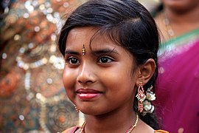
A young girl identifying as Hindu

Kiwis of Indian ethnicity have a variety of different religious beliefs. These include: Hindu, Sikhs, Muslims, Jains, Parsis, and Christians

Go online and research each and provide the following information for each:

1. Name of Religion
2. Summarize the key beliefs
3. Where did it originate
4. How many worldwide followers are there?
5. When and where did it start? How did it start?
6. How many followers are there in New Zealand?
7. Main celebrations/holidays

Possible sources: https://teara.govt.nz/en/diverse-religions/page-1
*It is also acceptable to use sources such as Wikipedia to complete this exercise.

Lesson 3: Cartoon and Text Analysis

It has been said that a picture tells a thousand words – and a well-written text can conjure up a thousand images in someone’s mind. Have a look at the cartoon below. It was created in 1920. It depicts Chinese and Indian migrants in New Zealand at a time when people were afraid they would soon become the dominant culture.

a. How can you identify the Indians?
b. How are they depicted?
c. What stereotypes are being conveyed?
d. What do you think the caption ‘Will it come to this’ means?
e. What do you think the message is by the creator – that is, what was his purpose for drawing this cartoon?
f. If you were of Chinese or Indian ethnicity, how would this make you feel?
The Wellington-based Free Lance newspaper, June 6, 1920.
Task 2: How much has really changed? There are people today who are fearful that New Zealand will be overrun with Asians.

In 2010, TV presenter Paul Henry caused a firestorm when he asked then Prime Minister John Key if he was going to pick someone for Governor-General who looked like a ‘real’ New Zealander and represented most Kiwis (the previous Governor General was of Indian ethnicity). Here is his picture:


Photo of former New Zealand Governor General Anand Satyanand. Photo courtesy of Office of the Governor-General of New Zealand. Mr Satyanand was born in Auckland, has Kiwi citizenship and is as much a New Zealander as some who’s family has been here for 200 years.

Listen to the clip here:
https://www.youtube.com/watch?v=YqAEvkNtJ6A (47 sec.)

Paul Henry was eventually suspended by the TV station he worked for and later resigned in part over his laughing and making fun about how to pronounce the name of a particular Indian woman.

Class Discussion: Was the treatment of Paul Henry fair? Explain.
Task 3. Below is a poem that was published in the form of a Letter to the Editor of the Franklin Times, February 3, 1926, just as the White New Zealand League was starting up in Pukekohe. The paper’s editor was well-known for his racist views of Indians.

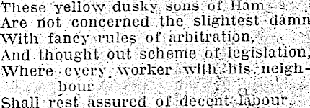

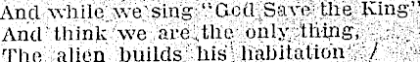

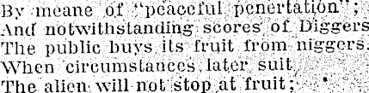

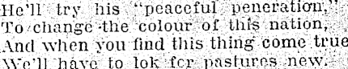

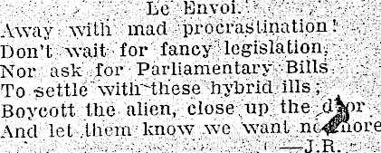

*The last 2 lines read: “Boycott the alien, close up the door, And let them know
we want no more.” What message is being conveyed? What is the writer trying
to accomplish?

How does the writer view Asian migrants? What is his solution?
*The fruit growers he refers to are the Indian and Chinese farmers in Pukekohe.

