Global Studies, Term 1, 2023 Mission Heights Junior College

Week 6

Lesson 1:

A Long & Dangerous Trip:
The First European Migrants to New Zealand

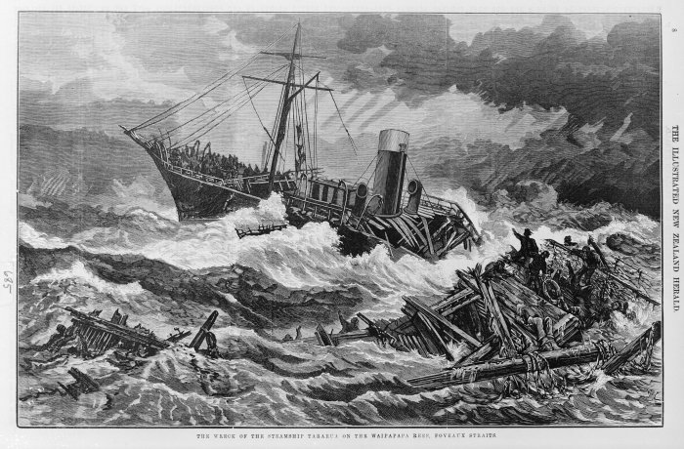 On April 11, 1886, the steamer Taiaroa struck rocks north of Kaikōura, and sank, showing just how perilous the trek to New Zealand was.

Success Criteria

Students will gain a basic understanding of the challenges faced the non-Māori peoples migrating to Aotearoa New Zealand during the 19th century (1800s). Focus will be on the dangerous and everyday trials and tribulations they had to endure. By the end of the week students will be able to list key health issues that were routinely encountered during the voyage and key differences between first class passengers in comparison to those in the poorer steerage sections.

Lesson 1: Early Non-Māori Migration to New Zealand

Students will open their Red books and write “Week 6 Lesson 1: Early non-Māori Migration and Travel to New Zealand.”

Task 1: This week we are going to read a story written by Kiwi writer John Wilson on what it was like traveling to New Zealand on the early passenger sailing ships. The story can be accessed at:
https://teara.govt.nz/en/the-voyage-out

We will read ‘Section 3: Cabin and Steerage,’ together as a class.

Class Discussion: While it may seem shocking how different classes of people (wealthy and poorer passengers were treated). Do the class distinctions between passengers, still happen today? What about first and second-class passenger sections on ships and airplanes? Is this a modern-day example of class distinctions?

After reading Section 3, we will answer the following questions together, in our Red books:

Class Distinctions
1. What was the difference between passengers in the steerage section of the ship and the poop deck?

2. What percentage of passengers were able to afford living in the nicer poop deck?

3. Writer Samuel Butler organised a choir on the ship the Roman Emperor. Why did some of the wealthier passengers complain?

Conditions in Steerage
4. Describe what the conditions were like for passengers living in the steerage section.

Church Services
5. How did religion help to bring rich and poor passengers together?

Task 2: We will watch as a class, ‘Could You Survive a Victorian Ocean Cruise on SS Great Britain?’ at:

https://www.youtube.com/watch?v=wfhxdRPIoDo

We will stop at the 20-minute mark and have a class discussion.

As you watch the documentary, note any differences between the rich and poor passengers that you find surprising, in a series of dot-points.

Week 6 Lesson 2:

Task 1: We will finish watching the documentary from the 20:00 mark to the end.

Class Discussion: What other aspects of early passenger ship life did you find surprising?

Second half of the class:

You are to break up into groups of between 5 or 6. You will take turns reading out loud and then work together to write down key dot-points from the Section you are assigned to. Each student will write down all of the dot-points you have come up with in the group, into their Red books. Here are the 5 topics:

Group 1: ‘Life on Board’
Group 2: ‘Sickness at Sea’
Group 3: ‘Early Steamers’
Group 4: ‘20th Century Steamers’
Group 5: ‘Air Travel’
Group 6: The Wreak of the SS Wairarapa

Information on the first 5 topics can be found on the Encyclopedia of New Zealand online at: https://teara.govt.nz/en/the-voyage-out

Information for group 6 can be found at the following sources:

- Paperspast (type in SS Wairarapa & you will get newspaper articles from the time of the disaster)

- https://en.wikipedia.org/wiki/SS_Wairarapa (the sources listed below the article are excellent reference material).
-----------------------------------------------------------------------------------------------------------------
Each Presentation should include:

1. a relevant, catchy title
2. at least 2 images (picture, photo, painting, sketch, etc.) with captions (a few words which describe the image)
3. No more than 10 slides
4. Tell a story – present key information – stay on topic.
5. Every group member must participate in the presentation.
6. Speaking time should average 45-seconds to 1-minute per person.
7. A slide titled ‘Key Takeaways’ where you will list 4-short dot-points that students in class will write into their Red Books under the title of your presentation.

Week 6, Lesson 3:
Students will be working in their groups on their Powerpoint presentation.

