All Welcome Here – A Celebration of Cultures:

Week 4
Culture & Collective Identity

‘Man, maker of tools, rules and moral judgements.
–Philip Bock

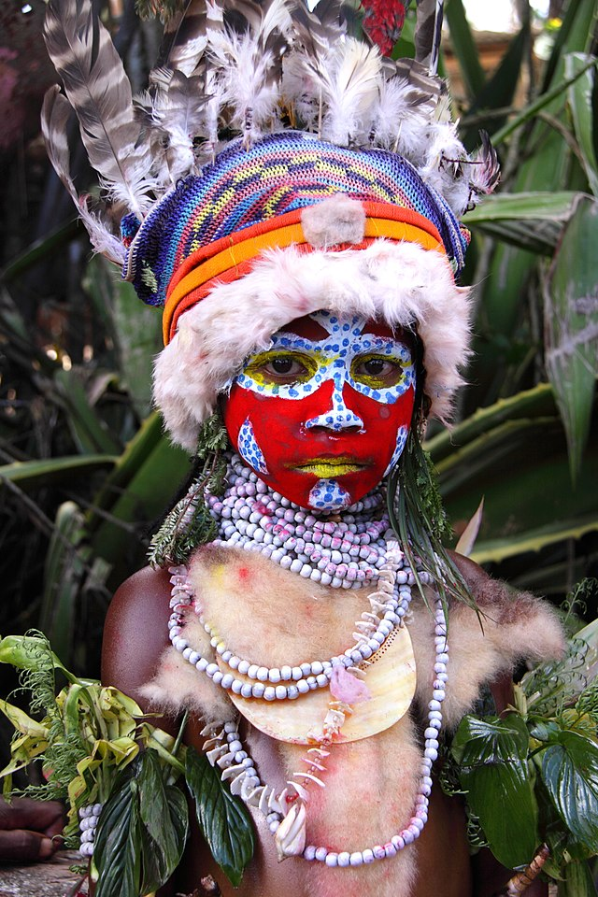
Mount Hagen, Papua New Guinea 2009 from Wiki Commons.

.

Week 4, Lesson 1: Exploring Culture

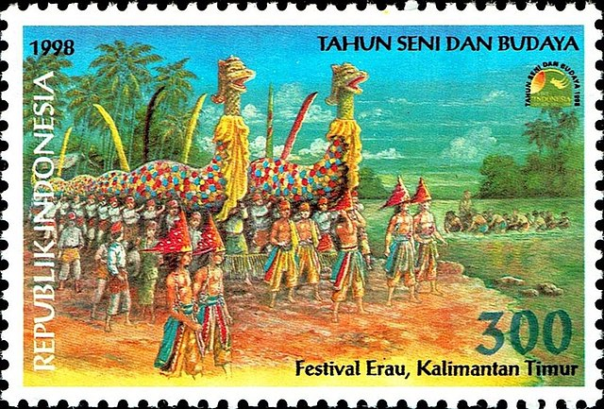

Success Criteria

By the end of this week, students will be able to define key features of culture and be able to construct a culture flower. They will also be able to recount key aspects of Kiwi culture and how it compares to a foreign culture, namely, the Nacirema people.

Activities
1. Reading
2. Writing
3. Participation in class discussion
4. Participation in group work (collaboration)

Lesson 1: What is Culture?

Task 1: Write the following definition into your Red books.

Culture is the language, beliefs, customs, laws, myths and legends shared by a group of people. Culture helps to connect people together.
Class Discussion

Look at the different definitions of culture.

- For example – A school’s culture can be defined as the traditions, beliefs, policies, and norms within a school that can be shaped, enhanced, and maintained through the school’s principal, teachers and student leaders.

- A people without the knowledge of their past history, origin and culture is like a tree without roots.
– Marcus Garvey
Does Marcus Garvey think culture is important? Why?

Task: Summarise the following information in your books:

- Material culture:
the things that people collect and leave behind (objects and artifacts).

Examples: a spear, a walking stick

- Non-Material culture:
what is in our heads – thoughts and ideas.

Examples: Rules, social roles (e.g., women wear pink, boys shouldn’t cry, men pay for a movie if on a date)

Class Discussion: Other Examples of NonMaterial Culture

    - Love, marriage, families, how we raise children
    - Religion
    - Manners – table etiquette, how we address elders
    - Time and importance – How do we view time compared with how Germans or Pacific Islanders view time?
    - Non-verbal communication – when is it appropriate to display affection? How close should you stand to someone (their cultural bubble)?

An example of Non-Material culture from Australian Aboriginal Culture

- In the Tanami Desert, members of the opposite sex are not allowed to look at their cousins – it is a big no-no.
- It is also acceptable in some tribes for a woman to who has wronged someone else (spoken badly about them) to allow herself to be beaten up (punched and kicked) by several other women as punishment – after which they can be friends again.
Source: Mr Bartholomew – first hand observation.
Create a Culture Flower
In your books, create a culture flower pedal. In the yellow part write ‘Culture’ and for the pedals write a word or words that make up key aspects of someone’s culture. In addition to the definition on slide 3, you may wish to look up different definitions online.


Homework: Please ensure that your books are up-to-date. Anything not completed in class automatically becomes homework.

Week 4 Lesson 2
Looking through the Eyes of Another Culture

In learning about the other, about many ‘others,’ our conception of humanity is enlarged and enriched. We gain insight into the plasticity of human culture. We begin to see that our way of life is determined not so much by nature but by culture and history.
– David Mayberry-Lewis

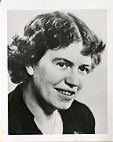
Above: Arguably, the most famous Anthropologist of the
20th century. Can you name Her?

Task 1: Body Ritual Among the Nacirema People

- Watch the video ‘Who are the Nacirema?’

- https://www.youtube.com/watch?v=fdtcRVduqaQ (7:58 sec.) Go to the 5:20 sec. mark and stop the video. Write out the following questions and answers in your Red Book under the heading – ‘The Strange Nacirema Tribe’

1. Do you think the Nacirema people are strange? List the reasons.

2. Can you think of any similarities between the Nacirema and people living in New Zealand?

Now continue playing the video.
3. What is your reaction to the remainder of the video? Were you surprised? Why?

The Nacirema

4. Why did Horace Miner write the article on the Nacirema?

- The Nacirema—American spelled backwards—was Horace Miner’s way of noting that many scientists who study cultures (Anthropologists) tend to hype up the perceived weirdness of other cultures. The point of his article was to highlight that “everything that’s normal to us seems weird to someone else.”

Task: Can you think of at least two seemingly strange customs that Kiwis engage in – that people from another country might think of as strange? (Hint: ‘Sweet as…”). Write these examples into your Red book.

Week 4 Lesson 3

A Culture-Related Current Event

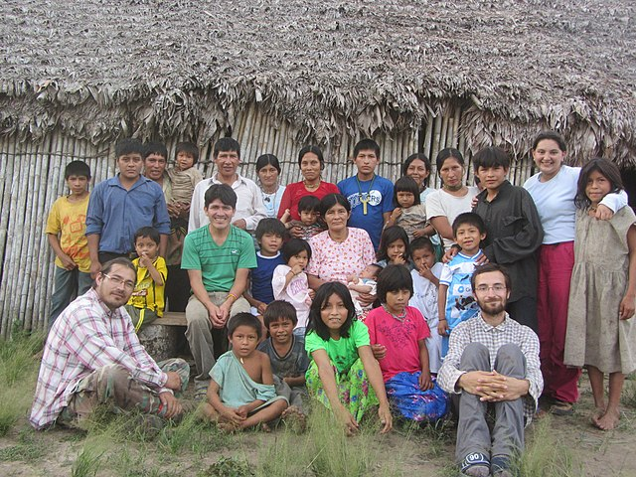
Meet the Tsimane people of Bolivian Amazonia

- Go online and access the following article: “Why this Amazon tribe may have the world's healthiest hearts.” CBS News. Here is the link: https://www.cbsnews.com/news/amazon-tsimane-tribe-diet-lifestyle-habits-healthy-hearts/

- Under the heading ‘Cultural Current Event’ in your Red Book,

- 1) Write a short summary of the article in your own words.
Include who, what, where, when, and why.

- 2) Create several key dot-point of important information.

What is the source of this article? Is it considered reliable? Why or why not?

Class discussion:

What makes for a reliable source of online material?

Based on what we have learned about culture, is this tribe’s remarkable heart health related to genetics or their diet and lifestyle? In other words, is it nature or nurture?

What is it that they are doing that appears to protect their hearts?

Now watch the video ‘Breakfast for Heart Health.’
https://www.youtube.com/watch?v=pgLMNw2TmDQ (1:20 sec).

Class Discussion on video

