Week 7

Icon Presentations & Beyond

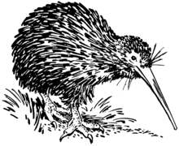

Lessons 1 and 2:

All students will give their icon presentations. No exceptions
(If for some reason we are online – you will give it online).

It should have:
1. an image of the icon
2. a short history of the icon and why its significant
3. What does it taste like, smell like, feel like, etc.
Remember, it should be written into your Red Book which you can hold when you give your presentation.
4. Length 30 seconds to 1-minute
(You may wish to bring a physical object to show such as an L & P bottle or a bag of pineapple Lumps or a stuffed Kiwi Bird.

Success Criteria
Students will become familiar with the brief histories of an array of New Zealand icons. By the end of the week, they will be able to identify several specific icons and their significance.

Activities
1. Reading
2. Writing
3. Participation in class presentations

Task: While presentations are being given, students are taking short notes.

As each presentation is given, students will write down the class lesson and date, then write down the name of each icon given along with at least one dot-point about an interesting piece of information about it.

Below: A possible Icon Template that some may use as a guide
& on the following page a sample completed Icon

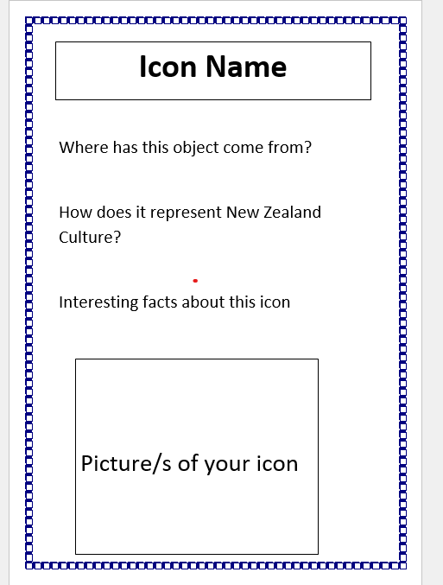

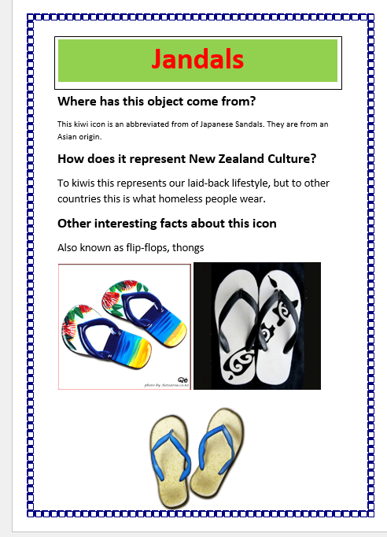

Week 7 Lesson 3

Task 1: In your Red book write ‘Week 7 Lesson 3.’ Today we will learn about push and pull factors involved in migration. There are two key terms you need to know.

Push factors: things that push you out of the country you are living in. Examples: crime, low paying jobs)

Pull Factors: things that attract you to your new country. Examples: cleaner air, higher better health care.

Class Discussion:
Have any students experienced push or pull factors? Describe them.
What are some common push and pull factors for migrants coming to New Zealand?

Task 2: You will be given the Migrant Assessment. We will go over it in class. It starts on the next page.

Global Studies Mountains Whanau – Term 1 2023

The Migrant Experience
Assessment

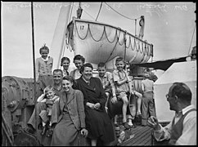
Date given & due: Week 7 Lesson 3 & due Week 10 Lesson 1
Class time given: 3 Sessions (Week 9)
Format: A booklet, hand-written or word processed
or a poster with teacher approval

Students will:
Interview a person who migrated to New Zealand and collect information to create a booklet which describes their experience.

Instructions:
- Find an adult to interview who migrated to New Zealand (They must be 18 and older).
- Use the interview questions provided at the end of this handout.
- Create 5 headings and place the information under one of the 5 headings. Include the interview transcript with your booklet.

Your information should appear in 5 sections:

- An Introduction
- A. Migrant’s name
- B. Family situation (what other nuclear family members migrated with them to New Zealand). *Nuclear family = ONLY the mother, father, sister, brother.

Possible sentence starter: When ________ first came to New Zealand, they arrived with their….

- Leaving Home

- Identify what the migrant brought from their old country (at least two items)
- Identify what things the migrant left behind (for example, pets, a house and car)

- Push & Pull Factors
- Your model should show at least 3 push and/or pull factors for their country of origin and New Zealand.

4. Adapting to their New Life
- Write a paragraph describing the differences between their life in their home country and their life in New Zealand (for example, clothing, food).

Possible Sentence Starter:
There were many differences between life in _________ and New Zealand. One such example is…

- Write a paragraph about the challenges faced in their first year due to: language differences (e.g., limited ability to speak English), finding work, cultural differences, getting around. What has your migrant done to overcome some of these challenges?

Possible Sentence Starter:
During their first year in New Zealand, ______ _________ faced many challenges. One difficulty that had to be overcome involved………

5. A Visual

- Include at least one relevant visual – these may be of your migrant, their country of origin or anything you have referenced in your interview. These may be hand-drawn, photographs or sourced from the internet. If from the internet they must be referenced. The picture should include a caption (a few words under it describing what the picture is about)

Interview Questions you will need
to ask to Complete the 5 Sections:

1. Information required for the Introduction

- What is your first and last name?
- Are you married?
- Do you have children?
- What year did you come to New Zealand?
- What country do you come from?

2. Information you need to talk about them leaving their origin

- What things did you bring with you? (List two)
- What things did you leave behind? (List two)

3. Information you will need to create a Lee’s Migration model

- List some good things about the country you migrated from
- List reasons why you left your country
- List some reasons for migrating to New Zealand
- What are some negative aspects of living in New Zealand

4. Information you will need to describe their new life

- What are the differences between your home country and New Zealand? (e.g. food, weather, language, customs, education, culture)
- What challenges did you face when you came to New Zealand? (e.g. language, getting a job)
- What did you do to help you with these challenges?

5. They may have some pictures that will help you

- Do they have any photographs I could copy for my assignment?

Planning Sheet for Students with
English as a Second Language

1. Information required for the Introduction

- What is your first and last name?
- Are you married?
- Do you have children?
- What year did you come to New Zealand?
- What country do you come from?

2. Information you need to talk about them leaving their origin

- What things did you bring with you? (List 2 things)
- What things did you leave behind? (List 2 things)

3. Information you will need to create a Lee’s Migration model

- Why did you leave your country? List some reasons.
- Why did you think that New Zealand was a good place to live?
- What things about New Zealand do you not like and not like?

4. Information you will need to describe their new life

- What are the differences between your home country and New Zealand? (e.g. food, weather, language, customs, education, culture)
- What difficulties did you face when you came to New Zealand? (e.g., language, getting a job, different food, weather)
- What did you do to help you with these challenges?

5. They may have some pictures that will help you
- Do they have a photo you could copy for your assignment?

