Week 6: Types of Culture

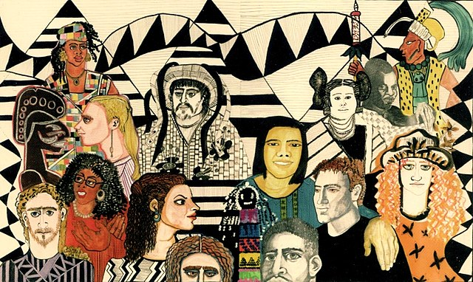
The painting ‘Pure Diversity.’ Source: Wiki Commons
Success Criteria
Students will gain a basic understanding of the depth and breadth of human social and cultural diversity and be able to list different specific examples from several non-Kiwi cultures. They will also be able to identify several different cultural icons of New Zealand society.

Activities
1. Reading
2. Writing
3. Participation in class discussion
4. Participation in group work (collaboration)

Lesson 1 Celebrating Differences

Task 1: Read about the following examples of human cultural variation.

The Philippines

- A strong handshake is seen as admirable in the United States and U.K., but in much of the East, particularly the Philippines, it is seen as a sign of aggression

Touching and Shaking Hands

- Some strict Muslim woman will not shake hands with a man. To confuse matters, some Muslim men can decide if he shake hands with a non-Muslim woman. People in these cultures generally avoid touching people of the opposite sex who are not family members.

Eating in China

- When dining in China, never force yourself to clear your plate out of politeness -- it would be very bad manners for your host not to keep refilling it. Instead, you should leave some food on your plate.
- In parts of India, people cook with dried cow manure.

Chewing Gum

- In Singapore most types of gum have been illegal since 1992 - and you can be fined 100s of dollars for chewing it in public.

Tipping

- In Japan and Korea, a tip is considered an insult, rather than a compliment, and for them, accepting tips is akin to begging. However, this tradition is beginning to change as more Westerners bring their customs with them to these countries.

Hand Gestures

- The “Okay" sign (thumb and forefinger touching to make a circle) is very far from OK in much of the world. In Germany and most of South America, it is an insult, similar to giving someone the finger.

Task: In your Red Book describe 3 different examples that we have not mentioned, of cultural expectations that Kiwis might find unusual, but is normal for another culture (do this in 1 to 3 sentences each).

a. If your parents or grandparents were not born in New Zealand, you could ask them for examples. If not, find examples online or from your own personal experiences.

b. Have you ever taken a trip outside of New Zealand? Surely you would have seen customs that surprised you!

Week 6 Lesson 2

Class discussion on how scientists study different cultures.

Task: Read the quotation below, after which we will talk about what Clifford Geertz meant when he said cultures must be interpreted (and we will write the question and answer in our Red Books).

Cultures must be Interpreted.

- Here is what one of the world’s most famous cultural anthropologists once said about culture:

- “…man is an animal suspended in webs of significance he himself has spun, I take culture to be those webs, and the analysis of it to be therefore not an experimental science in search of law but an interpretive one in search of meaning.”
– Clifford Geertz

What does Geertz mean?

- He is trying to understand the meaning behind certain behaviours. For instance, what is the difference between a wink, a twitch and a squint? There is only one way to find out - to ask the person. That’s how anthropologists study cultures – by observing and talking to people.
- This is very different to the ‘hard’ sciences: chemistry, maths, physics, where you are dealing with universal laws.
- The problem with studying people is that they are unpredictable and can deceive.

Lesson 2 – Continued
What is an Icon?

- A person or thing regarded as a representative symbol and worthy of respect, often of a country.
- For example, the All Blacks are iconic symbols reflecting determination, mateship and teamwork.

Task: Write the definition and example in your Red

What is Kiwi Culture?

- Watch the McDonald’s Kiwi Culture ad.
- https://www.youtube.com/watch?v=Z5CX_NCf8Ow
- List in your Red Books the different icons in the ad on the board. DISCUSS. What is Kiwi culture?

Discussion on Kiwi Icons

Silver Fern
Worn by many sports teams – including the world-famous All Blacks – the silver fern emblem is proudly flown at sporting events all over the world. Inspired by New Zealand indigenous ferns, the silver fern emblem was first worn by the New Zealand Native Rugby Team on their 1888 tour of Britain.



Buzzy Bee
A popular children’s toy, the Buzzy Bee has been entertaining New Zealand youngsters since the 1940s. With wings that turn and make a clicking noise, it’s a hit with kids everywhere and a definite inclusion in the Kiwiana Hall of Fame!

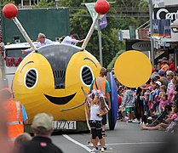

Other Kiwi Icons

Pavlova
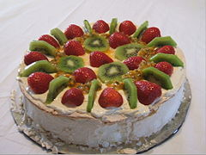

Gum Boots

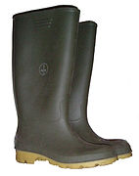

Marmite

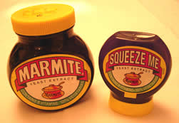

Historic Kiwi TV Ads

Once students have chosen their icon, they can write up the presentation on one-page in their Red Books.

To end the class, I would like you to watch the video clip on iconic Kiwi TV ads:

https://www.youtube.com/watch?v=1LUmJjA3kEQ

Task: What are some of the key themes embodied in these ads?

Week 6 Lesson 3

Choosing and Preparing your Kiwi Icon
for Presentation

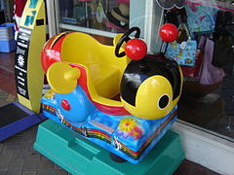
Buzzy Bee children’s ride in Warkworth, New Zealand

We are going to go around the classroom and students are going to choose a Kiwi icon that they are going to give a 1 to 2-minute presentation on. You are to pick from the following list. No more than 2 students can pick the same icon. If there is another icon not on the list – you can choose it (subject to teacher approval!).

Possible Icons

Kiwi Paua Shell
Silver Fern Buzzy Bee
L&P Fish & Chips
Rugby Black
Jandals Pohutukawa
Bungy Jumping Sheep
Marmite Kiwifruit
Pavlova Rugby Ball
BBQ (Barbecue) The All Blacks
Meat Pie Sky Tower
Gumboots Pineapple Lumps
Hokey Pokey Netball
Bach A & P (Agricultural and Pastoral) Shows
Preparing your Icon

Once students have chosen their icon, they can write up the presentation on one-page in their Red Books.

They need to be ready to present next class. These must be written into your Red book. They are NOT to be done online.

