Week 5 Lesson 1: Human Migration

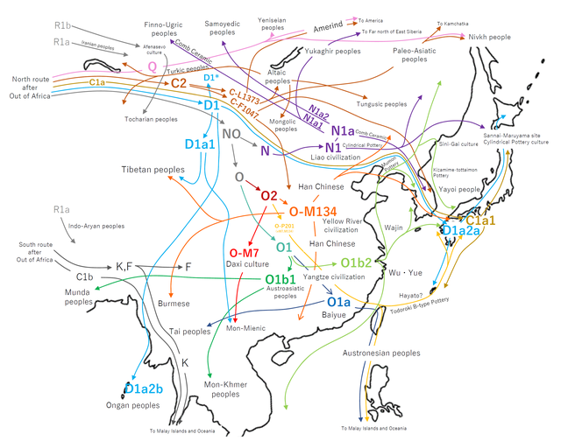
The story of human migration is complicated! Wiki Commons image

Success Criteria
Students will gain a basic understanding about human migration to New Zealand and be able to list several benefits that migrants bring to their new country. They will able be about to recount popular myths about migrants and identify examples of xenophobia.

Activities
1. Reading
2. Writing
3. Participation in class discussion
4. Participation in group work (collaboration)

Week 5 Lesson 1: The Importance of Human Migration

- Task 1: Under the heading ‘Migration,’ write the following definition into your Red Book:

Migration is when a person moves from one place to another, especially to find work or better living conditions.

Class Discussion

At one time or another, our ancestors were all migrants. Our descendants all came from somewhere else before they settled here.

Xenophobia is the fear of foreigners. Is what happened in the video xenophobia or just a hate crime?

- We will watch the video and ask ourselves – why do some people hate migrants?

- What do you think should happen to the woman?

https://www.youtube.com/watch?v=ENstHImVNfY (27 secs.)

Here is a brief update on the story:
- https://www.youtube.com/watch?v=EaXnr7kH6ec

Task: Why Immigrants are Good for New Zealand

Watch the video clip – ‘Why immigrants are a good thing’ from Al Jazeera at: https://www.youtube.com/watch?v=N0OXEPipq-k

- In your Red Book write the Task heading. Create a series of dot-points that address the following claims (that is, tell why they are not true. Where possible, give facts/statistics).

Migrant Myths

1) commit more crimes: Sentence starter: According to numerous studies, immigrants are less likely to…

2) accept lower wages:

3) take jobs:

4) steal benefits:
Week 5 Lesson 2

Culture-related Current Event

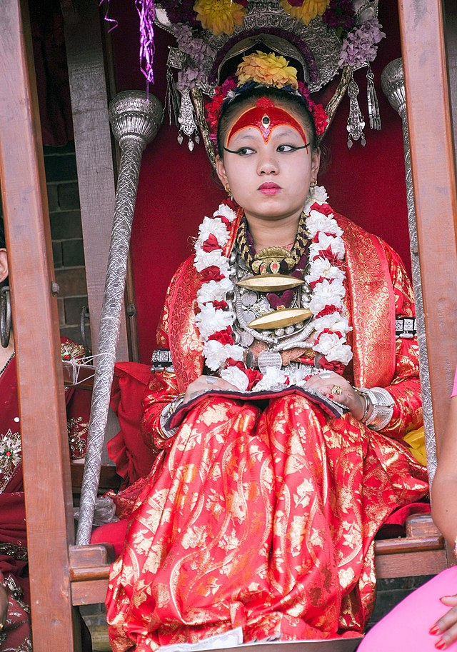
A Kumari Goddess in Nepal. Image from Wiki Commons.

Go online and access the following article: “Life of a Kumari Goddess (in Nepal): The Young Girls Whose Feet Never Touch Ground.” It is an incredible story of girls who are worshipped as gods!

- Here is the link: https://www.youtube.com/watch?v=A7gLC4l5Nmo

Under the heading ‘Culture-related Current Event #2’ in your Red Book:

- 1) Write a short summary of the article in your own words. Include who, what, where, when, and why.

- 2) Create several key dot point of important information.
Week 5 Lesson 3

Mini-Poster

On a single blank page in your Red book, create a poster with the theme of cultural diversity, tolerance and inclusion. No cut and pasted images please; the main focus is on the text; if you cannot draw, use Pak n’ Save stick figures! See example below!
What information that you have learned thus far this year, would you like people to know?



The poster project should take 45-minutes, giving any students who have fallen behind, the opportunity to catch up.

Homework: Please ensure that your books are up-to-date. Anything not completed in class automatically becomes homework.

