Global Studies, Term 1, 2023 Mission Heights Junior College

An original Teaching Unit created by Robert Bartholomew
Ethnic group: Scottish, German, French; Race: Human

All Welcome Here –

A Celebration of Cultures in Aotearoa New Zealand

Culture & Collective Identity

‘There is no ‘them’ and ‘us.’ There is only ‘us.’
– Greg Boyle

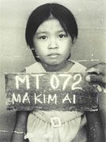
Not just a number. The face of human migration.
A young Vietnamese refugee in a camp in Malaysia
Many Kiwi refugees have come from Malaysian camps

Social Sciences Strand: People use different ways to sustain their culture and
identity

Aotearoa Histories Strand: Finding a place in Aotearoa New Zealand

Unit Overview:

This unit will introduce basic aspects of human migration to the Aotearoa New Zealand and how various ethnic groups that make up the great Kiwi melting pot, have managed to maintain their culture and identity in relation to New Zealand society. Students will become familiar with basic vocabulary and concepts on culture, identity and migration. We will also explore the delicate balancing act between the desire to retain old cultural traditions and beliefs, and assimilating into the new culture – the new hybrid which creates a vibrant and rich society that supports tolerance, diversity and inclusion.

Week 3: Migration 101 – An Introduction

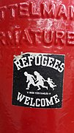

Success Criteria
Students will gain a basic understanding of migration and views on immigration and immigrants over the past century in New Zealand. They will be able to define and differentiate between a ‘migrant’ and a ‘refugee,’ and ‘race’ and ‘ethnic group.’

Activities
1. Reading
2. Writing
3. Participation in class discussion
4. Participation in group work (collaboration)

Lesson 1 An Introduction Migration

Task 1: Students will begin this unit by opening their Red books to two blank pages near the front. At the top of the page, using a ruler, draw a horizontal line (a line that goes sideways across the page) about a third of the way down the page. Above the line write the unit title: “All Welcome Here: A Celebration of Cultures in New Zealand.”

Below the line, write todays date and: “Lesson 1 – An Introduction Migration”

Next write down the following observation about human migration:

We are all immigrants. Our descendants all came from somewhere else before they settled here.

Class Discussion:

1. What is migration
2. Why is it important?
3. How does it makes us stronger as a country
4. Did you know that over 27% of Kiwi citizens who were born in another country?

Teacher to write key dot-points on the board that students come up with as a class (students to write these into their books)
(total time ~ 15 minutes)

Task 2: Cultural ‘Get to know you’ Activity –

a. we will go around the room and students will say which country they were born in (Teacher to write on the board & students to write the list of different countries in their books).

b. we will go around the room again and ask students which country their parents were born in (Teacher to write on the board & students to write in their books).

We will compare lists and see how close they are to the 27% of Kiwis who were born overseas. This will be done in the form of a percentage bar graph.

(This will take up the remainder of the class period)

*Alternative, the teacher can have the students can do the school bus activity where they line up and interview the student opposite them for 3 minutes, learning about their backgrounds by asking question (1.5 minutes per student), then rotating on to the next student.

Homework: Please ensure that your books are up-to-date. Anything not completed in class automatically becomes homework.

Lesson 2: Some Basics about Migration & New Zealand

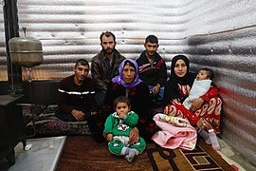

Task 2: Students will access the reading, ‘Migration – The Big Picture” on pages 5-9 of this lesson and skim over it silently for 3 minutes.

Next, as a class, we will take turns reading the text out loud and we will answer the following questions in our Red Books:

1. What is the difference between a migrant and a refugee?
Possible sentence starter – “A migrant is someone who _______________________, while a refugee can be defined as ________________________________________.

2. What is the difference between an ‘ethnic group’ and a ‘nationality?’

3. What was the goal of the White New Zealand League in Pukekohe?
Possible sentence starter – “The goal of the White New Zealand League was to…”

4. Name two groups that the League targeted.

5. Race is a myth? Explain.
Possible sentence starter – “The statement ‘Race is a Myth’ means….”

6. Summarise the remaining key points from the reading as dot points (good note-takers put it in their own words and do not copy word for word).

7. List 5 ethnic groups other than the ones listed in the Lesson #1 Reading.

Homework: Please ensure that your books are up-to-date. Anything not completed in class automatically becomes homework.
Week 3 Lesson 2 Handout:
Migration 101– The Big Picture
By Robert Bartholomew

People come here penniless but not cultureless. They bring us gifts. We can synthesize the best of our traditions with the best of theirs. We can teach and learn from each other...
– Mary Pipher

As you read through this lesson, write down the definitions of any words you do not understand.

This unit is about migration. There are many different definitions for this word. Here are a few:

- The seasonal movement of animals from one region to another.
- The movement of people from one place to another.
- The movement of people across a specified boundary for the purpose of establishing a new home.
- The movement of an object (the house migrated 3 feet after the flood).
- The infection migrated to his liver, making him feel unwell.

In this unit, we will use a simple definition of migration as the movement of people from one country to another to find work, better living conditions and a new, permanent home.

Benefits of Migration

Having migrants arrive in a country like New Zealand has many benefits. Some invest money and create new businesses which provide jobs. Others bring with them skills that are in demand such as in IT (Information Technology) or engineering. They also bring a fascinating array of religious and cultural diversity. New Zealand has people from nearly every country in the world. It also has a long history of welcoming people from different parts so the globe who have contributed to making it a better place. Mission Heights Junior College is a good example. We have students from many different countries and cultural backgrounds. They make our school an exciting, interesting place to be. So long as no one tries to force their beliefs on others, and they do not advocate hurting others, Mission Heights is willing to accept people from any country or religious belief. Some Kiwis are worried that the government is taking in too many migrants but consider this: About one in four Kiwis were born overseas, and the other 75% were descendants of people who came from other countries.

While this unit will focus on migration in New Zealand history, we will begin by placing this topic in global perspective. In recent years, there has been a surge in the number of migrants fleeing certain countries to escape poverty and war, especially in parts of Asia, Africa and in the Middle East. Countries in Europe, Africa and the Middle East have been especially hard hit by the migrant crisis because it is located nearby and many walk to their borders or make the dangerous journey in unsafe boats. In New Zealand, we have not been impacted as much because as we are surrounded by water, and people have to fly in or reach here by boat which is difficult and very rare. New Zealand has largely escaped the migrant crisis largely due to its geographical isolation. Many of these migrants are poor and want to make a better life for themselves and their children. Other migrants fall under the category of refugees. These are people who have been forced to flee their country because of war, persecution or violence. A refugee is someone who has a well-founded fear that if they go back to their home country they would be in danger of being killed or arrested because of their religion, race, nationality, political opinion or membership in a particular group.

The Fear of Migrants

Today some people are afraid of migrants and refugees. There is a fear that they will bring with them high rates of crime and violence, or they will take our jobs and change our national values. The fear of foreigners is known as xenophobia. It comes from the Greek word xenos (strange) and phobos (fear). It literally means fear of strangers. In this sense, ‘strangers’ refers to foreigners. Human beings have a natural tendency to fear foreigners: people from other countries who may have strange beliefs and customs. Of course, these customs are strange because we are not familiar with them. However, if we had grown up their shoes (assuming they wear shoes), it would be seen as normal.

From time to time, every country experiences periods of the exaggerated fear of foreigners migrating to their country and causing problems. New Zealand is no different. For instance, during latter 1800s, there was a widespread fear of Chinese goldminers in New Zealand, especially in the Otago region on the South Island where many of them worked. During the 1920s and 30s, a great fear swept across the country over the threat posed by immigrants from India and China. They were referred to as ‘Asiatics’ (referring to people from Asia). This scare occurred after it was reported that a small number Asians, especially those from India and China, were having babies with Māori women. People worried that New Zealand society was going to fall apart if it continued. One New Zealand Member of Parliament, William Reeves (1857-1932) referred to them as a race or ‘dirty’ people of low intelligence who lacked morals (a sense of right and wrong).

On December 2, 1925, the editor of the The Franklin Times wrote that “the Hindoo (meaning people from India)…forms the danger point…. The great majority of the Hindoos we have are… a cowardly race, who never fought for themselves or anyone else. . . . The people we get are the lowest classes… from the towns and farm labourers from the country.” Fearful that the country would soon be overrun by these newcomers, that same year a group of European farmers and business owners in the South Auckland town of Pukekohe formed The White New Zealand League to keep the country ‘white’ and stop all Asian migrants from coming into the country. Shortly after forming, the League was very popular and many town and city councils (the people who are elected to run their community) openly stated that they supported the League.

It is important to emphasize that most countries have a far worse record of treating migrants than Kiwis, but it is important to acknowledge that this is part of our history.

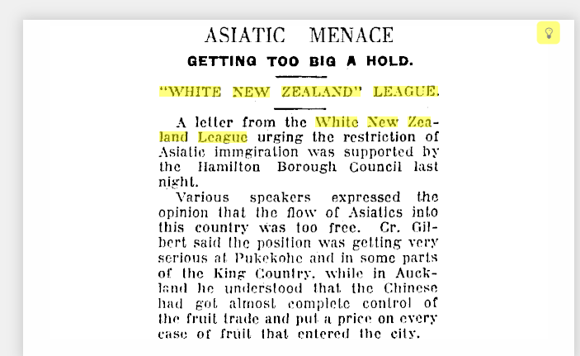
A newspaper article on the White New Zealand League,
Waikato Times, July 1, 1926, p. 8.

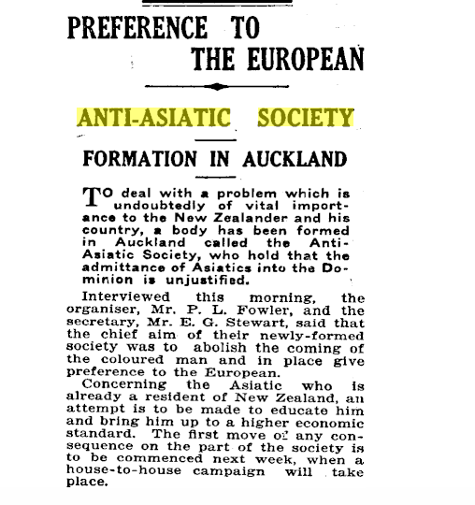
The Sun newspaper (Auckland), July 4, 1927, p. 12.

The Myth of Race

It is also important to understand that the fear of people from different races is real, but ‘race’ itself is a myth. There is no such thing. People who believe that one race is superior to another are known as racists, and while their actions are real and harmful, their ideas are not grounded in science any more than if someone believed in the Easter Bunny or Santa Claus. If you believe, it is real to you, but they are still imaginary beings.

There is also no such thing as a full-blooded Māori or any ‘pure’ race. This is not an opinion. It is a scientific fact. Human DNA is 99.9% identical. There is only one race in the world: the human race. Jews, Muslims, Christians, Africans, Asians and Europeans all originate from the same genetic stock. When completing this chapter, it is vital to understand this as you move through it.

Instead of race, it is more appropriate to refer to people by their ethnic group. ‘American’ or ‘Kiwi’ are not ethnic groups, they are nationalities and refer to the nations from where they originate. Examples of ethnic groups would be Irish, German, Jewish, Italian, Chinese. It does not refer to a religion or a political belief. For example, a Muslim is not an ethnic group.

Homework: In your books, list 5 ethnic groups that have not been mentioned in this lesson.

Lesson 3 The Vocabulary of Migration
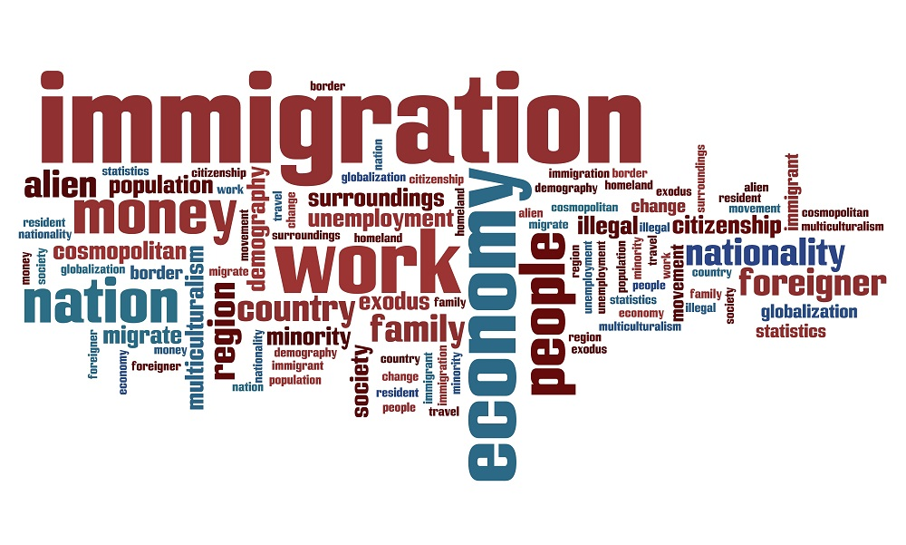
Notebook check to see that everyone is up-to-date. Place your notebooks on the table, opened to the last lesson to see that it has been completed.

Task 1: We will go over question 7 from last class and hear from students and the answers they came up with.

Task 2: Let’s play the ‘Where are you from Game.’

Watch the video clip ‘Where are you REALLY from?’
https://www.youtube.com/watch?v=igWYMo4z2OQ (2:41 sec.)

Class Discussion on clip:

Why are so many people concerned with ‘where they are from – originally?’

Has this ever happened to you? How did it make you feel?

Task 3: Vocabulary words

Students will write down the following definitions in their Red Books and number them beginning with 1. Some of the definitions have already been provided. As we go over each of the words, your teach will clarify any question.

1. Colony: an area controlled by another country.
(For example, New Zealand was once controlled by Great Britain).

2. Origin: Starting point

3. Push Factors: Factors causing people to move from their country of origin
(Examples: violence, crime, pollution).

4. Pull Factors: Factors that attract people to move to their new country
(Examples: education, employment opportunities).

5. Counterflow: When people migrate by later change their mind and return back to live in their old country
(Common reasons: homesick, disappointment, and couldn’t get a job).

6. Intervening Obstacles: Factors that prevent or make it difficult to migrate.
(Examples: new language, leaving family and friends behind, obtaining a visa, cultural differences, and the high cost of travel).

7. Migrate: to move from one country or place to another.

8. Destination: arrival place.

9. Neutral Factors: Factors that are of no concern to people when they migrate.

10. Refugee: someone who leaves their country as they are being mistreated and may be in danger.

Extension Activity: Students should have a look at your shoes, clothes, pencil case, computer, etc. and see where they were made. This shows how dependent we are on other countries for our goods. List the item and where it was made – below.

Example:

Item: Where Made
Glue stick France

Homework: Please ensure that your books are up-to-date. Anything not completed in class automatically becomes homework.

. While I write “humans and animals,” from the standpoint of biology, humans are a form of animal.
. Fallow, Brian (2015). “Busting Winston Peters’ Immigration Myths.” New Zealand Herald, June 26.

