Y9 DVC - Mission Heights Junior College

Design Brief – Mailbox
Situation (also known as the design problem)

Letter boxes can be an excellent design feature of a house or business, yet most letter boxes are a plain box with a slot for letters and a space for larger items and are seen as more of a functional thing rather than something that could be both functional and interesting.
Design Brief
Your task is to design, develop and make a prototype letterbox which will enhance the space where it is located. You will need to have a stakeholder to work with who will be the main person that will have an interest in your outcome. Your stakeholder can be a member of your family, or anyone else who would have a need for your design outcome.
Design specifications
- The letterbox must meet the relevant codes of practice for local authorities and NZ Post (see the sheet at the end of this guide for the NZ Post letterbox specifications)
- Your letterbox design can be any shape
- The design should fully reflect the needs of your client.
Your design work is divided into sections, each section will be explained during class time
Section 1/ Design brief, client outline and client needs
This section is an outline of the design problem together with the design considerations, the main stakeholder and the location of the outcome. This will be digitally produced using A4 format (google slide, MS Word, MS powerpoint etc) and will include this information:
On the first slide/page;
- Copy the design problem/situation and then copy the design brief below the design problem. You must edit the text so that it is in the first person (“your task” becomes “my task”)
- State who will be your main client/stakeholder
- include a photo of the place that your letterbox design will be based upon
- state what are the problems with the existing mailbox design
Section 2/ Questionaire. This will be used to find out information that will help in the design of your mailbox
Construct a short questionnaire that asks your client;
- what are their main interests?
- what are their preferences for a new design of letterbox?
Write in their answers. At the end of the answers, add a summary that describes the main needs of the your client
Section 3/ Letterbox investigation – look at various four different letterbox designs that could help you design a new letterbox for your client. Each of the designs will be evaluated to determine the things in the bullet points below.
- Their plus points
- Their interesting points
- Their minus points
- Are they creative, boring, functional
- What materials they are made from?
Section 4/ Concept ideas - Sketches of your ideas (at least two different ideas) for possible letterbox designs.
Concepts should show different views that show design features, materials it could be made from, sizes it could be (remember the NZ Post specifications)
how could it be supported or fixed in place? Sketches should be three dimensional. Your notes should tell the reader about your ideas, how suitable are they? Would they meet the needs of your client and the design specifications?
Section 5/ Development of a chosen concept idea – identify one of your concept ideas as the one you will develop. It should be the one that best meets the needs of your client. Develop the idea to show details of the letterbox. Develop means improve and refine your design in stages to a point where it is the best outcome, look at each of the separate parts in turn
Section 6/ A final design of the developed letterbox – this is a three dimensional drawing of the final design that shows what it will look like when finished, it should be drawn by hand and colour rendered to be realistic, it should include the main dimensions
Section 7/ A formal working drawing of the model showing the final design features - One A3 page. This drawing will show the shape and dimensions of your mailbox design. The drawing should be an orthographic drawing which shows three views of your final design, a front or main view, an end view and a plan (birds eye) view. The drawing will be made using formal drawing equipment (drawing board, tee square and instruments)

To do this you start with the final design drawing, use this drawing to sketch the three views with main dimensions and then use this drawing to complete your orthographic drawing. The drawing will be to scale. This means that whatever the dimensions are on the final design, the model should be made in proportion (half size will be scale 1:2, quarter size will be scale 1:4, one fifth size will be 1:5) The drawing must show:
- Three separate views of the mailbox
- The chosen scale it will be made to
- The main dimensions needed to make the mailbox design from the orthographic drawing
- The construction lines that were used in the drawing (no erasing!)

Note: no model making will be started without ALL sections of work being completed
Section 8/ Model – A model of your final design in proportion that shows the design features. You will have access to cutting, shaping, painting and fastening equipment to make your model but work outside of school is expected and you must obtain any materials not readily available at school.
- The prototype model must be a maximum size of 200 X 200 X 200 mm
- Modelling materials such as cardboard, core flute (real estate sign) medium density fibreboard (MDF) will be available for modelling, if you need special materials you will have to supply these yourself. If required, a base board will be supplied to mount the model on.

Section 9/ Final Evaluation – you need to be able to judge your design in terms of how effectively the outcome satisfies the requirements of your design brief and client specifications. A written evaluation should include comments from your client on the final outcome.

Instructions for assignment work;
- Work will be on a mixture of A4 (digitally produced/printed and A3 (hand drawn) paper
- Each sheet should have your name and your option class bottom right hand corner (your name - 9 DVC)
- Colour should be used to enhance sketches
- Notes must be neat, preferably in black pen or word processed, if by hand, use light pencil guidelines or a tracing of black guidelines under the sheet, digital text must be 12 point in size, arial or similar plain type font.
- Sheets must be free of smudges and marks, when drawing, use paper to rest your hands on so sheets remain free of sweaty hand marks.

Mailbox specifications (NZ Post)
Help our Posties deliver your mail safely, securely and efficiently by meeting our mailbox specifications.

Designing your mailbox
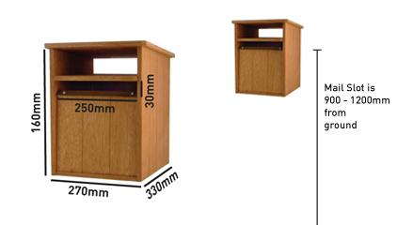
Illustration only – mailboxes are not available for purchase
- Ensure the main mail slot is big enough to take several A4 size magazines without needing to fold them. If you receive parcels, you should consider having a separate parcel area in your mailbox.
- Your mailbox should be deep enough (from front to back) to take the length of an A4 size item so that mail can be pushed in far enough to drop out of sight securely.
- Your mailbox should be large enough to hold all of the mail you receive. If you frequently receive parcels, ensure your mailbox is large enough to accommodate them, out of sight from the street.
- Ideally, your mailbox will have a separate area to take newspapers.
- You can still have fun with your mailbox design - just allow for the minimum internal dimensions shown in the diagram below to make mail delivery easy and safe.
- Spring loaded flaps must not be fitted on mailboxes as they may cause injury to your Postie.


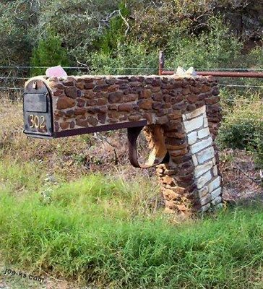

Client interview
Question – describe the letterbox you have at present?
(Write in a description of the existing letterbox)
Example Answer –
“it’s a metal one, a rectangular shape that has a top that opens where the mail goes, it is made of painted metal and sits on a metal pole in the ground”
Question – I am going to design a new letterbox which reflects your families interests, what are some things that you are interested in and could be incorporated into a new letterbox design?
(Write a list of all the things you can think of that reflect the people who live in the house and their interests and likes)
Model Answers –
- We keep chickens as pets and sell their eggs from our house …..
- My Mum and Dad like motorcycles ….
- My wife in a nurse …..
- We have a cat that causes lots of trouble ….
- We like going fishing …..
- My husband is a builder ……
- My oldest boy likes playing computer games like World of Warcraft….
- another son who is mad on aircraft ….
Summary;
I have found out from my client information (insert your findings) which gives me some ideas to work on for designs. I now need to come up with some design ideas that reflect the things I know about them and what reflects their interests and likes.

