LI: To plan a narrative using a story board.

Steps to success:

MUST: I can order key events in a story.
SHOULD: I can use sensory and figurative language to describe the setting and character.
COULD: I can make predictions and plan an alternative ending to the animation.

Today you are going to use a story board to order the main events from the animation ‘Alma’.

You are then going to plan what happens next to Alma (after she has been turned into a doll).

Using the images attached, plan your narrative of Alma.

Remember to make notes (using bullet points) on the following:
- setting description
- character thoughts and feelings
- character actions and motivations
- include figurative language





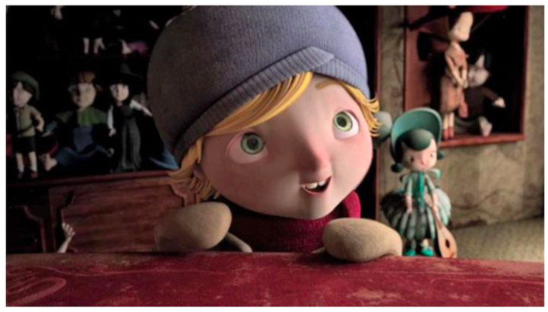
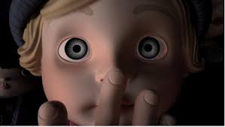
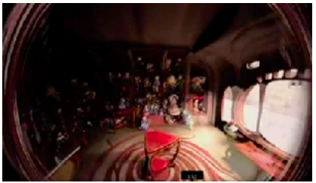
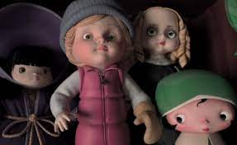

Now plan an alternative ending.
- What happens next to the doll of Alma?
- Does she escape?
- Does the doll shop owner appear?
- Can Alma help the next child and stop her becoming another victim of the magical doll shop?

Create a storyboard of at least 6 cells using storyboardthat.com or CANVA.com to show a new ending of the story.

It’s up to you!

