Year 7 Science Assessment 2: Experimental Investigation
Students will participate in a physical world investigation to see what material would be the best to go down a slide the fastest.
Physical World physical inquiry and physics concepts L3
- Explore, describe, and represent patterns and trends for everyday examples of physical phenomena, such as movement, forces, electricity and magnetism, light, sound, waves, and heat. For example, identify and describe the effect of forces (contact and non-contact) on the motion of objects; identify and describe everyday examples of sources of energy, forms of energy, and energy transformations.

Investigating in Science: L3/ L4
- Build on prior experiences, working together to share and examine their own and others knowledge
- Ask Questions, find evidence, explore simple models and carry out appropriate investigations to develop simple explanations
Communicating in Science:
- Begin to use a range of scientific symbols, conventions, and vocabulary.
Engage with a range of science texts and begin to question the purposes for which these texts are constructed.

Practical Work | You can use equipment with support and follow safety procedures. | You can use equipment and follow safety procedures. | You can use equipment appropriately and explain safety procedures. | You have selected and used equipment appropriately.
Managing self | Has not followed instructions and has not been able to complete the investigation with support | Can somewhat follow the task instructions and has completed the investigation with support | Followed the task instructions and completed the investigation with minimum teacher input. | Able to following the task instruction & work independently to complete the practical investigation

Forces | You have yet to identify different types of forces | You have identified different types of forces | You have described different types of forces | You have described, with examples, different types of forces
Friction | You have yet to identify friction as a force | You have identified friction and how it influences movement | You have described friction and how it influences movement | You have described friction and how it influences movement, with examples
Overall | Working Towards | At | Above | Beyond

Year 7 Science Assessment 2: Experimental Investigation

Imagine if sliding were a Commonwealth sport. It would certainly be a fun and popular one. The fastest person down the slide would win the gold medal. !
Obviously the clothes you wear to go down the slide will determine how fast you can go


You are going to do an investigation to see what material would be the best to go down a slide the fastest.
AIM
The aim of this investigation is to find the best material to wear down a playground slide

VARIABLES
Independent variable - What variable are you changing ?

Dependent Variable / What variable will you be measuring ?

Control Variable - what will you keep the same ?
1.
2.
3.

EQUIPMENT / APPARATUS
List the equipment used here:
1.
2.
3.
4

METHOD
This is when you describe how you will do this experiment. Be precise and to the point. Much like a recipe.

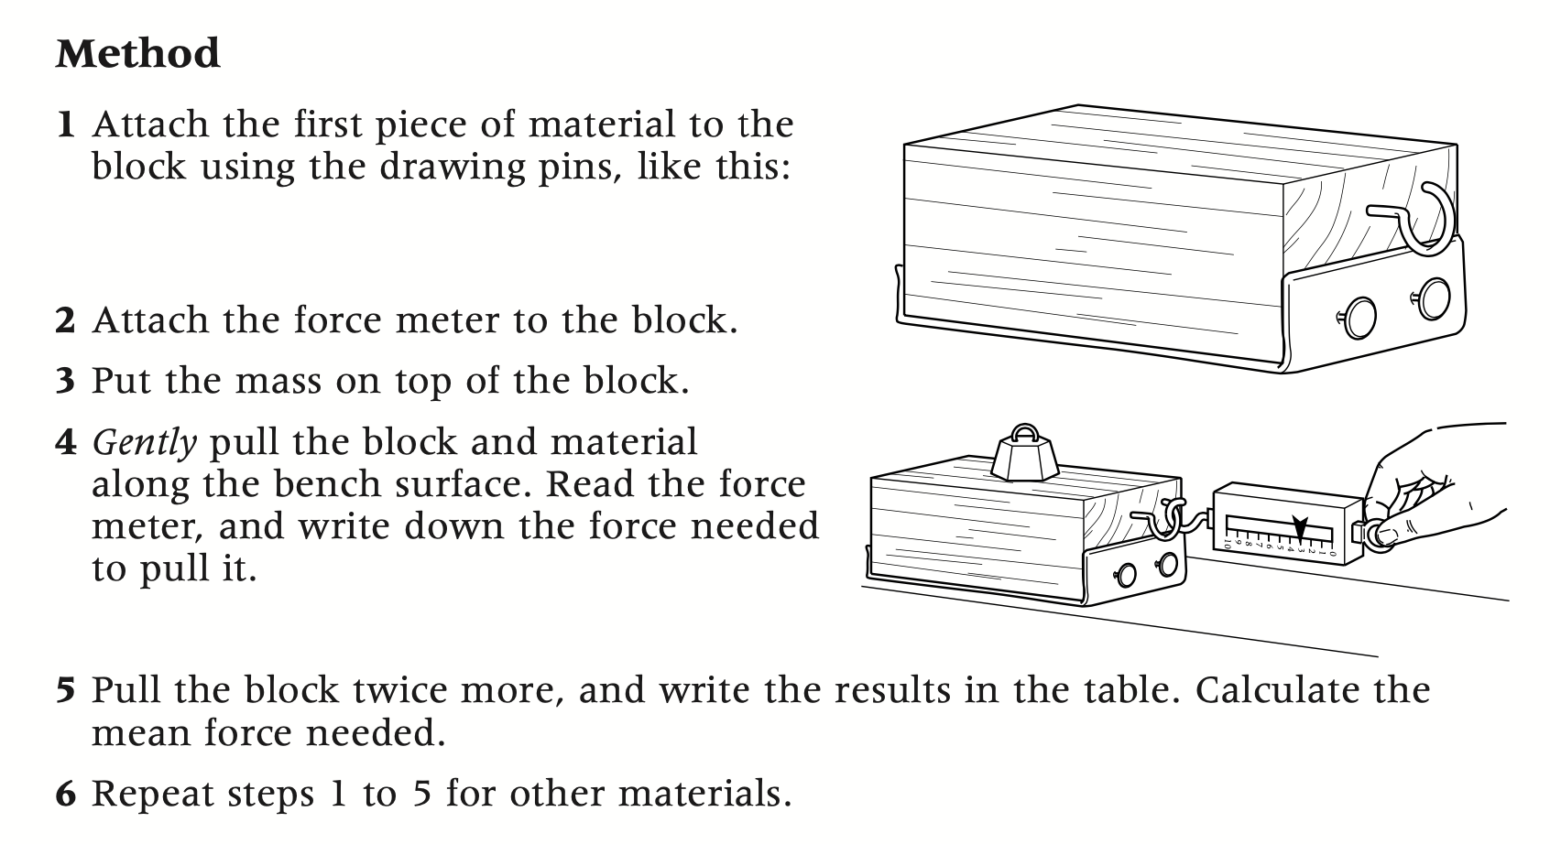

RESULTS
To get more accurate results you will test each material 4x and find the average force. Fill in your results in the table given below. Use your calculator to work out the average force used
Material to slide down slide | Force needed to pull block (N) |  |  |  | Average Force needed to pull block (N)
Material to slide down slide | Pull 1 | Pull 2 | Pull 3 | Pull 4 | Average Force needed to pull block (N)

GRAPH
Present your results in a BAR chart underneath

CONCLUSION / Considering your results
- Write a conclusion for your experiment.

- Say which material produced the most and least friction, and which one you would wear to go fast on a slide.

- Answer the following questions
It took the biggest force to pull the block with ___________________ on it
This material has the _________________ (most/least) friction.
It took the smallest force to pull the block with ____________________ on it.
This material has the _______________ (most/ least) friction.
If I wanted to go fast down a slide, I would wear clothes made from ________________

- IN your own words write a few sentences about friction using the words in the block below
Resistance force, Newtons, opposing force, acts in the opposite direction to motion, can be good, can be bad, brakes of a bicycle , engine parts, lubrication

DISCUSSION / EVALUATION
Is there anything you could have done to improve your investigation ?

