Week 5 – The Week of August 22 to September 28, 2022

Lessons 1 to 3 –

Preparing for your Assessment:
How to do Basic Research

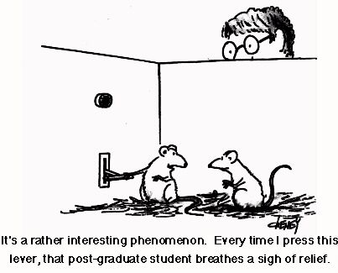

Success Criteria
By the end of this week, students will have refreshed their skills at conducting online searches for specific information using key social science databases on EPIC and an array of other online sources. They will also be able to assess the reliability of evidence and know the difference between primary and secondary sources. Students will also become familiar with potential assessment topics on which to take a social action.

Lesson 1:
Read the Source Interpretation Powerpoint.
I will also go over this in class and discuss/answer any questions as they arise. The information covered will be source interpretation advice including key terms and definitions.

Lesson 2:
Read the Handout ‘Assessing Sources’ which is in a separate file. I will go over this in class as well. This will include:

Types of Evidence
Primary
Secondary
Evaluating Websites:
Using Wikipedia (or not)
Writing Style
Bias
Fact
Opinion
Cartoons, paintings, sketches, photos
Useful
Reliable
Relevant
Significant/Significance

Lesson 3:
Read the Handout ‘Possible Information Sources for Global Studies Research’ which is in a separate file. I will go over this in class as well. This will include such tools as:

How to access the Mission Heights Middle School Library
EPIC databases
Academic OneFile
General OneFile
Australia/New Zealand Reference Centre
MasterFILE Complete
Books:
Newspapers
Magazines
Online sources
Websites
Can I use Wikipedia?
Auckland Libraries Council
Google Books
The Wayback Machine

