Week 5 – The Week of August 22 to 28, 2022

Global Warming & Us

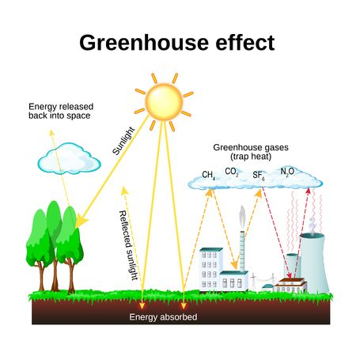

The Basic Mechanism of Climate Change

Lesson 1: How we Got Here in the First Place?

Success Criteria
Students will gain an understanding of the key mechanisms that are driving global warming and to be able to list the impacts of these mechanisms on life in New Zealand.

Task 1:
Watch the clip, “Earth’s population over Time.” This will show how an increase in population growth is placing unprecedented pressure on resources and generating large amounts of pollution and trash:

https://www.youtube.com/watch?v=PUwmA3Q0_OE 6:24 (start at 1:01)

Class discussion: Is it realistic to think that the earth and humanity can survive indefinitely without some changes to this situation? In other words, can we keep going on this way indefinitely before we could see serious consequences to the Earth’s ecosystem?

List in your Red Book, at least four problems that you can think of that are a result of overpopulation:

1.
2.
3.
4.

Task 2:
Watch the NASA clip on global temperatures.
https://www.youtube.com/watch?v=Z4bSxb5THm4

Coincidence?
Could greenhouse gasses created by humans be responsible? NASA says yes – that the build-up of CO² in the atmosphere is related to human activity.

While some people claim that global warming is a hoax or ‘fake news,’ nearly all the world’s climate scientists are convinced that the evidence is overwhelming and that something must be done quickly to stop the temperature rise.

Task 3: Google the article: ‘What's the difference between global warming and climate change?’ and read it. Look up any words that you do not understand and place them in your glossary.
Access the article by typing the title into Google or go to:
https://www.climate.gov/news-features/climate-qa/whats-difference-between-global-warming-and-climate-change

In your Red Book under the heading ‘Climate Change’ vs ‘Global Warming,’ write a one-paragraph summary comparing the difference between ‘global warming’ and ‘climate change.’

Climate Change

Global Warming

Task 4: Extension exercise (optional)
In your book, write a newspaper article the explains the process of global warming. Include a catchy title. Explain why this can have a serious impact on the earth’s future.

Week 5 Lessons 2 & 3:

Current Event Analysis on Global Warming

New Zealand’s Plastic Crisis

Read the article below which was first published in The Guardian on September 20, 2021.

New Zealand is not as clean or green as we think – plastic waste is polluting our land
Lizzy Carmine
Ignorance about plastic recycling has tricked us into guilt-free consumption – decision makers have to give us sustainable options
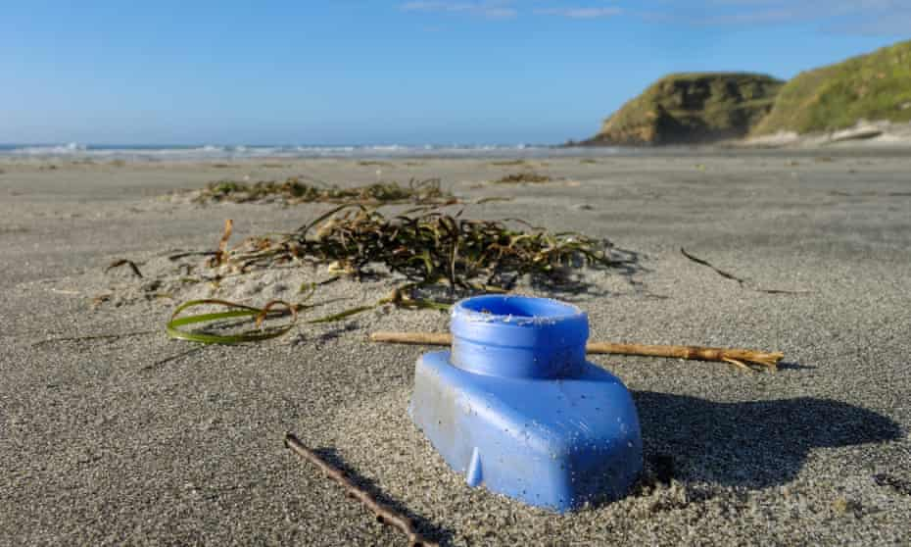

Discarded blue plastic bottle part buried on a beach on New Zealand's west coast. A deathtrap for small creatures.

Growing up my school lunches were covered in plastic wrapping, like those of many of my schoolmates. I was taught from a young age to pick up my rubbish and recycle, and I trusted the recycling systems in place especially because New Zealand streets were so clean. Years later, I saw a video on Facebook of a turtle with a straw in its nose, but I knew Kiwis weren’t to blame, our rubbish systems were too sturdy. Ignorance is bliss, and ignorance is the cause of the world’s plastic pollution crisis.
The illusion was shattered for me when I watched For The Blue, a documentary by Project Blue, a group of young ocean enthusiasts from Aotearoa, who travelled across the globe to investigate the world’s plastic-waste crisis – only to find themselves back in clean, green New Zealand experiencing the effects of the global plastic epidemic in their own back yard. During their visit to a once pristine area in the South Island, they found plastic trash strewn across the land, after the Fox river breached a closed landfill on its ban
The surging water sent waves of plastic trash through untouched landscapes, including a marine reserve and unmodified wetlands. This shocking event emphasised the hidden reality of plastic pollution on our own soil, the result of broken recycling systems and poorly placed coastal landfills. There are at least 321 closed landfills set up across Aotearoa situated next to the coastlines and riverbanks, and it’s only a matter of time until many of these may burst under rising seas and increasing floods.
Kiwis trust their plastic waste will be recycled when it’s put in the recycling bin. Unfortunately, New Zealand facilities can only recycle three types of plastic, the other plastics are difficult to recycle and therefore sent to landfills across the nation or exported overseas. By and large, every day we are using single-use plastics which are polluting our earth.
The plastic pollution crisis is blamed on countries in South-east Asia which have become dumping grounds for the western world’s plastic waste. Countries like New Zealand are guilty of offloading difficult to recycle plastic to developing countries who are without adequate recycling facilities.
Developing countries accept the imported plastic for money, contributing to their population’s health problems. Since China shut the doors on importing waste from other countries, nations like Malaysia have been the recipients of New Zealand’s trash. For Kiwis it’s largely a case of “out of sight, out of mind”.
Single-use plastic consumption thrives off our busy lifestyles and need for time convenient products like pesky plastic takeaway containers. Our “take, make, dispose” consumerism style needs to transition to a circular one “reduce, reuse, recycle”.
The swapping of traditional cosmetics and household products for plastic-free alternatives has already started gaining momentum in mainstream stores. But our economy needs to normalise sustainable packaging options – if it’s within people’s means to buy products that leave zero waste, they should, as this will help drive the demand for companies to provide affordable and accessible sustainable options for everyone. Reusabowl are an example of Kiwi ingenuity that allows customers to still enjoy takeaway options but waste free. Takeaway stores partner with Reusabowl, who offer a bowl borrowing system; borrow a bowl for $10 and get a full refund upon returning it. It’s the perfect example of a circular economy.
The New Zealand government has kicked off its mission to phase out single-use and hard to recycle plastics by 2025, after its ban on single-use plastic shopping bags in 2019. This includes bans on polystyrene takeaway packaging, plastic cutlery and plates, straws and fruit stickers. The government is sending a clear message about its stance on transitioning to a low-waste economy. However, there will still be a large amount of plastic waste which is unaccounted for on our supermarket shelves, that we will not have the capacity to recycle for some time, and that will ultimately go to landfill as plastic can only be recycled a handful of times. This is a good first step, but we have much more work to do.
New Zealanders’ misinformed ideas about where our plastic waste ends up has tricked us into guilt-free plastic consumption. Unknowingly we have polluted developing countries, the ocean and our own home. We are running out of time. Plastic producing giants and broken recycling systems need to take accountability for the mess they’ve created and put in meaningful work to fix their unsustainable practices. As individuals we can refuse plastic at the source to limit waste from landfill. But ultimately the decision makers at the top of our waste systems and mass corporations need to change – our future depends on it.

Task 1 – Response A:

Answer the follow questions in your Red Books: List in dot-point form, the different ways that New Zealand is having a problem with how it disposes of its trash.

Task B – Response B:

Write a letter to a friend in which you propose a solution to the problem of garbage in New Zealand being dumped and buried in landfills.

Lesson 3:

Designed for the Dump:
Why we cannot keep living this way!

One of the problems today with controlling pollution has to do with the way products are made and disposed of. Watch the short video, ‘The Story of Stuff’ at: https://vimeo.com/22868620

Answer the following questions:

1. Stuff moves through a system from production to extraction to distribution to consumption to ______________.

2. What percentage of the original forest is left in the United States? (3:15 sec.)

3. The US has about 5% of the population, but they use ____ percent of the world’s resources.

4. What percent of the world’s original forests are gone?

5. At the 9:30 sec. mark, the announcer observes that she bought a cheap radio, but who really paid for it?

6. What percentage of the materials that are produced end up as trash within 6 months?

7. What is ‘planned obsolescence?’

8. What is ‘perceived obsolescence?’

9. How many pounds does the average American throw away every day?

10. What is your solution to the problem of how to dispose of our stuff in a way that addresses the problem of simply dumping it in a landfill and covering it with dirt? This could be one of the most important problems we face in the world.

Write a letter to the editor of the New Zealand Herald explaining what you think should be done by the Kiwi Government to address the problem of waste. Include a catchy headline.

